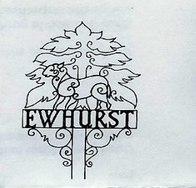
EWHURST PARISH COUNCIL
WITH ELLENS GREEN

Clerk to the Council: Joanna Cadman Tel: 01483 268627 email: clerk@ewhurstellensgreen-pc.gov.uk

ACTION LIST: November 2025

Date of meeting | Minute no | Action | responsibility
Jan 25 | 014iii | House on the Green | JL/MH  Have looked at the problem, MH in discussions with WBC and SCC
Mar 25 | Ps | Lights opposite hall | Clerk  It was agreed to investigate further lighting to the car park entrance, to facilitate crossing the road, and not to trouble the residents for use of their gate lighting.
Mar 25 | 043 | Thames Water work on the Green | MH/Clerk  Some work has been done on the path, but very poorly. MH has written a 7 day letter to Thames Water  Cllr Townsend is in contact with new representative at Thames Water and will discuss with him.
June 25 | 096b | New Village Hall | Clerk  The Diocese has not yet responded to our enquiry.  The Clerk will approach the Diocesan Secretary for her help
July 25 | 111 | Wifi | JM  To continue negotiations with Community Fibre
Sept 25 | PS | Light opposite hall | Clerk  Repaired
Sept 25 | 132 | Cemetery tree/laurels | Clerk  Members agreed the second quotation of £1100 + VAT to clear the left fence all the way to the top, cutting back the laurels to near the boundary.  Proposed by Cllr Clowes, Seconded by Cllr Henry, all in favour
Oct 25 | 143c | Manhole cover | Clerk  Tidey and Webb have confirmed that there is a manhole, buried deep under the turf. They cleared out the hole and re-set it. The Clerk has written to state that we expect them to return to re-do it if there are any issues, such as flooding, as a result.
Oct 25 | 145 | Ewhurst Green footpath | Clerk/JB/MW  A further quote has been received in the sum of £2,750 to repair the footpath from Bostocks Close to the manhole cover.  WBC will be asked for their help
Nov 25 | 157 | Fire safety | Clerk  Agenda item – January meeting
Nov 25 | 161 | Glebe refurbishments | Clerk  Agenda item – January meeting

