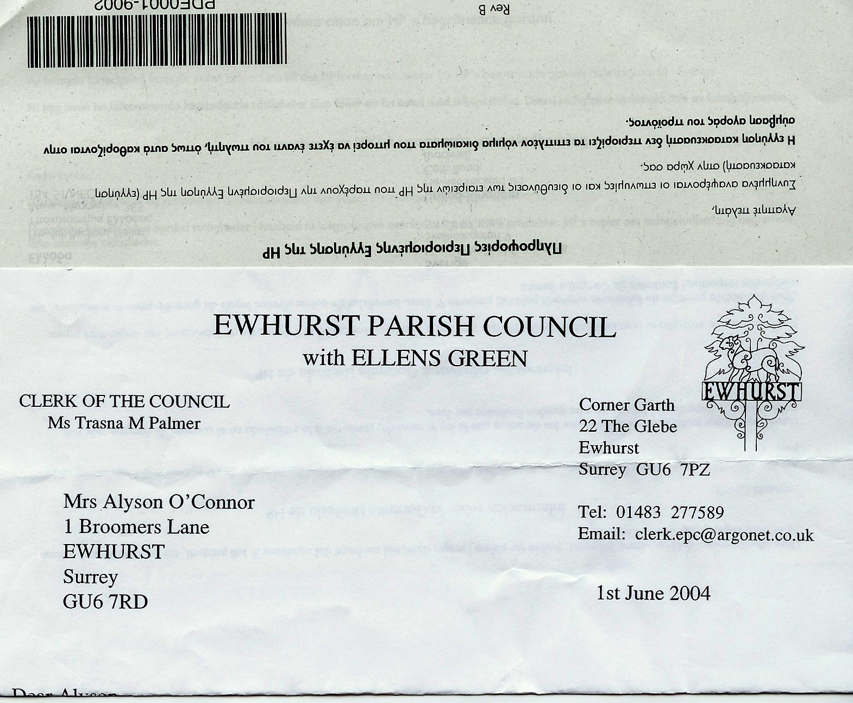
Ewhurst & Ellens Green News
Keeping our community informed about local issues and events

Issue 02 December 2025

If you would like to receive regular updates from the Parish Council by emailed newsletter, please email your details to:
clerk@ewhurstellensgreen-pc.gov.uk

Katy was nominated by the Trustees of Ellen’s Green Memorial Hall for her 38 years of voluntary service as the Booking Secretary of the Ellen’s Green Memorial Hall. A task she has undertaken with great gusto, energy, care, patience, kindness and understanding.

She has selflessly spent many hours attending to the smooth running of the Hall, as an administrator, a caretaker, a cleaner, a warden and a fundraiser for both the Hall and the Playground.

In the citation Mary also spoke of Katy’s many years volunteering as the leader of the Ellen’s Green Toddlers Group, providing a very welcoming and inclusive environment as well as showing kindness and compassion at all times.

Katy also ran the Ewhurst Junior Players group for many years.
Lord-Lieutenant’s Award
for Appreciation
presented to Katy Rapley

On Monday 27th October 2025, Mary Cresswell, the Deputy Lord-Lieutenant of Surrey, presented Katy Rapley with His Majesty’s Lord-Lieutenant’s Award of Appreciation for her service to the community of Ellen’s Green & Ewhurst.

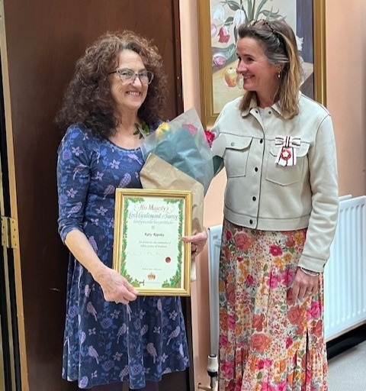

**Photo of Hazelbank Stores with Christmas Decorations**
Surrey Hills Christmas Candlelit Concert 2025
Sunday 7th December
at 7pm
St Nicholas Church, Bury St, Guildford

The Surrey Hills choirs are proud to bring joy and celebration to the season with our annual Christmas Concert at St Nicolas Church, Bury Street, Guildford.

The setting is beautiful and we will add to the atmosphere by filling the church with candles to create a magical spectacle. There will be some well-known carols for the audience to join in with, including Once in Royal David’s City, and our two choirs will beguile you with songs old and new.

Our mixed voice choir, the Surrey Hills Chamber Choir, will sing several pieces by living composers which are modern takes on much older texts. These include Michael McGlynn’s Wexford Carol, from a 500 year old Irish original, and Michael John Trotta’s Veni, Veni Emmanuel. Tavener’s The Lamb, Whitacre’s Lux Aurumque and Arvo Pärt’s Morning Star are more ethereal and mysterious, whereas Assersohn’s Make we joy now in this fest is fast and full of fun. With Morten Lauridsen’s O Magnum Mysterium we have one of the most beautiful and popular Christmas pieces of the last 30 years.

Joanna Forbes Lestrange’s Advent O Carol will see the Chamber Choir joining forces with the ladies of the Surrey Hills Singers, who will also sing Amy Fell Bernon’s high energy, festive Throw Open your
Shutters, as well as David Waggoner’s sublime blending of Infant Holy and The First Noel in his Noel Fantasy. They will also be performing a set of three beautiful songs on the theme of the winter landscape, Winterlight, also by Amy Bernon, The Snow by Edward Elgar and Tundra by Ola Gjeilo.

Tickets are £14 for adults and £5 for under 16s including drink and nibbles after the concert. They will be available to book online from Friday 21st November at www.singsurreyhills.com.
The Surrey Hills Singers rehearse in Ewhurst on Monday mornings and will welcome new singers to their open rehearsals in January. Contact debbie@surreyhills-choirs.co.uk if you’d like more information on joining.

Parish Council News

XXXXXXXXXXXXXXXXXXXXXXXXXXXX

Ewhurst Tennis Courts

We now have a membership scheme for use of our freshly refurbished tennis courts on the recreation ground.

For £25.00 per annum, a whole household can play when they wish. The courts are secured with a combination lock and the number will be changed on a regular basis, with all members being advised as soon as this is done. To become a member, email the Clerk at joanna.cadman@ewhurstellensgreenpc.gov.uk
or phone on 07711 566458 and she will talk you through the process and sign you up.

You can, alternatively ‘pay and play’ by visiting the village shop and paying £5.00 to receive the current lock combination number.

Enjoy our lovely courts!

XXXXXXXXXXXXXXXXX
XXXXXXXXXXXXXXXXX
X TIME INFORMATION X
XXXXXXXXXXXXXXXXX
XXXXXXXXXXXXXXXXX

Rural Housing
Together with Surrey Community Action, the Parish Council is planning to run a Housing Needs Survey in the new year. This is a short piece by Surrey Community Action about rural housing and housing needs surveys.
The cost of housing in rural areas has become out of reach for many of those who have grown up in and have strong connections with countryside communities. Young people, people with rural jobs and young families can often find themselves priced out of their area and rural communities can become socially unbalanced and unsustainable.
Surrey Community Action, a countywide charity that supports voluntary and not-for-profit groups, operates a Rural Housing Enabling service that works together with parish councils, local authorities and housing associations to facilitate the provision of appropriate and affordable rural homes.
Recently completed projects include a 9-home development at Livery Close in Hambledon and a 17-home development at Poland Meadow adjacent to Brockham near Dorking. These developments (and many others) are not for profit and provide homes of various tenures for local people including shared ownership and affordable rent. The homes will remain affordable for future generations of occupiers and people with a strong local connection will be prioritised when the homes are re-let or re-sold.

When considering a rural affordable housing project, it’s necessary to know what the local housing need is. The number and types of homes needed, and what cost would be genuinely affordable for local people are all important if a housing development is to really serve the community.
To understand local housing need, Surrey Community Action works with parish councils to carry out housing needs surveys. A questionnaire is sent to all households in a parish asking about current and future housing need. The information gathered is compiled together with evidence from other sources to create a picture of local housing need and affordability.
This information informs the parish council and others what type of housing is suitable for local people and can potentially enable the parish to justify a ‘Rural Exception Site’ where planning permission can be granted at a site where housing would not normally be allowed. The purpose of a Rural Exception Site is to provide genuinely affordable homes for a rural community in perpetuity. They’re typically funded with a mix of bank loan and government grant.
The route to providing appropriate and affordable homes is not always easy but there are many examples in Surrey and elsewhere of small housing schemes that fit well into their area and are enabling single people and families to remain living in their community.
If you have any questions, you are welcome to contact the Parish Council Clerk at clerk@ewhurstellensgreen-pc.gov.uk or rural housing enablers at Surrey Community Action on 01483 447121 or email davidc@surreyca.org.uk .



A Small Charity,
Big Heart.
Registered charity no. 242392

The Ewhurst Charity is a small, registered charity set up to support the people of the Parish of Ewhurst and Ellens Green.

We can offer financial help to:
- those in need, hardship or distress
- further your education
- provide equipment for educational purposes
- support the emotional wellbeing of members of the community.

If you wish to be considered for a grant, please do not hesitate to contact us at theewhurstcharitysecretary@gmail.com.
Applications will be treated in the strictest confidence.
Ellen’s Green Mission Hall Fund
Registered charity number 242393

This local charity gives small grants to organisations, groups and schools whose members on the whole live in the parish of Ewhurst and Ellens Green, and give benefit to the local community. Recent awards have helped support community clubs and buildings, children’s activities and church groups, as well as one-off local fundraising appeals. EGMHF also supports organisations whose wider influence benefits the people of Ewhurst and Ellen’s Green. Sayers Croft Trust and Citizens Advice SW Surrey are recent examples.

Could EGMHF help your group?

The Trustees meet once a year (usually in January) to decide on the next batch of grants to be paid from the Fund’s investment income.

If your group needs support, please email the Fund Secretary at allenplusjan@btinternet.com.

St Peter and St Paul Church
The Parish Church

Since Ewhurst is once again standing as a single parish, we would like to consider re-introducing our previous custom of having a regular monthly service at your Mission Hall in Ellens Green and perhaps a Carol Service in the Christmas period. Services at present are 9.00am and 10.30am on alternate weeks. Details are on the website.

Suggestions or ideas would be welcome.

Please contact the Church Wardens:
Liz Tingley - liztingley@outlook.com or
Martin Lockwood - mglockwood8@outlook.com

It is your Parish Church and you would be most welcome at any time.
EWCARE
The EwCare Good Neighbour Scheme has been running for 27 years, helping any resident in need of assistance in Ewhurst and Ellen’s Green.
Over the years we have had many wonderful volunteers: Drivers and Duty Officers and those who help with both. But time marches on and volunteers retire as they are no longer able to help so we are looking for new volunteers who can either take clients to their hospital or doctor’s appointments, or to take the weekday calls requesting assistance between 10.00am and 12 noon. We use WhatsApp to communicate between our volunteers, which reduces the need for time consuming phone calls. We are about to begin using an Internet logging application, specially written for schemes like ours, so eventually removing the need for paper records and our famous ‘EwCare Bag’.
If you would like to become a volunteer, appropriate training is available. Please call Angie on 01483 277505 for more details.
If you wish to use EwCare to assist you, you can call us on 01483 277606 from Monday to Friday between 10.00am and 12 noon. The message will give you the phone number of the Duty Officer to call to arrange for your assistance. They will get back to you when a volunteer has been allocated for your job.
We are self-funding and so request a donation from our clients to cover the cost of the transport provided. We have suggested donations for trips, but clients should donate only what they can afford. Our volunteer drivers claim a mileage allowance for the trips they do.
So please get in touch if you need help or if you wish to join EwCare as a volunteer; we will be happy to see you.
Jackie Avery, Chairman

