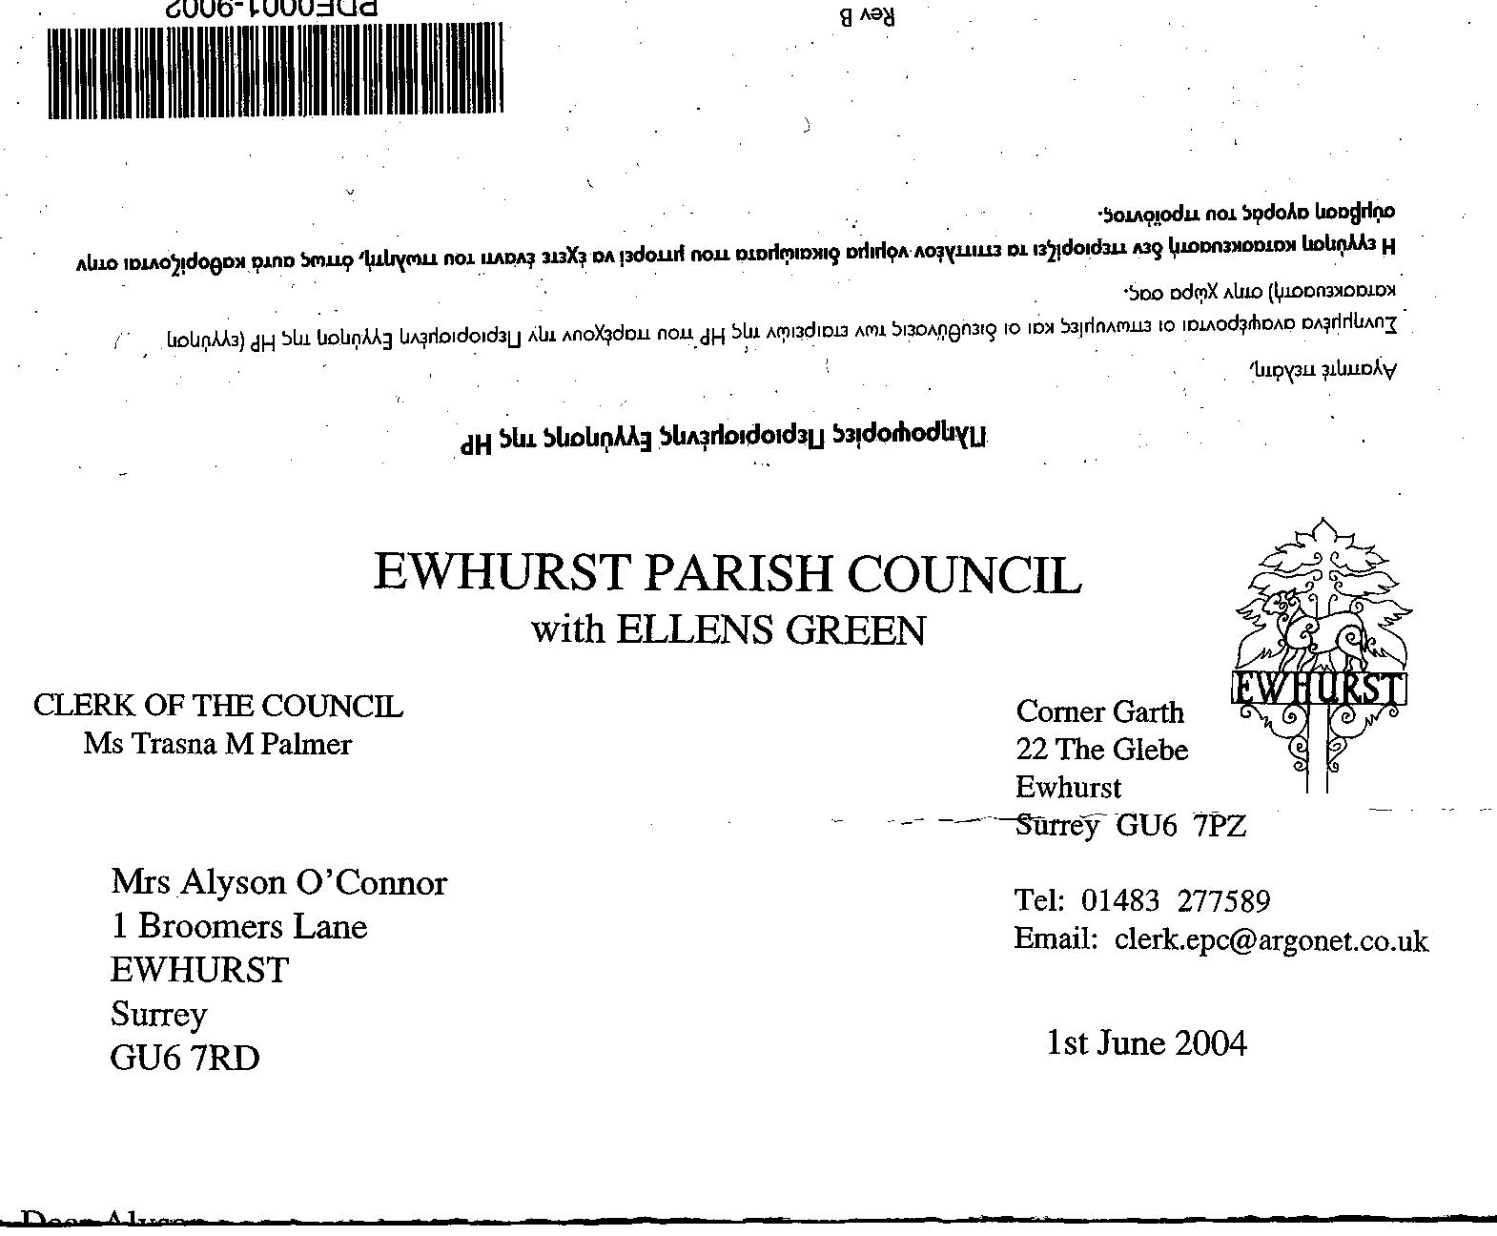
EWHURST PARISH COUNCIL
WITH ELLENS GREEN

Clerk to the Council: Joanna Cadman Tel: 01483 268627 email: clerk@ewhurstellensgreen-pc.gov.uk
EWHURST WITH ELLENS GREEN PARISH COUNCIL MEETING.
Minutes of a Meeting of the Parish Council held at
8.00 pm on Monday 15th September at the EYSC

Present:` Cllr N Clowes (in the chair), Cllrs J Bloomfeld, T Bloomfield, V Henry, M Higgins, J Lilley, J Mitchell
L Tingley, M White.
6 members of the public
The Assistant Clerk, Mrs J Luker Brown

In attendance: The Clerk, Mrs J Cadman

- Tennis Courts: members of the public were concerned that the current locking of the courts, together with charging and deposit and a fee, was excluding the younger members of the village, who are not provided for in other ways. They had read Cllr T Bloomfield’s proposal in the Community noticeboard (detailed under agenda item 127 (2025) and were generally in favour, but suggested that the surface on the tennis courts be extended to the basketball area. One resident wished to provide tennis rackets and balls, to be kept on the court, to give people a chance to try the sport without outlay.

- Light opposite village hall: the light in the hedge has stopped working again. The residents in the house opposite have not put on their lights in the evening.

- Speeding on the Green: Cllr Clowes explained that the speed limit will be reduced to 30mph if the promised build-outs are installed to slow traffic. At present these are in the planning stage, and then there will be full consultation with the residents on the Green.

114 (2025) | APOLOGIES FOR ABSENCE: all members were present.
115 (2025) | DECLARATIONS OF INTEREST: none were made.
116 (2025) | MINUTES OF PARISH COUNCIL MEETING HELD MONDAY 21ST JULY 2025: these were agreed as a correct record of the meeting and signed by the Chairman.
117 (2025) | ACTION LIST:
  Date of meeting | Minute no | Action | responsibility
  Jan 25 | 014iii | House on the Green | JL/MH  MH reported that WBC have done some work and put additional work on their autumn programme. SCC are also involved and he will push them for action
  Feb 25 | 027 iv | Tennis courts | Clerk  Professional has agreed to terms of £10 per hour, with £5 for residents, to be paid retrospectively. Noted that this could not be enforced or controlled.  A new booking system was discussed on the agenda
  Mar 25 | Ps | Lights opposite hall | Clerk  A letter has been written to the new owners
  Mar 25 | 043 | Thames Water work on the Green | MH  Some work has been done on the path, but very poorly. MH will follow this up again.  The Clerk will obtain a quote for this, if necessary the Parish Council will carry out the work and re-claim from Thames Water
  June 25 | 093 | Entrance to Bowls Club | Clerk  Agenda item
  June 25 | 096b | New Village Hall | Clerk  The Diocese has not yet responded to our enquiry.
  June 25 | 096c | Bowls Club | Clerk  It was agreed that the Parish Council had no grounds to get involved in the ongoing differences between the Bowls Club and the Short Mat club, but it is possible to mediate on a personal level and to draw up an agreement for both parties.  A rent review is due.
  July 25 | 106 | Statutory authorities | All  To respond to the consultation by the 5th August
  July 25 | 108 | CAT | JM  To complete matrix for cricket club application
  July 25 | 109 | Gas central heating for Glebe | NC  Another quote is needed
  July 25 | 111 | Wifi | JM  To continue negotiations with Community Fibre  Agenda item October meeting
  July 25 | 113i | Infant School | NC  A meeting had been held with the headmaster, who outlined their plans for progression from an Infant School to a Primary school. To do this, a new toilet block is needed, and playing fields.  He was assured that the Parish Council would support their plans an hope to be able to offer them additional facilities in time.  It was noted that the response to the consultation was exceptionally good for a village this size.
  July 25 | 113ii | WhatsApp group | Clerk  To be set up
  July 25 | 113v | PCC | LT  To write a piece for the next newsletter asking for representative from Ellens Green
118 (2025) | MATTERS ARISING not covered by the Action List:  Cllr Lilley thanked everyone who was involved in the litter pick at Ellens Green
119 (2025) | THE PLANNING COMMITTEE: Minutes of planning meeting held 21st July 2025: these were agreed to be a correct record of the meeting.
120 (2025) | CIL COMMITTEE  - Minutes of the meeting held 3rd September: noted.  - Application for playground refurbishments at Ellens Green memorial hall: members accepted the CIL committee’s proposals that the application for £7,200 is approved. Matched funding has been obtained elsewhere, as agreed. Proposed by Cllr J Bloomfield, Seconded by Cllr Higgins, all in favour.  - New Access to burial ground: members accepted the CIL committee’s proposal that the quotation for gravel on webbing be accepted, at a cost of £4,420. Proposed by Cllr Lilley, Seconded by Cllr Henry, all in favour.
121 (2025) | FINANCIAL REPORT:  - Expenditure for July and August 2025: the expenditure of £82,293.59 was noted and approved.  - Cost centre report to end August 2025: noted and approved  - Bank reconciliation statement to end August 2025. Verified against the bank statement and signed by a Member of Council  - Annual Return External Auditors Report and AGAR accountability statements and accounting statements. Circulated to all members and posted on the website, in accordance with legislation, together with a notice advising public rights of access to the Parish Council’s accounts. Members noted that no matters were raised by the external auditor and thanked the Clerk for again returning a clear audit.  - Review of current financial position: The Clerk summarised the Council’s current financial position: currently, half way through the financial year, expenditure is close to budget in almost all areas, with some underspends and a few small overspends. The Council carried forward £29,000 of unallocated reserves at the beginning of the financial year, but this money needed to be husbanded carefully, as the Council is facing a substantial amount of unbudgeted expenditure at the moment, specifically with the costs of the Community Asset Transfer on the Glebe and Cricket Club. This was noted.
122 (2025) | HOUSING NEEDS SURVEY: Commissioned by Ewhurst Parish Council, run by Surrey Community Action (SCA). Proposed letter and questionnaire circulated. Members noted that it was possible to add up to 4 more questions to the questionnaire, but that these would have to be approved by WBC.  SCA will advertise the survey, post the questionnaire and covering letter to all households in the Parish, and to the businesses.  The Survey will be advertised in the Christmas edition of the newsletter and will be sent out in the first week of January with a deadline for replies of 4 weeks. SCA will produce a report on the replies.  The cost of printing and postage, including reply paid envelopes, will be in the region of £!600. Members agreed that it is essential to understand the housing need in this parish and agreed to proceed. Proposed by Cllr T Bloomfield, Seconded by Cllr Higgins, all in favour.
123 (2025) | STATUTORY AUTHORITIES:  3 unitary councils: members ratified their agreement, made out of meeting, to support the 3 tier model. The letter of support had been circulated. Cllr Clowes advised that the 3 tier model means that the rural areas, such as ours, will be better represented.
124 (2025) | NEWSLETTER:  The summer newsletter had been completed in just 10 days and, thanks to the distributors, mainly drawn from the News and Views list, was delivered in most parts of the village in good time to advise residents of the date of Sue Handley’s memorial service. The next issue to be completed by the end of November, for circulation in early December. The Clerk believes she now has all streets covered by volunteers and is grateful to them. The Chairman repeated his thanks, echoed by members, to the Clerk and Assistant Clerk for all their work in getting a very good publication out, and in a very short time frame.
125 (2025) | COMMUNITY ASSET TRANSFER  The applications to acquire the Cricket Club and Ground, and the Glebe, have been accepted by WBC and their first invoice for legal costs has been paid.
126 (2025) | GLEBE REFURISHMENTS  The Clerk advised that she had spoken to Cllr Townsend and was hopeful of obtaining a grant from her Your Fund Surrey allocation, subject to agreement to the work from WBC..
127 (2025) | TENNIS COURTS  Refurbishment: the work has been completed to a very good standard and the courts re-opened for the majority of the summer holiday.  Access: a new agreement for access and payment is proposed, to prevent vandalism and contribute to the upkeep of the courts is proposed, as follows:  - The courts are secured with a combination lock so that only permitted tennis users can access them  - We offer annual memberships to all parish households at a cost of £25 per annum – all subscribing households would be given the initial lock number following payment. It should be noted that local tennis clubs annual adult memberships start at a minimum of well in excess of £100pp.  - We set up a members WhatsApp group so that regular changes of the lock numbers can be sent solely to subscribing households.  - We ask for voluntary donations for non-members playing with members.  - We ask that members play for a maximum of 2 hours, except with the permission of the council via the parish clerk.  - We are investigating investing in an online booking system. Until we have this up and running members can post on the WhatsApp group site when they are “booking” the courts.  - Membership will generally run from Jan 1 to 31 December. However memberships bought now will last till 31 Dec 2026.  - We would like to still maintain a pay as you play facility, with the shop able to hand out the lock number in return for a deposit and hire charge of £5 [max 2 hours play].  Members agreed these arrangements, which will be implemented by Cllr T Bloomfield and the Clerk.
128 (2025) | EYSC FIRE SAFETY ACCESS:  The Clerk had drawn up a list of actions to be taken to secure fire safety in the EYSC and this had been circulated. At present, the electrician was testing and – where necessary – replacing or upgrading fire exit illumination. Notices will be put in appropriate places, and users advised, that all exit doors are to be unlocked while the building is in use, and no-one should lock the building until they are satisfied at it is empty.
129 (2025) | WIFI TO CHURCH AND GLEBE: dealt with in the Action list agenda item. Agenda item: October meeting.
130 (2025) | WEINERBERGER: THE OLD BRICK WORKS  Having attended the recent presentation, which had a good turnout of local people, Cllr Henry advised that the proposals are for 13 new dwellings on the site of the Old Brick works, 9 self build and 4 affordable. Concern had been expressed at the lack of public transport, the distance to the village and the lack of facilities, and also the timing for the affordable housing. The site is classified as a previously developed site, so development will go ahead in some form.  This proposal will not attract CIL as the dwellings will be self build.  Cllr Townsend had advised that the Local Plan is currently on target, and the Parish Council wants to ensure that any development counts towards our housing allocation. .
131 (2025) | ENTRANCE TO BOWL CLUB CAR PARK: members agreed the sum of £655.00, plus vat, for Jennings Surfacing Ltd to repair the entrance potholes Proposed by Cllr J Bloomfield, Seconded by Cllr Lilley, all in favour.
132 (2025) | CEMETERY TREE WORK The Clerk advised that it would be necessary to do some substantial work to the tree that grows on the boundary and overshadows a neighbours garden. It had also been hoped to cut back the laurels on the left to the boundary. She would ascertain how much work could be done within the agreed budget in hand of £1800.
133 (2025) | PARISH UPDATE FROM CLERK  - EYSC kitchen: this is almost finished, with a small amount of cosmetic work to do. It was agreed to be very attractive.  - Cleaner: The Council has lost its cleaner, who has gone back to their own country. The Clerk is seeking a new cleaner, but warned that this was likely to be much more expensive than currently.  - Flags: both flags on the recreation ground flagpole are torn, the Clerk will order new ones.
134 (2025) | PARISH BUSINESS: other matters to be noted or included on a future agenda
135 (2025) | NEXT FULL MEETING OF THE PARISH COUNCIL: , Monday 20TH October, 8pm, EYSC.
136 (2025) | EXCLUSION OF MEMBERS OF THE PUBLIC AND PRESS  The Motion ‘ in accordance with the provisions of section 1(2) of the Pubic Bodies (admission to Meetings) Act 1960 the press and pubic be excluded from the meeting by reason of the confidential nature of the business to be transacted: staffing matters.  The meeting closed at 21.35.

