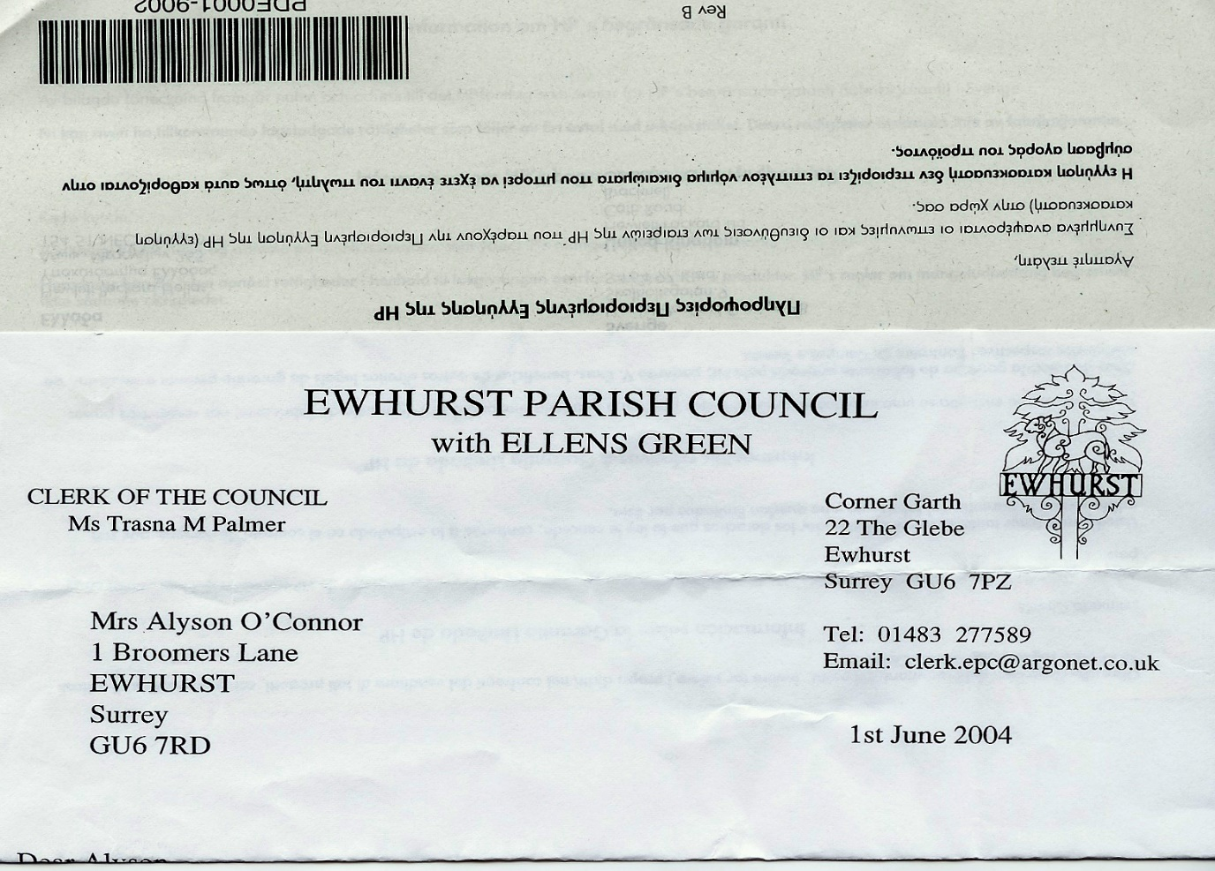**EWHURST PARISH COUNCIL**

**WITH ELLENS GREEN**

**Clerk to the Council: Joanna Cadman Tel: 01483 268627 email:** [**clerk@ewhurstellensgreen-pc.gov.uk**](mailto:clerk@ewhurstellensgreen-pc.gov.uk)

**CIL COMMITTEE MEETING**

**At the Glebe Centre, 9.30am**

**Thursday 9th October 2025**

**Present:** Cllr N Clowes (in the chair), Cllr M Higgins

In attendance: The Clerk, Mrs J Cadman

|  |  |
| --- | --- |
| 1. | **Apologies** were received from Cllr T Bloomfield |
| 2. | **Minutes from last meeting:** These were agreed as a correct record of the meeting. |
| 3 | **Matters Arising**   1. Tennis courts. Current management: The courts have been locked with a combination lock and members of the public can either sign up for household membership at £25 per annum, or ‘pay and play’ by obtaining the code for the lock from the village shop in exchange for £5.00. The code will be changed monthly. A notice has been put on the court to this effect, with the Clerk’s contact details for more information.   Over the last month, with ‘pay and play’ in operation together with a deposit for the key, around £250 had been taken in payments for court use.   1. Village halls – a full reply is still awaited from SCA. The Clerk will chase. 2. Access to burial ground – completed. A gate is needed, the Clerk to action. |
| 4. | **Housing Needs Survey:** Members agreed that the questionnaire was complete in itself, and that SCA had the experience to know what questions should be asked, but that SCA be asked to emphasise that all data remains confidential by putting these words in bold and in red.  David Cowan will write a piece for the newsletter and the questionnaire will be delivered to all households in January. |
| 5. | **Current CIL monies held by the Parish Council**  The Council has to date received: £130,470.51  Spend to date: £56,422.00  Interest added: £900.00  *Funds remaining £74,948.51*  Potentially committed to build outs on Green: £20,000  It was agreed to husband the funds and not to actively seek applications for the time being. |
| 6. | **Village Hall**  In order not to lose sight of this potential project, the following was agreed to be actioned between meetings:   1. View other new or fairly new village halls (**Clerk)** 2. Arrange a discussion with the CIL team at WBC regarding other potential funds (**MH)** 3. Obtain new plans from the architect for a smaller hall with fewer parking spaces. (**TB)** 4. Assess the existing village hall for potential value (**NC)** |
| 7. | **Date of next meeting**  As it is not essential to meet in the short term, the next meeting was agreed for Thursday 8th January 2026, 9.30am, at the Glebe Centre. |
|  |  |