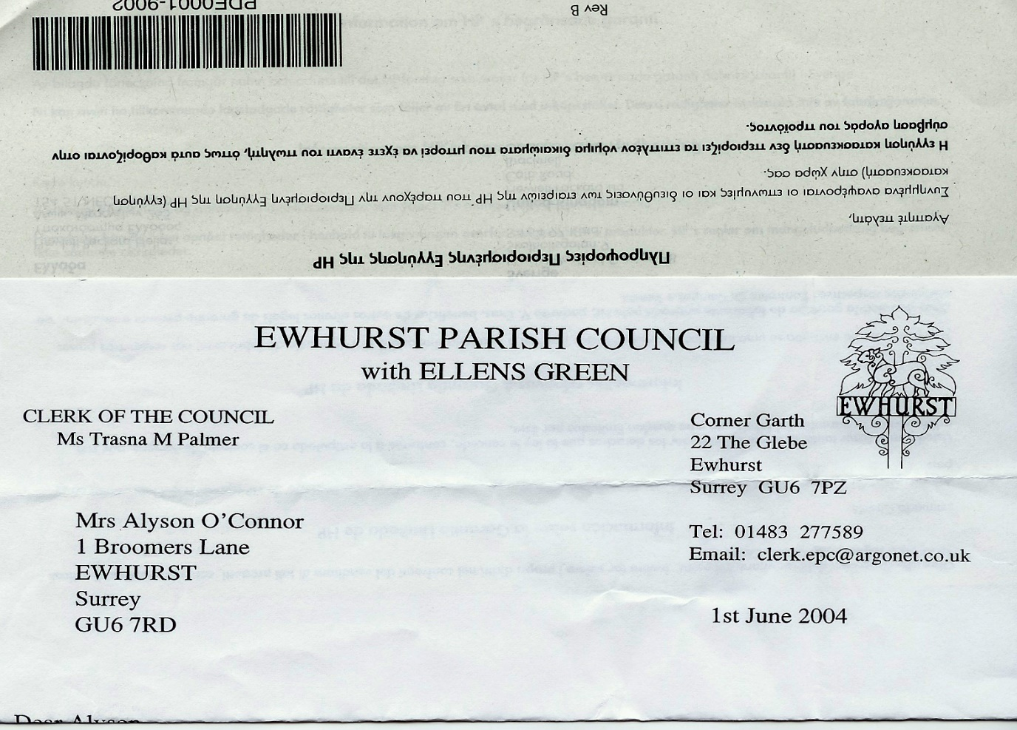 **EWHURST PARISH COUNCIL**

**WITH ELLENS GREEN**

**Clerk to the Council: Joanna Cadman Tel: 01483 268627 email: clerk@ewhurstellensgreen-pc.gov.uk**

**ACTION LIST: September 2025**

|  |  |  |  |  |  |  |  |  |  |  |  |  |  |  |  |  |  |  |  |  |  |  |  |  |  |  |  |  |  |  |  |  |  |  |  |  |  |  |  |  |  |  |  |  |  |  |
| --- | --- | --- | --- | --- | --- | --- | --- | --- | --- | --- | --- | --- | --- | --- | --- | --- | --- | --- | --- | --- | --- | --- | --- | --- | --- | --- | --- | --- | --- | --- | --- | --- | --- | --- | --- | --- | --- | --- | --- | --- | --- | --- | --- | --- | --- | --- |
| |  |  |  |  |  |  |  |  |  |  |  |  |  |  |  |  |  |  |  |  |  |  |  |  |  |  |  |  |  |  |  |  |  |  |  |  |  |  |  |  |  |  |  |  |  |  | | --- | --- | --- | --- | --- | --- | --- | --- | --- | --- | --- | --- | --- | --- | --- | --- | --- | --- | --- | --- | --- | --- | --- | --- | --- | --- | --- | --- | --- | --- | --- | --- | --- | --- | --- | --- | --- | --- | --- | --- | --- | --- | --- | --- | --- | --- | | |  |  |  |  |  |  |  |  |  |  |  |  |  |  |  |  |  |  |  |  |  |  |  |  |  |  |  |  |  |  |  |  |  |  |  |  |  |  |  |  |  |  |  |  |  | | --- | --- | --- | --- | --- | --- | --- | --- | --- | --- | --- | --- | --- | --- | --- | --- | --- | --- | --- | --- | --- | --- | --- | --- | --- | --- | --- | --- | --- | --- | --- | --- | --- | --- | --- | --- | --- | --- | --- | --- | --- | --- | --- | --- | --- | | |  |  |  |  | | --- | --- | --- | --- | | **Date of meeting** | **Minute no** | **Action** | **responsibility** | | Jan 25 | 014iii | House on the Green | JL/MH  Have looked at the problem, MH in discussions with WBC and SCC | | Feb 25 | 027 iv | Tennis courts | Clerk  Professional has agreed to terms of £10 per hour, with £5 for residents, to be paid retrospectively. Noted that this could not be enforced or controlled.  A new booking system was discussed and arrangements will be put in place by TB/Clerk | | Mar 25 | Ps | Lights opposite hall | Clerk  A letter has been written to the new owners | | Mar 25 | 043 | Thames Water work on the Green | MH/Clerk  Some work has been done on the path, but very poorly. MH will follow this up again.  The Clerk will obtain a quote for this work | | June 25 | 096b | New Village Hall | Clerk  The Diocese has not yet responded to our enquiry. | | June 25 | 096c | Bowls Club | Clerk  It was agreed that the Parish Council had no grounds to get involved in the ongoing differences between the Bowls Club and the Short Mat club, but it is possible to mediate on a personal level and to draw up an agreement for both parties.  A rent review is due. | | July 25 | 111 | Wifi | JM  To continue negotiations with Community Fibre  **Agenda item October meeting** | | July 25 | 113 | PCC | LT  To write a piece for the next newsletter asking for representative from Ellens Green | | Sept 25 | OSb | Light opposite hall | Clerk  To arrange for light in hedge to be repaired. | | Sept 25 | 132 | Cemetery tree/laurels | Clerk  Quotations are being sought | | | |