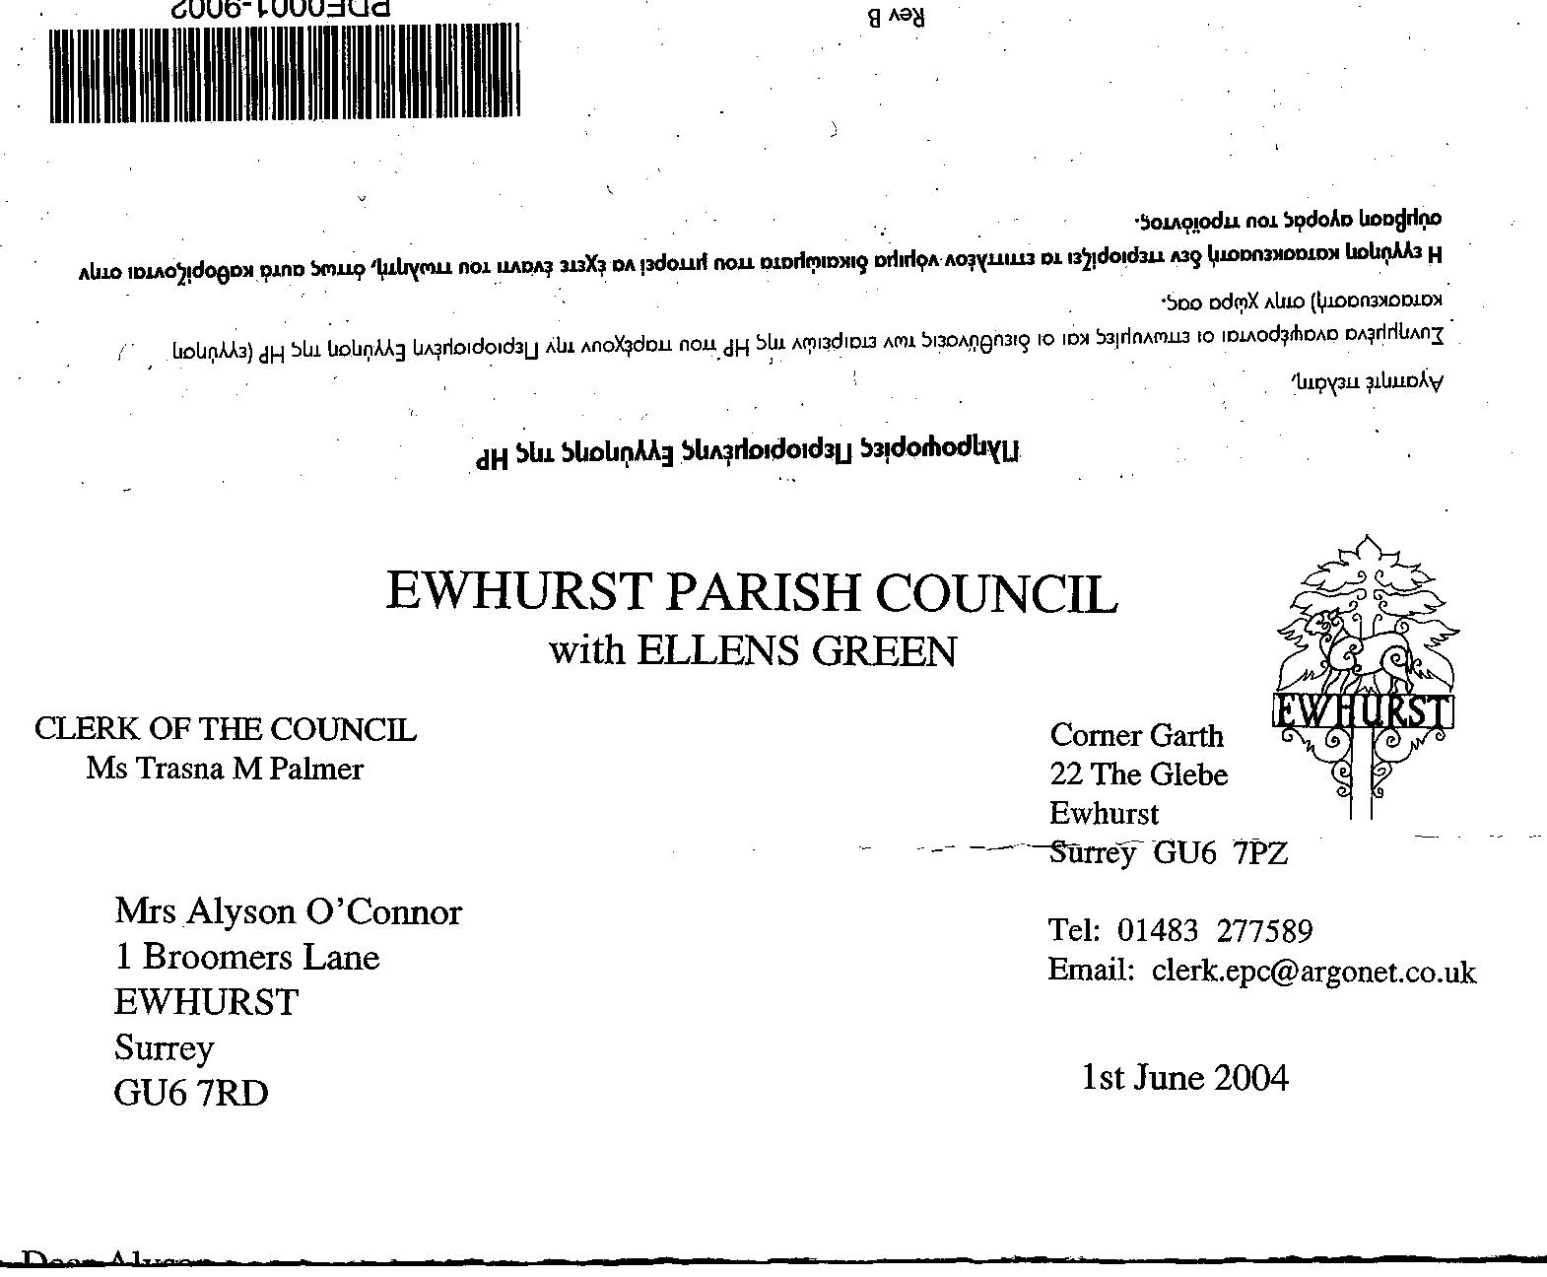
EWHURST PARISH COUNCIL
WITH ELLENS GREEN

Clerk to the Council: Joanna Cadman Tel: 01483 268627 email: clerk@ewhurstellensgreen-pc.gov.uk
EWHURST WITH ELLENS GREEN PARISH COUNCIL MEETING.
Minutes of the Meeting of the Parish Council held at
8.00 pm on Monday 21st July at ELLENS GREEN MEMORIAL HALL

Present: Cllr N Clowes (in the chair), Cllrs J Bloomfield, T Bloomfield, V Henry, M Higgins, J Lilley,
J Mitchell, L Tingley, M White
1 member of the public
In attendance The Clerk Mrs J Cadman
The Assistant Clerk, Mrs J Luker-Brown

PUBLIC SESSION:
- CIL application for Memorial Hall: The Clerk confirmed that this will be discussed by the CIL committee at the September meeting and a recommendation made to the September full Council meeting.
- Statutory authorities: it is difficult to understand at this stage exactly how the change to unitary authorities will affect Parish and Town Councils.
- Community Asset Transfer: With the change in local government structure, local authorities will be seeking to rid themselves of some assets, which can then be taken on by Parish Councils.

098 (2025) | APOLOGIES FOR ABSENCE. All members were present.
099 (2025) | DECLARATIONS OF INTEREST: none were made.
100 (2025) | MINUTES OF ANNUAL PARISH COUNCIL MEETING HELD MONDAY 16th JUNE 2025 were agreed as a correct record of the meeting and signed by the Chairman.
101 (2025) | ACTION LIST: to receive reports from Members and the Clerk
  Date of meeting | Minute no | Action | responsibility
  Jan 25 | 014iii | House on the Green | JL/MH  Have looked at the problem, MH to talk to WBC
  Feb 25 | 025iii | Ewhurst Charities | Clerk  Copy from Henry Smith in the newsletter, copy from Ewhurst Charity to be included next time, once received
  Feb 25 | 027 iv | Tennis courts | TB  Professional has agreed to terms of £10 per hour, with £5 for residents, to be paid retrospectively. Noted that this could not be enforced or controlled.  TB is taking advice from the Lawn Tennis Association on a booking system.
  Mar 25 | Ps | Lights opposite hall | Clerk  A letter has been written to the new owners
  Mar 25 | 043 | Thames Water work on the Green | MH  Some work has been done on the path, but very poorly. MH will follow this up again.
  June 25 | 091 | Newsletter | Clerk  Agenda item
  June 25 | 092 | Build out on the Green | CIL Committee  Agenda item
  June 25 | 093 | Entrance to Bowls Club | Clerk  A second quotation to be sought
  June 25 | 095a | EYSC access | Clerk  Agenda item
  June 25 | 096b | New Village Hall | Clerk  The Diocese has not yet responded to our enquiry.
  June 25 | 096c | Bowls Club | Clerk  It was agreed that the Parish Council had no grounds to get involved in the ongoing differences between the Bowls Club and the Short Mat club, but it is possible to mediate on a personal level and to draw up an agreement for both parties.  A rent review is due.
102 (2025) | MATTERS ARISING not covered by the Action List:  - Lights in the Glebe: the work to replace the solar lights was carried out on the 14th July.  - Sewage Leak on the recreation ground: the work was commenced on the 2nd July and has been completed.  - 094 (2025): Tennis courts: refurbishment work started on the 21st July. The proposed new noticeboard is deferred pending research on a new booking system.
103 (2025) | THE PLANNING COMMITTEE: Minutes of planning meeting held 19th May 2025 were agreed as a correct record of the meeting.
104 (2024) | CIL COMMITTEE  - Minutes of the meeting held 2nd July were noted.  - Build outs on the Green: members agreed to cover any overspend on the Build outs, up to a limit of £20,000, subject to consultation with residents. SCC will formally consult with residents once they have drawn up plans, but in the meantime have asked the Clerk to advise residents of the current state of play. Proposed by Cllr Lilley, Seconded by Cllr Higgins, all in favour.  - New Access to Burial Ground: Members agreed to the quotation of £4,995 + VAT, for a new access to the right side of the lych gate. Proposed by Cllr White, Seconded by Cllr J Bloomfield, all in favour. Before progressing, however, the Clerk was asked to ascertain the cost of gravel on webbing, as being less stark. Agreement to be sought by email and ratified at the September meeting It was also agreed that a gate will be required.
105 (2025) | FINANCIAL REPORT:  - Expenditure for June 2025 of £15,319.75 was noted and approved.  - Cost centre report to end June 2025 was noted and approved.  - Bank reconciliation statement to end June 2025. Verified and signed by a Member of Council
106 (2025) | STATUTORY AUTHORITIES:  Two proposals had been received, for 3 or 2 unitary authorities in Surrey, to be run in different ways. Cllr Higgins summarised the position as follows:  Surrey County Council + Elmbridge & Mole Valley (2-unitary model)  Proposal  - Split Surrey into two unitary authorities: East Surrey (Elmbridge, Epsom & Ewell, Mole Valley, Reigate & Banstead, Tandridge) and West Surrey (Guildford, Runnymede, Spelthorne, Surrey Heath, Waverley & Woking)  Rationale & Support  - Strategic efficiency: They argue that a two-council split is simpler than splitting things 3 ways. This aligns better with managing land, housing targets, business activity, highways, and financial sustainability.  - Financial viability: They state that only having 2 Unitary Councils will create greater savings than having 3 Councils.  Nine Borough/District Councils (3-unitary model)  Proposal  - Create three unitary councils:  - East Surrey: Epsom & Ewell, Mole Valley, Reigate & Banstead, Tandridge  - North Surrey: Elmbridge, Runnymede, Spelthorne  - West Surrey: Guildford, Surrey Heath, Waverley, Woking  Rationale & Support  - Local accountability: Borough and district councils stress that three units offer greater responsiveness and engagement, reflecting local identity and preferences.  - Public backing: A surveys carried out by the District and Borough Councils showed over 60% of residents preferred a three-council model.  - Economic Geography: They argue that three authorities better mirror the county’s economic and community zones (East/North/West). For example, Waverley relates more to Guildford etc than it would Spelthorne which is next to Heathrow Airport.  - Democratic concerns: They are concerned that two large unitary councils risk being ‘remote’, creating a “democratic deficit” with diminished local voice.  There are currently presentations ongoing in relation to the support for 3 unitary Councils, with an in person event Tuesday 29th in Cranleigh and also a webinar on 4th August. The deadline for responses is the 5th August.
107 (2025) | NEWSLETTER:  - A second quotation for printing the newsletter was sought, and was more expensive. As agreed and ratified by email, the Council will continue with the present printers.  - The newsletter has been completed and has gone to the printers. Distribution will take place this coming week. A copy was tabled at the meeting, as final work was done after the agenda is published.  - The Chairman wished to record his thanks to the Clerk for the huge amount of work in taking over and publishing the Newsletter. The Clerk responded in kind recording particular thanks to her Assistant, who had made it possible to turn this round in 10 days, in time for residents to be informed of Sue Handley’s memorial service on the 3rd August.
108 (2025) | COMMUNITY ASSET TRANSFER  Members ratified their emailed agreement to the CAT applications for the Glebe and for the Cricket Club. In response to a query, the Clerk confirmed that the Council would not apply to acquire the common, because of the expense of the trees and pond, although the Council would continue to maintain it.  Currently, a further questionnaire from WBC had been completed on behalf of the Glebe and WBC had acknowledged receipt but given no time frame for a response. A further questionnaire was being completed for the Cricket Club, currently pending some information from the Club.  Members agreed to pay WVC’s reasonable costs in relation to these applications. Proposed by Cllr Mitchell, Seconded by Cllr T Bloomfield, all in favour.
109 (2025) | GLEBE REFURISHMENTS  Double Glazing: two quotations had been sought the previous winter and the clerk had asked for new quotations, one of which had been received. It was agreed to choose which of the two companies provided the best value for money. Proposed by Cllr White, Seconded by Cllr J Bloomfield, all in favour.  Gas central heating: one quote had been received. It was agreed to explore this in more detail and seek a second quotation, with the purpose of accepting the best value for money quotation and having the work completed before the winter.
110 (2025) | EYSC ACCESS: The Clerk and Assistant Clerk met with Surrey Fire and Rescue service and their report was cirdculated. Although not mentioned specifically in the report, Pawel Jurczyk, Fire Safety Advisor, recommended that both fire exits (front and back) are unlocked whenever the EYSC is used, so that there are alternative means of escape. He also pointed out that the doors between each section are fire proof, which allows ½ hour for escape from each section.  The Clerk was asked to work through the recommendations in the report and implement them. Agenda item: September meeting.
111 (2025) | WIFI TO CHURCH AND GLEBE:.  Cllr Mitchell reported as follows:  1. Overall Position  - Community Fibre (CF) has confirmed they can deliver fibre connections to business and community premises in Ewhurst, including the Glebe Community Centre and the Old Rectory/Nursing Home/Church complex.  - However, they have ceased all residential build in Ewhurst Parish for now. Their network team is prioritising “densifying” existing urban networks before any new rural residential rollout.  CF will keep in contact with BDUK about funding to support rural residential build. There’s no firm timetable for any residential connections. It will check that the new civils work can include extra capacity to make later residential connections easier when/if that is funded.  2. Costings Received (Inclusive of VAT):  - Glebe Community Centre (GU6 7PY)  - 22m soft trench, 2m footway  - Will feed only the Glebe Centre  - Approximate civils cost: £3,208.92 inc VAT.  - Monthly service fee also payable: £64 + VAR, reduced from £125 + VAT.  - Old Rectory / Church Complex (GU6 7PX)  - Sites covered: The Vestry, Wilson Room, Rectory, St Peter & St Paul’s Church, Old Rectory Nursing Home  - 30m footway trench, 10m soft trench  - Approximate civils cost: £5,495.16  - Can enable up to four separate service orders  - Requires PCC to confirm with the local authority that a PBO splice box can be mounted externally on the listed church building. CF believes listed building consents may allow this with local authority agreement.  - CF will also approach the Nursing Home about contributing to the cost.  CF has advised that the Parish Council could go ahead with just the Glebe centre even if the Old Rectory and the Church Complex were left.  3. Residential Coverage  - There is no immediate plan to extend fibre to surrounding residential properties in the Glebe.  - CFL has paused all residential expansion in our area for now.  - The new build to the Glebe Centre could make future residential connections technically easier if funding becomes available – perhaps around September–October, but no guarantees.  4. Service Continuity  - CF confirms that no existing infrastructure will be turned off until there is a full fibre alternative.  - Residents should be reassured that copper telephone lines will remain available under BT’s Universal Service Obligation and Ofcom’s digital switchover rules until suitable replacements are in place.  5. Payment Terms and Next Steps  - Community Fibre requires the civils cost to be invoiced and paid in advance of build.  - Council would also need to agree the monthly service charge once quoted.  RESOLUTION:Cllr Mitchell Proposed that the installation costs to the Glebe of £3,208.92 be approved in principle, but deferred until September before confirming with Community Fibre, in the hope that the service can be rolled out to the wider community, which will reduce the costs. Seconded by Cllr Clowes, all in favour.
112 (2025) | PARISH UPDATE FROM CLERK  Nothing further to report
113 (2025) | PARISH BUSINESS: other matters to be noted or included on a future agenda  - Infant School: Cllr Higgins advised that Surrey County Council are consulting on the proposal to turn the Infant School into a Primary School, starting September 2026 with the year 2’s moving into a year 3. Reception class will stay as one class of 15 pupils, but eventually all other classes will have two years combined. This scheme should ensure that the school remains in the village.  The Clerk advised that this consultation had been advertised in the Newsletter. The final date for responses is the 26th September. Agenda item: September.  - WhatsApp group: Cllr Mitchell requested that a WhatsApp group of Councillors be set up, so that members could be alerted to the need to respond to time influenced consultations and decisions. This would only be used for Parish Council business. The Clerk requested that it be used to alert members to the need to respond to emails, so that an audit trail can be kept of discussions and decisions. This was agreed, for an experimental period to the end of the year.  - Cemetery laurel work: Agenda item: September.  - Ellens Green picnic: Cllr Lilley recorded thanks to everyone who had supported the picnic, especially local businesses who had been very generous.  - Parochial Church Council: Cllr Tingley said that it would be very helpful to have a Ellens Green resident on the PCC. A piece to be put in the next newsletter
114 (2025) | NEXT FULL MEETING OF THE PARISH COUNCIL: , Monday 15th September, 8pm, EYSC.  The meeting closed at 21.35 and was followed by refreshments.

