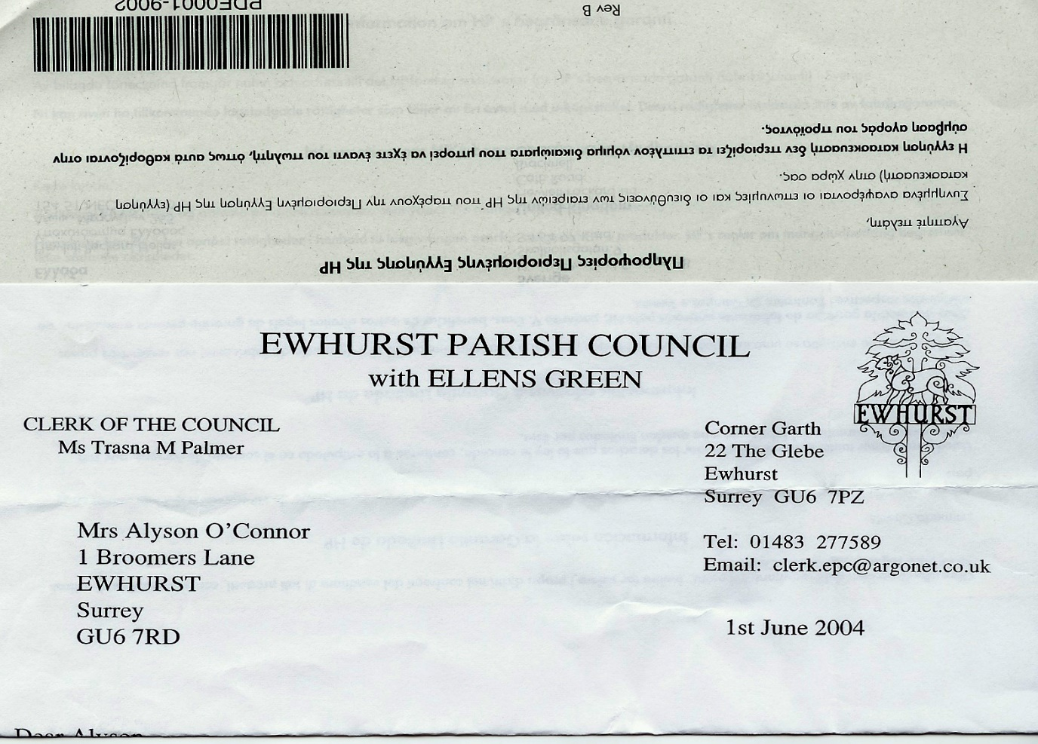**EWHURST PARISH COUNCIL**

**WITH ELLENS GREEN**

**Clerk to the Council: Joanna Cadman Tel: 01483 268627 email:** [**clerk@ewhurstellensgreen-pc.gov.uk**](mailto:clerk@ewhurstellensgreen-pc.gov.uk)

**CIL COMMITTEE MEETING**

**At the EYSC, 9.30am**

**Wednesday 3rd September 2025**

**Present:** Cllr N Clowes (in the chair), Cllrs T Bloomfield and M Higgins

David Cowan, Surrey Community Action

In attendance The Clerk, Mrs J Cadman

|  |  |
| --- | --- |
| 1. | **Apologies:** All members were present |
| 2. | **Minutes from last meeting:** Were agreed as a correct record of the meeting. |
| 3. | **Housing Needs Survey:** David Cowan  Mr Cowan presented a draft questionnaire and letter which would be posted to each house in the village, and advertised online and by posters. It will also be delivered to businesses and the school, who would be asked to give it to their employees. The questionnaire could also be accessed online.  The Parish Council were able to add up to 4 questions to the survey, which would be approved by the Borough Council before it is sent out.  The Parish Council will pay the cost of the postage for delivery and receipt of reply paid envelopes, with an estimated outlay of £1,680. A date would be set for receipt of replies, usually 4 weeks from posting.  It was agreed, subject to Council approval, to advertise the Survey in the next newsletter, due out at the beginning of December, and to send the survey out at the beginning of January. |
| 4. | **Matters arising**   1. Tennis courts: The courts had been vandalised whilst the refurbishment work was in progress, and it was agreed to lock the courts and charge a deposit for the key, held by the village shop. After some discussion, and whilst researching a booking system, it was agreed to reduce the deposit but charge £5 for hire.   Cllr Higgins advised that this move was very unpopular, after years of the courts being free for all, but members recognised that the courts both need to be protected, and to bring in an income, as they had done in the past.  Until it has been possible to find a workable booking system, it was agreed to recommend to Council that a combination lock is fitted to the tennis court gate and that a membership system is implemented, charging £25 for a family and a fee of £5 for single visits. Cllr Bloomfield will draw up a statement for social media and the website.   1. Recreation ground car park lighting – The Clerk reported that the electrician had found an earth fault when connecting the lights to the mains, and UK Power Networks had visited to establish the problem and advise the electrician of the solution, which was now being implemented. 2. EYSC kitchen – the kitchen is now well underway after a slight delay in August and will be finished by the time of the Parish Council meeting. |
| 5. | **Village hall on the allotments site**   1. Meeting with School: The School hope to change their status to a Primary School by the autumn term of 2026. In order to receive SCC approval, they need to provide extra toilet facilities and a playing field. They were assured that the Parish Council would continue to ensure that they had a playing field and that this would be taken into account during the planning for a potential new hall, which might also provide useful facilities for them. 2. Plans for a village hall on the site adjoining the allotments had been drawn up by Diego Perez and were examined. It was agreed that Cllr Bloomfield would go back to him and discuss the optimum size for a hall and parking. 3. The Clerk will ask Surrey Community Action for information on other halls in the area that were newly built. |
| 6. | **Current CIL monies held by the Parish Council:** The Parish Council has received £130,470.51 to date and has spent £47,227.30, leaving a balance of £83,243.21, plus interest of £900, making a total of £84, 143.21. £35,695 has potentially been committed to projects. |
| 7. | **Ellens Green Memorial Hall:** The Clerk was asked to clarify the amount needed by the Trustees for work to the playground, and this funding can then be ratified at the next Parish Council meeting. |
| 8. | **New Access to burial ground:** Members agreed to recommend to Council that the quotation for £4420, plus VAT, from Tidey and Webb be accepted, to provide a gravel surface with webbing for the new access. |
| 9. | **Date of next meeting:** 9th October 2025, 9.30am. As the EYSC will be in use, the meeting will be held in the Glebe Centre. |