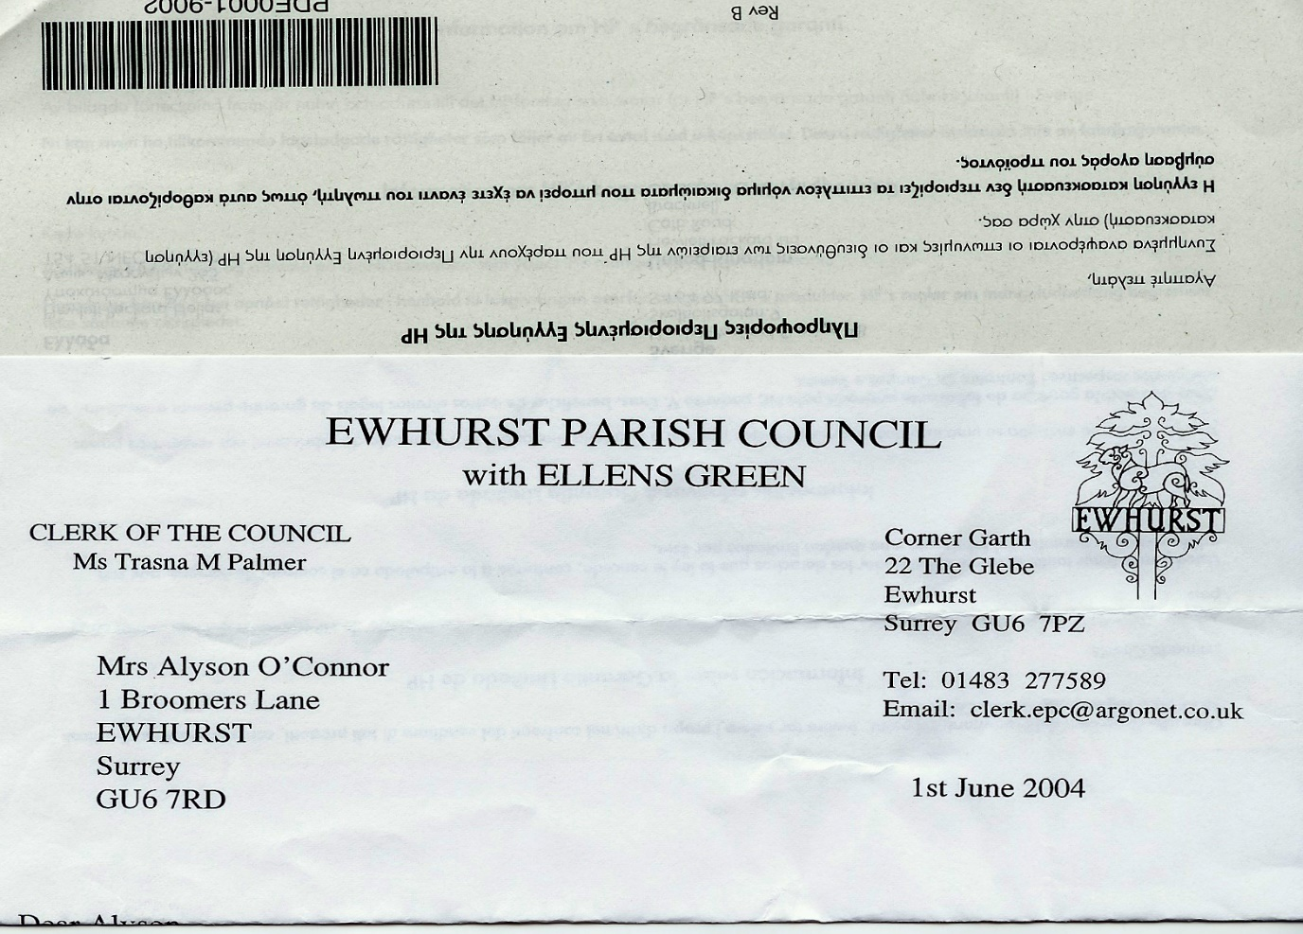 **EWHURST PARISH COUNCIL**

**WITH ELLENS GREEN**

**Clerk to the Council: Joanna Cadman Tel: 01483 268627 email: clerk@ewhurstellensgreen-pc.gov.uk**

**ACTION LIST: August 2025**

|  |  |  |  |  |  |  |  |  |  |  |  |  |  |  |  |  |  |  |  |  |  |  |  |  |  |  |  |  |  |  |  |  |  |  |  |  |  |  |  |  |  |  |  |  |  |  |  |  |  |  |  |  |  |  |  |  |  |  |  |  |  |  |  |  |  |  |
| --- | --- | --- | --- | --- | --- | --- | --- | --- | --- | --- | --- | --- | --- | --- | --- | --- | --- | --- | --- | --- | --- | --- | --- | --- | --- | --- | --- | --- | --- | --- | --- | --- | --- | --- | --- | --- | --- | --- | --- | --- | --- | --- | --- | --- | --- | --- | --- | --- | --- | --- | --- | --- | --- | --- | --- | --- | --- | --- | --- | --- | --- | --- | --- | --- | --- | --- |
| |  |  |  |  |  |  |  |  |  |  |  |  |  |  |  |  |  |  |  |  |  |  |  |  |  |  |  |  |  |  |  |  |  |  |  |  |  |  |  |  |  |  |  |  |  |  |  |  |  |  |  |  |  |  |  |  |  |  |  |  |  |  |  |  |  |  | | --- | --- | --- | --- | --- | --- | --- | --- | --- | --- | --- | --- | --- | --- | --- | --- | --- | --- | --- | --- | --- | --- | --- | --- | --- | --- | --- | --- | --- | --- | --- | --- | --- | --- | --- | --- | --- | --- | --- | --- | --- | --- | --- | --- | --- | --- | --- | --- | --- | --- | --- | --- | --- | --- | --- | --- | --- | --- | --- | --- | --- | --- | --- | --- | --- | --- | | |  |  |  |  |  |  |  |  |  |  |  |  |  |  |  |  |  |  |  |  |  |  |  |  |  |  |  |  |  |  |  |  |  |  |  |  |  |  |  |  |  |  |  |  |  |  |  |  |  |  |  |  |  |  |  |  |  |  |  |  |  |  |  |  |  | | --- | --- | --- | --- | --- | --- | --- | --- | --- | --- | --- | --- | --- | --- | --- | --- | --- | --- | --- | --- | --- | --- | --- | --- | --- | --- | --- | --- | --- | --- | --- | --- | --- | --- | --- | --- | --- | --- | --- | --- | --- | --- | --- | --- | --- | --- | --- | --- | --- | --- | --- | --- | --- | --- | --- | --- | --- | --- | --- | --- | --- | --- | --- | --- | --- | | |  |  |  |  | | --- | --- | --- | --- | | **Date of meeting** | **Minute no** | **Action** | **responsibility** | | Jan 25 | 014iii | House on the Green | JL/MH  Have looked at the problem, MH to talk to WBC | | ~~Feb 25~~ | ~~025iii~~ | ~~Ewhurst Charities~~ | ~~Clerk~~  ~~Copy from Henry Smith in the newsletter, copy from Ewhurst Charity to be included next time, once received~~ | | Feb 25 | 027 iv | Tennis courts | Clerk  Professional has agreed to terms of £10 per hour, with £5 for residents, to be paid retrospectively. Noted that this could not be enforced or controlled.  TB is taking advice from the Lawn Tennis Association on a booking system.  **Agenda item** | | Mar 25 | Ps | Lights opposite hall | Clerk  A letter has been written to the new owners | | Mar 25 | 043 | Thames Water work on the Green | MH  Some work has been done on the path, but very poorly. MH will follow this up again. | | June 25 | 093 | Entrance to Bowls Club | Clerk  **Agenda item** | | June 25 | 096b | New Village Hall | Clerk  The Diocese has not yet responded to our enquiry. | | June 25 | 096c | Bowls Club | Clerk  It was agreed that the Parish Council had no grounds to get involved in the ongoing differences between the Bowls Club and the Short Mat club, but it is possible to mediate on a personal level and to draw up an agreement for both parties.  A rent review is due. | | July 25 | 106 | Statutory authorities | All  To respond to the consultation by the 5th August | | July 25 | 108 | CAT | JM  To complete matrix for cricket club application | | July 25 | 109 | Gas central heating for Glebe | NC  Another quote is needed | | July 25 | 111 | Wifi | JM  To continue negotiations with Community Fibre  **Agenda item** | | July 25 | 113i | Infant School | NC  To report on meeting with headmaster | | July 25 | 113ii | WhatsApp group | Clerk  To be set up | | July 25 | 113v | PCC | LT  To write a piece for the next newsletter asking for representative from Ellens Green | | | |