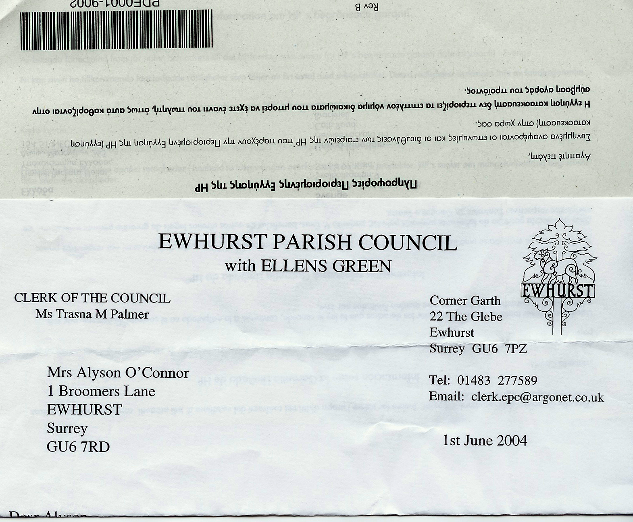 | Ewhurst and Ellens Green Parish Council  Information available from Ewhurst Parish Council under the Model Publication Scheme

Information to be published | How the information can be obtained | Cost
Class 1 – Who we are and what we do
(Organisational information, structures, locations and contacts)
Who’s who on the council and its committees | Hard copy  Website | Disbursement cost
Contact details for the Clerk and Council Members | Hard copy  Website | Disbursement cost
Location of council office and accessibility details | Hard copy  Website | Disbursement cost
Staffing structure | Hard copy  Website | Disbursement cost
Class 2 – What we spend and how we spend it
(Financial information relating to projected and actual income and expenditure, procurement, contracts and financial audit)
Full accounts and audit report | Hard copy  Website | Disbursement cost
Finalised budget | Hard copy  Website | Disbursement cost
Precept | Hard copy  Website | Disbursement cost
Financial Standing Orders and Regulations | Hard copy  Website | Disbursement cost
Grants given and received | Hard copy  Website | Disbursement cost
List of current contracts awarded and value of contract | Hard copy  Website | Disbursement cost
Members’ allowances and expenses | Hard copy  Website | Disbursement cost
Class 3 – What our priorities are and how we are doing
(Strategies and plans, performance indicators, audits, inspections and reviews)
Minutes of Full Council meetings | Hard copy  Website | Disbursement cost
Annual report to Parish Assembly | Hard copy  Website | Disbursement cost
Class 4 – How we make decisions
(Decision making processes and records of decisions
Timetable of meetings (Council, any Committee/Sub-committee meetings and parish meetings) | Hard copy  Website | Disbursement cost
Agendas of meetings (as above) | Hard copy  Website | Disbursement cost
Minutes and meetings (as above) - NB this will exclude information that is properly regarded as private to the meeting | Hard copy  Website | Disbursement cost
Reports presented to Council meetings - NB this will exclude information that is properly regarded as private to the meeting | Hard copy  Website | Disbursement cost
Reponses to consultation papers | Hard copy  Website | Disbursement cost
Responses to planning applications | Hard copy  Website | Disbursement cost
Class 5 – Our policies and procedures
(Current written protocols, policies and procedures for delivering our services and responsibilities)
Policies and procedures for the conduct of council business:  Procedural Standing Orders  Committee and Sub-committee terms of reference  Delegated authority in respect of Officers  Code of Conduct  Policy statements | Hard copy  Website | Disbursement cost
Policies and procedures about the employment of staff:  Equal Opportunities Statement  Health and Safety Policy  Policies and procedures for handling requests for information  Complaints procedures (including those covering requests for information and operating the publication scheme) | Hard copy  Website | Disbursement cost
Record management policies (records retention, destruction and archive) | Hard copy  Website | Disbursement cost
Class 6 – Lists and Registers
(Currently maintained lists and registers)
Any publicly available register or list (if any are held this should be publicised; in most circumstances existing access provisions will suffice) | Hard copy – some information may be available for inspection only | Disbursement cost
Fixed Asset Register | Hard copy  Website | Disbursement cost
Register of Members’ Interests | Hard copy  Website | Disbursement cost
Register of gifts and hospitality | Hard copy  Website | Disbursement cost
Class 7 – The services we offer
(Information about the services we offer, including leaflets, guidance and newsletters produced for the public and businesses)
Seating, litter bins, war memorial, noticeboards, village signs | Available for inspection | Free of charge
Cemetery | Available for inspection | Free of charge
Allotments | Available for inspection | Free of charge
Bus shelters | Available for inspection | Free of charge
Newsletters | Delivered to all properties in the parish | Free of charge

Review Date: March 2026

