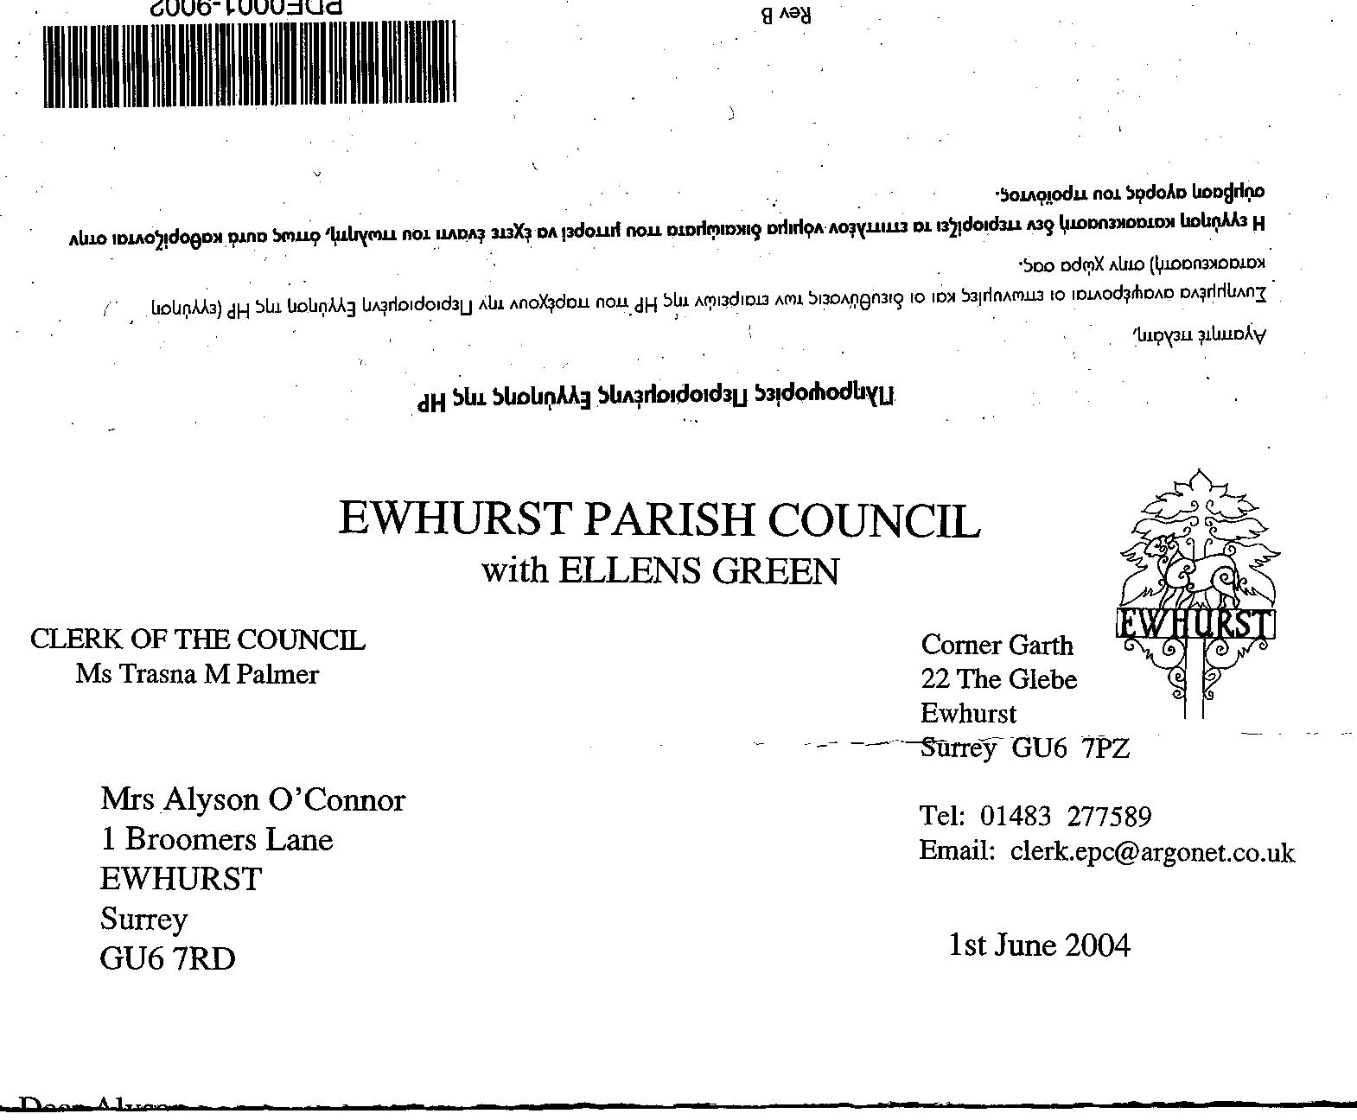
+ EWHURST PARISH COUNCIL
WITH ELLENS GREEN

Clerk to the Council: Joanna Cadman Tel: 01483 268627 email: clerk@ewhurstellensgreen-pc.gov.uk
EWHURST PARISH COUNCIL WITH ELLENS GREEN PARISH COUNCIL MEETING.
Minutes of the Annual Meeting of the Parish Council held at the EYSC
8.00 pm on Monday 19th May 2025

Present: Cllrs N Clowes, J Bloomfield, V Henry, M Higgins, J Mitchell, L Tingley, M White
2 members of the public
In attendance: The Clerk, Mrs J Cadman
The Assistant Clerk, Mrs J Luker-Brown

PUBLIC SESSION:
- Newsletter: A resident raised concerns about the lack of a newsletter in the village now that News and Views had gone and the editor of the Newsletter, Sue Handley, had sadly died before being able to pass the templates over. An editor was needed and the newsletter revived. The Chairman advised that he and the Clerk had discussed this and had agreed that the Clerk’s office would take this on temporarily. The Clerk proposed that her office does the first two issues in order to assess the amount of work needed, and then re-assess this in the autumn. This was agreed.

It would be necessary to find the list of people who delivered the newsletter in the past.

This matter will remain on the agenda.

- Lights opposite hall: A resident queried whether these were lit at night. The Clerk will investigate.

061 (2025) | ELECTION OF CHAIRMAN: Cllr Clowes was elected as Chairman, Proposed by Cllr Mitchell, Seconded by Cllr Henry, all in favour. Cllr Clowes signed the Acceptance of Office.
062 (2025) | APOLOGIES FOR ABSENCE. Were received from Cllrs T Bloomfield and J Lilley.
063 (2025) | DECLARATIONS OF INTEREST: none were made.
064 (2025) | ELECTION OF VICE CHAIRMAN Cllr Henry was elected as Vice Chairman, Proposed by Cllr Clowes, Seconded by Cllr Higgins, all in favour.
065 (2025) | MINUTES OF PARISH COUNCIL MEETING HELD 28th April 2025: agreed as a correct record of the meeting and signed by the Chairman.
066 (2025) | ACTION LIST: noted and actions agreed. Cllr Mitchell asked that the Action list be sent out as soon as possible after the meeting, to remind members of their agreed actions.
  Date of meeting | Minute no | Action | responsibility
  Mar 24 | 033 | Glebe Lease | JM/MH/Clerk  Ongoing and removed from this list
  May 24 | 077d | Invasive pond weed | Clerk  An order has been placed for the treatment  Treatment no longer needed
  Jan 25 | 014iii | House on the Green | Clerk  The Clerk has raised the issues with the Countryside Ranger
  Feb 25 | 025iii | Ewhurst Charities | Clerk  Copy awaited from Charities
  Feb 25 | 027 i | Cemetery | Clerk  No further plots will be sold in this area and no further interments are expected
  Feb 25 | 027 iv | Tennis courts | TB  Ongoing investigation into commercial use
  Mar 25 | Ps | Lights opposite hall | Clerk  A letter has been written to the new owners
  Mar 25 | 043 | Thames Water work on the Green | Agenda item: matters arising
  Mar 25 | 044 | Sewage Leak on recreation ground | Agenda item
  Apr 25 | Public | WiFi to church and Glebe | Agenda item
  Apr 25 | 058vi | Pimms Stall at Ewfest | All councillors  Agenda item – June meetng
067 (2025) | MATTERS ARISING not covered by the Action List  Wifi to the Church and Glebe: Cllr Mitchell reported that Community Fibre (previously Box Broadband) had met on the 14th May to discuss this issue, but he had not heard of the outcome of this meeting.  Build out on the Green: Speed survey currently in progress, the results should be known by the end of the month. Agenda item: June meeting.  055 (2025) Thames Water Reinstatement of Green Footpath: Cllr Higgins advised that he had been told that the reinstatement had been completed, but inspection showed that nothing had been done. He will continue to pursue this.
068 (2025) | ELECTION OF COMMITTEE CHAIRMEN  - Planning Committee: Cllr Henry, proposed by Cllr Clowes Seconded by Cllr Tingley, all in favour.  - CIL Committee: Cllr Clowes, proposed by Cllr Higgins, Seconded by Cllr White all in favour.
069 (2025) | POLICIES AND PROCEDURES RECOMMENDED FOR RE-ADOPTION  - Standing Orders  - Financial Regulations  - Complaints Procedure  - Data Protection Policy  - Press and Media Policy  - Financial risk assessment  Members accepted and agreed all policies and procedures as tabled. Proposed by Cllr White, Seconded by Cllr J Bloomfield, all in favour.
070 (2025) | REVIEW OF MEMBERSHIP OF EXTERNAL BODIES  SALC (Surrey Association of Local Councils: The Chairman and Clerk  GACC (Gatwick Area Conservation Campaign) Cllr J Bloomfield  CPRE (Campaign for the Protection of Rural England) Cllr Tingley  Weinerberger (Ewhurst Brickworks) Cllr White
071 (2025) | DATES OF FUTURE PARISH COUNCIL MEETINGS  - Annual Council Meeting: 3rd Monday in May  - Ordinary Meetings: 3rd Monday of each month, 8pm, excepting August and December, 8pm.  - Annual Parish Meeting: between the 1st March and 30th May.  - Planning meetings: 3rd Monday of each month, 7.15pm.  All agreed.
072 (2025) | PORTFOLIOS.  Members were reminded that, as portfolio holders, they are expected to take an active role in furthering the aims and interests of their portfolio.  - Finance: Cllrs T Bloomfield ad N Clowes  - Legal: Cllrs M Higgins and J Mitchell  - Planning: Cllr Henry  - Neighbourhood Plan: Cllrs T Bloomfield, N Clowes and M Higgins  - Community Infrastructure Levy: Cllrs T Bloomfield, N Clowes and M Higgins  - Highways: Cllr T Bloomfield and the Clerk  - Community events: Cllrs Lilley and Tingley  - Communications: Cllrs Clowes, Higgins and Mitchell  - Parish Buildings: Cllr White  - Environment: Cllr J Bloomfield  - Waverley Update: Cllr M Higgins  The Chairman thanked all members for all the work they did in the previous year, and the work they will do in the year to come.
073 (2025) | THE PLANNING COMMITTEE:  Minutes of planning meeting held 28th April: noted and agreed.
074 (2025) | FINANCIAL REPORT:  - final statement for the financial year 1/4/24 to 31/3/25 : noted  expenditure for April 2025: noted  - Appointment of Internal auditor for 2024/25: members ratified the appointment of Mulberry and Co as internal auditors for the year 2025/26. Propose by Cllr Tingley, Seconded by Cllr Henry, all in favour.  - Internal audit and timetable: the internal audit had been carried out by Mulberry and Co today and the report and Annual Governance and Accountability Return will be tabled at the June meeting for approval. Accounts and all relevant documents will then be available for inspection by residents, while the external audit is progressed.
075 (2025) | CIL COMMITTEE  - Minutes of meeting held 29th April were noted.  - Resurfacing of Recreation Ground car park: The Committee, having sought quotations from three contractors, recommended that the quotation from Tidey and Webb for porous tarmac and boundary lighting is accepted. Members noted that the boundary lighting would be paid for by S106 money which was given specifically for this purpose. The surfacing will be funded by CIL money. Proposed by Cllr Henry, Seconded by Cllr Tingley all in favour.  - Bowls Club lighting: S106 money had funded this work, which was now completed. Cllr White thanked the Parish Council, on behalf of the Bowls Club, for this great improvement to the Club facilities.
076 (2025) | EWHURST AND ELLENS GREEN INFORMATION BOOKLET QUOTATION  It was agreed that this booklet, produced by the FSPSP, was very useful as a means of drawing new residents into Ewhurst society and noted that the Parish Council had funded the booklet on its first printing three years ago.  As costs are of paramount importance to all sections of society, the Parish Council had asked FSPSP if advertising could be included, but they made it clear that they would not work on the booklet if advertising was allowed.  Members agreed that, despite this, they wished to support the booklet as being a valuable parish resource and that the Parish Council would fund the total cost of £1000 for 1250 copies. Proposed by Cllr Mitchell, Seconded by Cllr Higgins, all in favour.
077 (2025) | GLEBE REFURBISHMENT: deferred to June meeting
078 (2025) | SEWAGE LEAK ON RECREATION GROUND: The Clerk had met on site with a representative of Thames Water and was shown the cause of the problem. The old and compromised inspection pit which projects into the ditch behind the EYSC is overwhelmed with water after heavy rain, which puts more water into the system than it can cope with, and this results in flooding from the inspection covers further down the recreation ground. Thames Water plan to extend the footpath and bridge next to the inspection cover behind the EYSC, and extend the pipe which runs into the ditch, so that the inspection cover is effectively taken out of the water. It will also be replaced by a new cover, as will the two on the recreation ground.  The representative from Thames Water advised the Clerk that a complete survey of the drainage throughout the Parish would take place over the winter, when it was possible to see the weak spots, and upgrades effected where needed.  It is hoped that a full report will be received from Thames Water for the June meeting.
079 (2025) | VE DAY COMMEMORATIONS:  The Clerk reported a successful event. The service at 6pm had been well attended, and DL Mary Cresswell and the Chairman had both spoken about the anniversary and welcomed people to the evening. The Village Club had run the bar and the barbecue and were to be thanked for their commitment to the village. The Clerk had sourced the barbecue and the food but the surplus income had been kept by the Club to thank them for supporting the event.  Both flags had been replaced, bunting hung around the recreation ground, and the History Society had put on a WWII display in the EYSC. The War Memorial itself had been cleaned up for the day, following the replacement of the plaques the previous year  There had been a very good turnout for the Fabulous Nobodies and the weather had been very kind.  The Clerk thanked Cllr J Bloomfield for organising the recycling stations. He advised that 4 dustbins had been filled with recycling, and one of food waste. There had been very little litter.  On the 8th May, VE day itself, a service had been held at the War memorial at the Church and the Chairman had laid a wreath  Cllr Tingley reported complaints that residents had not been aware of the event. It was agreed that nothing more could be done than the 3 banners, notices on all notice boards, flyers in the shop and the pub and advice on the website, Facebook and Nextdoor, but that a newsletter would hopefully reach those who did not see any of these.
080 (2025) | PARISH UPDATE FROM CLERK: The Clerk had nothing further to report
081 (2025) | PARISH BUSINESS: other matters to be noted or included on a future agenda  - Entrance to Bowls Club: the surface has broken up and Cllr White has received a quotation for £600 to remedy this. Agenda item: June meeting  - Car in village hall car park: Cllr J Bloomfield thanked the Clerk for actions which had resulted in the untaxed car being removed.  - Fly tipping: Cllr J Bloomfield was thanked for reporting the fly tipping outside the Windmill pub. Thanks were also recorded to Cllr Mitchell for his work with WBC which resulted in new notices being posted regarding surveillance of the area.
082 (2025) | NEXT FULL MEETING ON THE PARISH COUNCIL: Monday 16th June, EYSC.
 | The meeting closed at 21.08.

