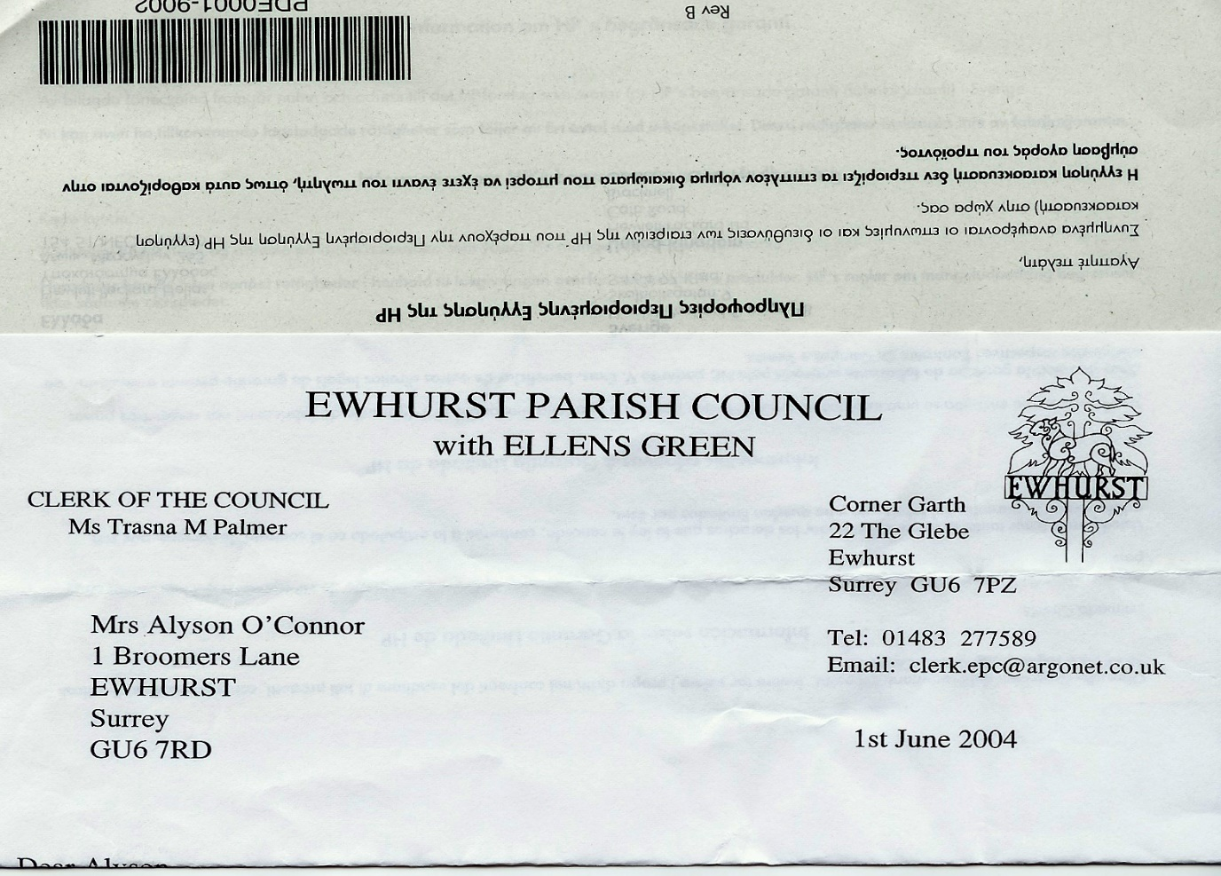 **EWHURST PARISH COUNCIL**

**WITH ELLENS GREEN**

**Clerk to the Council: Joanna Cadman Tel: 01483 268627 email: clerk@ewhurstellensgreen-pc.gov.uk**

**ACTION LIST: June 2025**

|  |  |  |  |  |  |  |  |  |  |  |  |  |  |  |  |  |  |  |  |  |  |  |  |  |  |  |  |  |  |  |  |  |  |  |  |  |
| --- | --- | --- | --- | --- | --- | --- | --- | --- | --- | --- | --- | --- | --- | --- | --- | --- | --- | --- | --- | --- | --- | --- | --- | --- | --- | --- | --- | --- | --- | --- | --- | --- | --- | --- | --- | --- |
| |  |  |  |  | | --- | --- | --- | --- | | **Date of meeting** | **Minute no** | **Action** | **responsibility** | | Jan 25 | 014iii | House on the Green | Clerk  The Clerk has raised the issues with the Countryside Ranger | | Feb 25 | 025iii | Ewhurst Charities | Clerk  Copy awaited from Charities | | Feb 25 | 027 iv | Tennis courts | TB  Ongoing investigation into commercial use | | Mar 25 | Ps | Lights opposite hall | Clerk  A letter has been written to the new owners | | Mar 25 | 043 | Thames Water work on the Green | MH | | Mar 25 | 044 | Sewage Leak on recreation ground | Clerk | | Apr 25 | Public | WiFi to church and Glebe | JM | | Apr 25 | 058vi | Pimms Stall at Ewfest | All councillors  Agenda item – June meeting | |