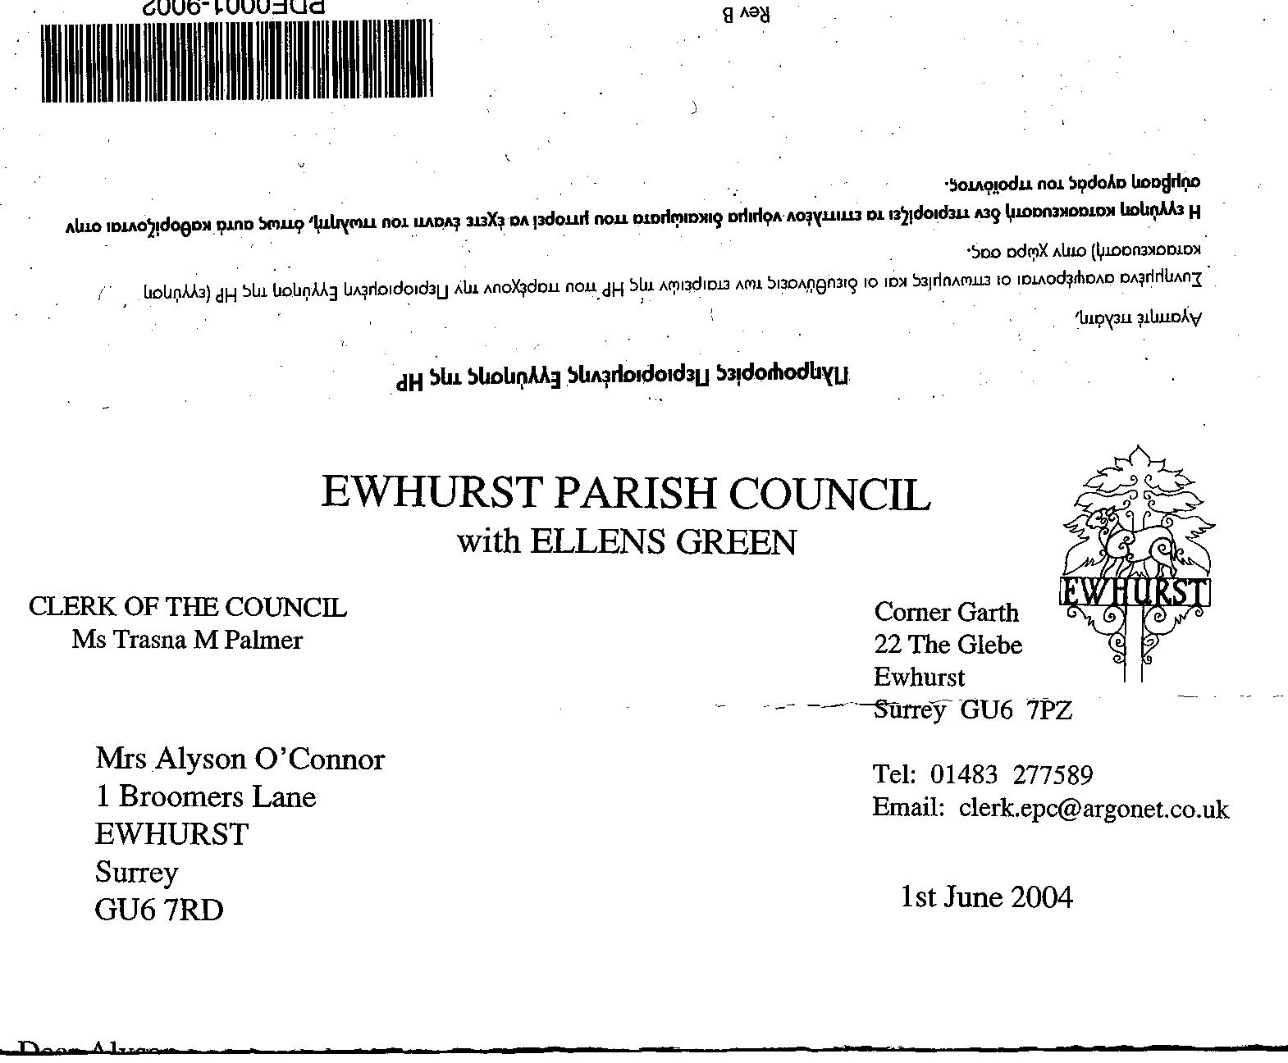
EWHURST PARISH COUNCIL
WITH ELLENS GREEN

Ewhurst Parish Council with Ellens Green Procedure for Dealing with Press and Media

1. INTRODUCTION
a. The purpose of this policy is to define the roles and responsibilities within the Council for working with the media and deals with the day-to-day relationship between the Council and the media.
b. It is not the intention of this policy to curb freedom of speech or to enforce strict rules and
regulations. Rather, it provides guidance on how to deal with issues that may arise when dealing with the media.
2. KEYS AIMS
a. The Council is accountable to the local community for its actions and this can only be achieved through effective two-way communications. The Council must maintain positive, constructive media relations and work with them to increase public awareness of the services and facilities provided by the Council and to explain the reasons for particular policies and priorities.
b. It is important that the press have access to the Clerk and to background information to assist them in giving accurate information to the public. To balance this, the Council will defend itself from any unfounded criticism and will ensure that the public is properly informed of all the relevant facts using other channels of communication if necessary.

3. THE LEGAL FRAMEWORK
a. The law governing communications in local authorities can be found in the Local Government Acts 1986 and 1988. The Council must also have regard to the governments Code of Recommended Practice on Local Authority Publicity.
b. The Parish Council’s adopted Standing Orders should be adhered to.

4. CONTACT WITH THE MEDIA
a. The Clerk and councillors should always have due regard for the long-term reputation of the
Council in all their dealings with the media.
b. Confidential documents, exempt Minutes, reports, papers and private correspondence should not be leaked to the media. If such leaks do occur, an investigation will take place to establish who is responsible and appropriate action taken.
c. When the media wish to discuss an issue that is, or is likely to be, subject to legal proceedings then advice should be taken from the Council’s solicitor before any response is made.
d. There are a number of personal privacy issues for the Clerk and councillors that must be handled carefully and sensitively. These include the release of personal information, such as home address and telephone number (although councillors contact details are in the public domain); disciplinary procedures and long-term sickness absences that are affecting service
provision. In all these and similar situations, advice must be taken from the Clerk before any response is made to the media.
e. When responding to approaches from the media, the Clerk and Chairman are authorised to make contact with the media. In specific cases the Clerk and/or Chairman may authorise other
councillor/s to respond to media requests.
f. Statements made by the Chairman and the Clerk should accurately reflect the Council's position on issues that relate to motions passed by the Council. On all other issues, statements should only be made for purposes of clarification. Such statements must be factual and must not incorporate the personal opinions of either the Clerk or the Chairman. Statements made to the media should make no reference to the position of individual, named councillors on any issue.
g. There are occasions when it is appropriate for the Council to submit a letter, for example to explain important policies or to correct factual errors in letters submitted by other correspondents. Such letters should be kept brief and balanced in tone and correspondence should not be drawn out over several weeks. All correspondence must come from the Clerk.
h. Should a councillor decide to communicate with or submit a letter to the media on any subject they should not use the term ‘Parish Councillor’ or give the impression, directly or implied, that they are writing on behalf of the Council unless authorised to do so by the Clerk or Chairman (clause 4(e) above).
i. Unless authorised to do so by the Clerk and/or Chairman, councillors may not discuss ant business of the Council that is confidential and/or not yet in the public domain.

5 ATTENDANCE OF MEDIA AT COUNCIL MEETINGS
a. The Local Government Act 1972 requires that agendas, reports and minutes are sent to the media on request.
b. The media are encouraged to attend Council meetings and seating and workspace will be made available.
c. Any filming or taping of Council proceedings by the media must be with prior notice and
permission of the Clerk and Chairman (see Standing Orders).

6 PRESS RELEASES
a. The purpose of a press release is to make the media aware of a potential story, to provide important public information or to explain the Council’s position on a particular issue. It is the responsibility of the Clerk and Members to look for opportunities where the issuing of a press release may be beneficial.
b. All press releases must be issued by the Clerk, and approved by the Chairman or Vice-chairman in his absence, in order to ensure that the principles outlined in section three (Legal Framework) are adhered to, that there is consistency of style across the Council and that the use of the press release can be monitored.

