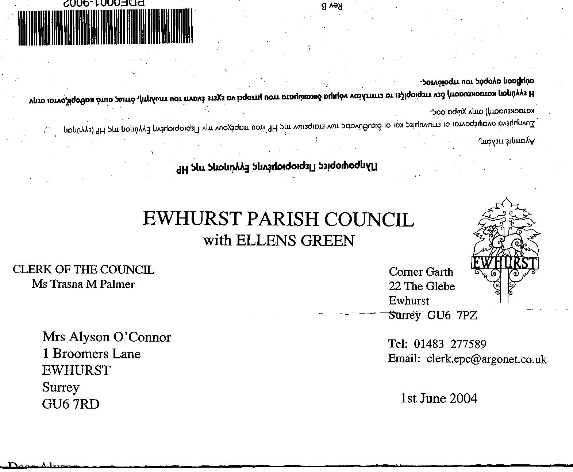
EWHURST PARISH COUNCIL
WITH ELLENS GREEN

Clerk to the Council: Joanna Cadman Tel: 01483 268627 email: clerk@ewhurstellensgreen-pc.gov.uk
EWHURST WITH ELLENS GREEN PARISH COUNCIL MEETING.
Minutes of the Meeting of the Parish Council held at
8.00 pm on Monday 28th April 2025 at the EYSC

Present: Cllr N Clowes (in the chair), Cllrs J Bloomfield, T Bloomfield, V Henry, J Lilley, M Higgins, J Mitchell, M White
3 members of the public
In attendance: The Clerk, Mrs J Cadman

PUBLIC SESSION: an opportunity for members of the public who live or work in the parish to ask questions relevant to the work of the Council.

- Wifi to the Church and Glebe: Tony Gauvain reported that Community Fibre has done a technical survey and costing for bringing fibre to the Church, the Wilson Room, the Rectory and the Glebe Centre. But they have now stated that BDUK (Building Digital UK) have withdrawn any hope of subsidy until 2027. He has asked them for a revised quote without the subsidy, and understands that they will report after their meeting on the 14th May. Tony was concerned that BT may end their copper wire connections, leaving the locations with no communications, including the alarm system for both the vestry and the Wilson room office, but he was assured that BT had a legal obligation to provide a telephone service where there was no alternative. Cllr Mitchell will discuss this with the company.

- Annual Parish meeting: there were a disappointingly small number of attendees. However the meeting had been advertised on the website, the noticeboards, by a banner and on Facebook and Nextdoor. Cllr Higgins made the point that most parish meetings were lightly attended nowadays.

- Build out on the Green: SCC Highways Engineer Adrian Selby had met with residents on the Green to discuss their concerns regarding the planned build out. Most of those attending wanted the speed limit reduced to 30mph but Adrian explained that this had to be self enforceable and current speeds would need to be less than 35mph. He would undertake a speed survey in May to ascertain usual speeds. Two further build outs were discussed, as it would then be possible to reduce the speed limit to 30mph.

046 (2025) | APOLOGIES FOR ABSENCE: were received from Cllrs T Bloomfield and L Tingley.
047 (2025) | DECLARATIONS OF INTEREST: none were made.
048 (2025) | MINUTES OF PARISH COUNCIL MEETING HELD 17th MARCH 2025: were agreed as a correct record of the meeting and signed by the Chairman.
049 (2025) | ACTION LIST:
  Date of meeting | Minute no | Action | responsibility
  Mar 24 | 033 | Glebe Lease | JM/MH/Clerk  Ongoing
  May 24 | 077d | Invasive pond weed | Clerk  An order has been placed for the treatment but Cllr J Bloomfield believed that the pond weed had gone. The Clerk will discuss with LEAP and hold the order for the time being.
  May 24 | 077f | Tennis courts | TB  Contract awarded for refurbishment of courts and new tennis nets
  Nov 24 | PS | Footpath at junction of Mapledrakes and Williams Close | Clerk  LEAP have laid the scalpings
  Jan 25 | Public 3 | Yellow spot on pavement | Clerk  Has been renewed
  Jan 25 | 014iii | House on the Green | Clerk  The Clerk has raised the issues with the Countryside Ranger
  Feb 25 | 025iii | Ewhurst Charities | Clerk  Copy awaited from Charities
  Feb 25 | 027 i | Cemetery | Clerk  There does not seem to be a current concern with other graves in the area as they are either empty and will be re-allocated, or have been occupied for a long time, with no arrangements for further interments.
  Feb 25 | 027 iv | Tennis courts | Cllr T Bloomfield  Ongoing investigation into commercial use
  Mar 25 | Ps | Lights opposite hall | Clerk  A letter has been written to the new owners
  Mar 25 | 043 | Thames Water work on the Green | Agenda item
  Mar 25 | 044 | Sewage Leak on recreation ground | Agenda item
050 (2025) | MATTERS ARISING not covered by the Action List:  Glebe Lease: Cllr White requested that the two outstanding items, repairing the double glazing and replacing the heating, be placed back on the agenda.
051 (2025) | THE PLANNING COMMITTEE: Minutes of planning meeting held 17th March 2025: these were noted. Cllr Henry gave an update on recent planning decisions.
052 (2024) | CIL COMMITTEE minutes of meeting held 26th March 2025: these were noted. A meeting of the committee will take place on Tuesday 29th April.
053(2025) | FINANCIAL REPORT:  - Expenditure for March 2025 of £14,606.52 was noted and agreed.  - Cost centre report to end March 2025 was noted.  - Bank reconciliation statement to end March 2025 was confirmed against the bank statement and signed by the Chairman.  - Internal Audit: will take place on the 19th May and the report submitted to the June meeting, prior to papers being sent to the External Auditor..
054 (2025) | BUILD OUT ON THE GREEN: discussed in the Public Session. No further action to be taken at this time..
055 (2025) | THAMES WATER REINSTATEMENT OF GREEN FOOTPATH: Cllr Higgins reminded the meeting that Thames Water’s contractors had recently installed a pressure regulator system on their main water pipe to the Green, and had gained access through the footpath . They had not restored the footpath. Cllr Higgins had reported this to Thames Water, who had inspected the site and agreed the work was not up to standard. They undertook to liaise with the contractor and to ensure that the footpath is correctly reinstated.
056 (2025) | SEWAGE LEAK ON RECREATION GROUND: The Clerk will meet with Dan Varnell, Field Operation Specialist from Thames Water, who has undertaken to investigate the historic flooding issues and who plans to make some alterations to the network and replace some covers.
057 (2025) | VE DAY COMMEMORATIONS 2025: 10th May :The Clerk reported as follows:  - The event on the recreation ground has been advertised with banners, on the website and on Facebook  - The Union and Ukraine flags will be replaced and the war memorial tidied up.  - There will be bunting around the recreation ground  - Rev’d Rosemary Mason will lead a short service of thanksgiving and commemoration at the war memorial at 6pm  - There will be a History Society display in the ETSC.  - The Fabulous Nobodies will play from 7.30pm  - The village club will run the bar  - The Clerk is having difficulty with the barbecue, as the company she had engaged had let her down. She will continue work on this.  - DL Mary Cresswell had kindly offered to help and will be asked to join our Chairman in opening the evening after the service.
058 (2025) | PARISH UPDATE FROM CLERK  Ewfest will take place on the 2nd August and will take the form of a day of music, combined with the usual carnival fun. Entry will be free. The following requests had been made to the Parish Council:  - Using a trailer from Cranleigh Freight as a stage. The Clerk had agreed this, subject to it being placed on the upper part of the recreation ground.  - The Clerk had confirmed that our insurance would cover the event.  - Members agreed that the EYSC toilets should be available and that the Parish Council would sponsor the cost of cleaning them.  - The Clerk had agreed that the second pitch could be used for parking, subject to the same provisos as at the last carnival, that no parking will be allowed on the pitch if it is wet, only parking around the edge if there has been some rain. The pitch can be used in full if it is dry and firm.  - Cllr J Bloomfield agreed to take charge with handling the rubbish in an environmentally responsible way. He would like to add a container for food waste this time.  - Members agreed to consider running a stall again, and discussed a Pimms stall, which had been run by the Parish Council before.
059 (2025) | PARISH BUSINESS: no further matters were raised.
060 (2025) | NEXT FULL MEETING OF THE PARISH COUNCIL: Annual Meeting: Monday 19th May, 8pm

The meeting closed at 21.00

