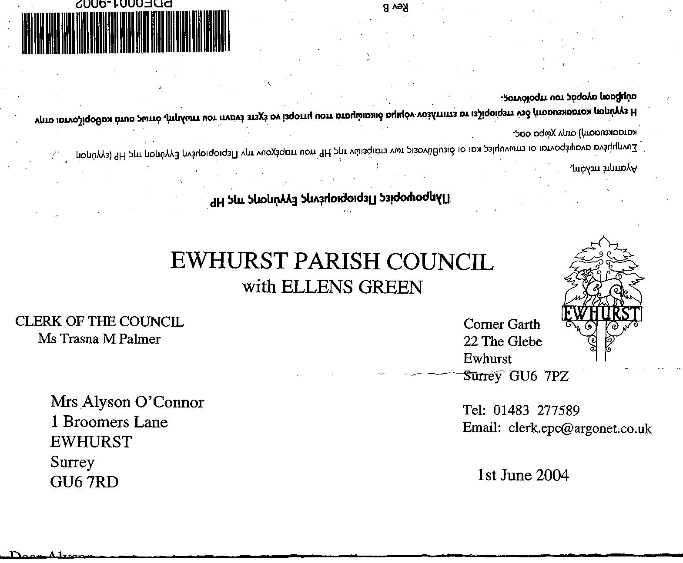
EWHURST PARISH COUNCIL
WITH ELLENS GREEN

Ewhurst Parish Council with Ellens Green’s procedure for handling a complaint against the Council

Should anyone contact Ewhurst Parish Council with Ellens Green, with a complaint against the Parish Council then the person receiving the complaint must direct them to the Clerk being the nominated officer for the Council for complaints. This may involve giving the Clerk’s details to the Complainant or taking the Complainant’s details to pass to the Clerk to make contact.

The Clerk shall speak with the Complainant and try to resolve the situation informally by measures or explanations. If the complaint cannot be satisfied by the Clerk then the Clerk shall request that the complaint be put in writing and addressed to the Clerk being the nominated officer for complaints, or the Chairman if they do not wish to write to the Clerk.

The Clerk or Chairman upon receiving the written complaint shall acknowledge the complaint in writing. In the letter the Council’s nominated officer, or Chairman, must advise the Complainant:

- When and where the complaint will be considered by Ewhurst Parish Council;

- Whether it will be treated as confidential or whether notice of the complaint meeting will be made public.

- That the complainant may bring with them a representative if they would like to;

- That seven clear working days before the meeting, the Parish Council must be given any documentation or other evidence the Complainant will rely upon. In return that the Parish Council must ensure the Complainant has any documentation upon which the Council will rely upon at the meeting, within the same time frame.

The Clerk must give the Parish Council members:

- Details of when and where the meeting will take place;

- The Clerk must give to all members of the Parish Council the documentation to be relied upon by both the Complainant and Ewhurst Parish Council, seven clear working days prior to the meeting.

At the meeting:

- The Parish Council must decide whether to exclude the public and press from discussions relating to the complaint, although a decision on the complaint must be announced in public.

- The Parish Council Chairman shall introduce everyone and explain that what will follow ultimately to arrive at a decision of how to progress;

- Firstly the Complainant or the Representative shall speak and outline the grounds of the complaint;

- The Clerk as nominated officer may ask questions following the Complainant’s outline;

- The members of the Council being the councillors and Chairman may then direct questions to the Complainant;

- The Clerk as nominated officer will then be able to explain Ewhurst Parish Council’s position and questions may be asked by the Complainant and the members of the council;

- The Clerk and then the Complainant will then have the opportunity to summarise their position;

- The Clerk as nominated officer and the Complainant shall then be asked to leave the room while the Ewhurst Council members decide whether there are grounds for the complaint. If any clarification is required the Clerk and Complainant will be asked to re- enter the room for questioning;

- If a decision is unlikely to be made quickly then the Clerk and Complainant shall be told when the decision is likely to be made and when it will be communicated to them.

After the meeting:

- The decision should be confirmed in writing within seven working days together with details of any action to be taken.

May 2025

