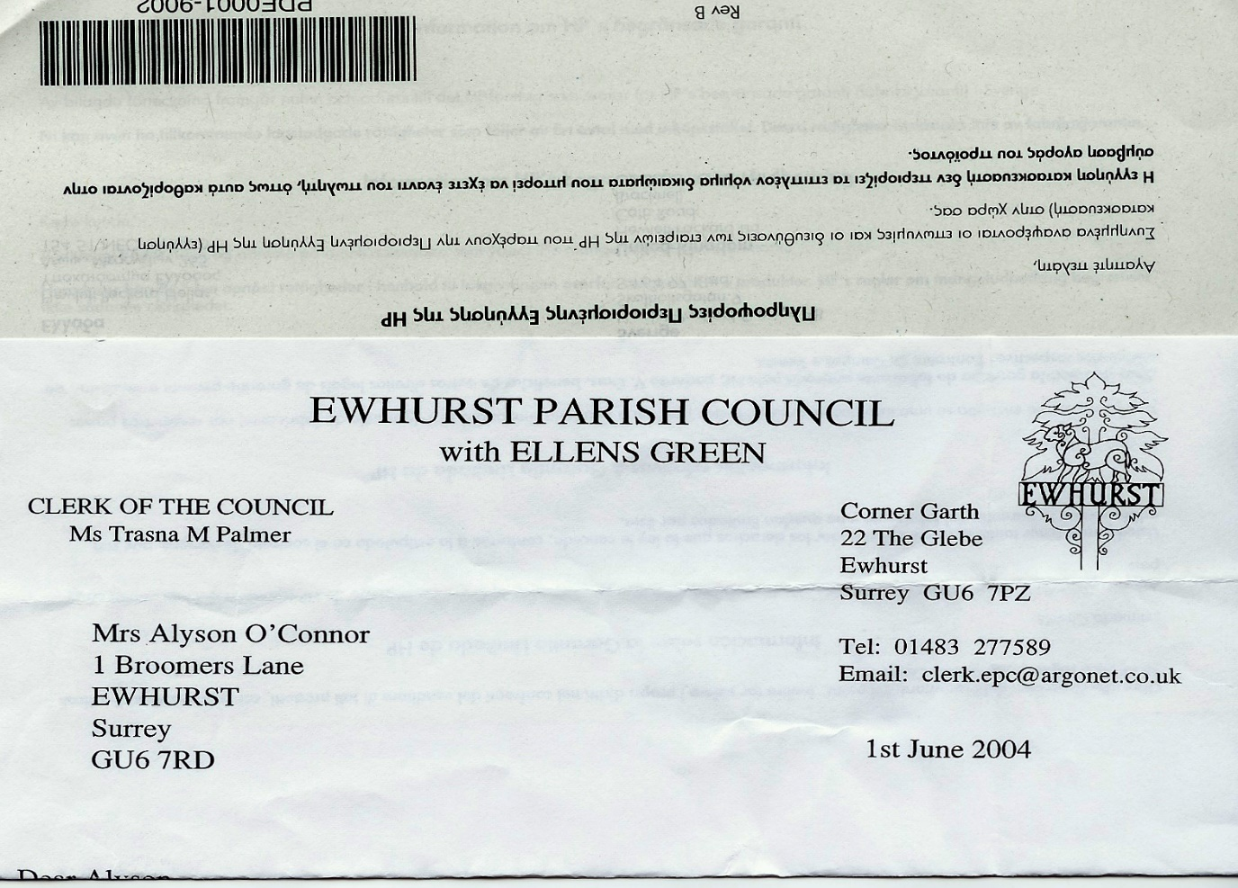**EWHURST PARISH COUNCIL**

**WITH ELLENS GREEN**

**Clerk to the Council: Joanna Cadman Tel: 01483 268627 email:** [**clerk@ewhurstellensgreen-pc.gov.uk**](mailto:clerk@ewhurstellensgreen-pc.gov.uk)

**CIL COMMITTEE MEETING**

**At the EYSC, 9.30am**

**Tuesday 29th April 2025**

**Present:** Cllr N Clowes (in the chair), Cllrs T Bloomfield, M Higgins, The Clerk, Mrs J Cadman

|  |  |
| --- | --- |
| 1. | **Apologies:** All members were present. |
| 2. | **Minutes from last meeting:** were agreed as a correct record of the meeting. |
| 3. | **Matters arising and outstanding actions**  *Housing needs survey:* Members agreed to meet with David Cowan, Surrey Community Action to discuss this in more detail. No date was set at this stage, so this would remain on the agenda.  *EYSC kitchen:* The Clerk will arrange meetings with the handyman and an electrician.  *Land for affordable housing:* the Clerk reported on a meeting with Adrian Selby to look at sightlines:   * The single lane access is an issue and it would potentially be difficult to increase it to two lanes. The access road is shared between the Parish Council and the residents who live there, and any changes would need to be agreed with them. * Passing places could be considered. * There is a telegraph pole carrying a substantial amount of electricity, crossing the area in question. Discussion with the electricity network company would be needed to understand what would be allowed, or whether it should be moved. * The sightlines onto the Street are good looking right (south) but very limited looking left (north). It may be necessary to agree with the owner of the build out and wall on the left that this be moved back to widen the access. * These limitations mean that the potential of the site for affordable housing is limited, due to the amount of traffic that would need access. However, a village hall would produce less traffic and would have a greater chance of being accepted.   Members agreed to take forward the potential for a village hall on this site. Cllr T Bloomfield will ask an architect acquaintance for outline ideas for a village hall on the site. It may be possible to ask this architect to look at the current village hall and advise on what could be done there, either with the site or with refurbishment. |
| 4. | **Recreation ground**  Members had received quotations from Tidey and Webb and from Webb for porous tarmac and gravel on webbing, following advice that non porous tarmac would require planning permission.  A quote had also been received from Jennings Surfacing, but they were unable to provide lighting.  It was agreed to recommend to council that the contract be awarded to Tidey and Webb. Their quotation for porous tarmac and peripheral lighting is £2,000 cheaper than the next quotation, and their professional and adaptable approach has been very much appreciated. |
| 5. | **Refurbishment of Tennis Courts**  The contract has been awarded to Martin Gurr, who will arrange a firm starting date later in May. |
| 6. | **Any other matters:**  Members reviewed the consultation around the build out on the Green and the wish from residents that the speed limit be reduced to 30mph. It seemed that the only way to do this was to create another build out near the cricket pitch, and potentially a third past the bend and nearer Somersbury Lane. The cost of each build out would be in the region of £25,000.  CIL money could be used for this work, without a new application, if it is included with the first build out. Members were of the view that it might be possible to recommend to Council that CIL money be used for one build out, if this would achieve the 30mph speed limit, but more justification was needed for two build outs. The Clerk would discuss with SCC Highways. |
| 7. | **Date of next meeting:** 28th May, 9am, to be confirmed. |