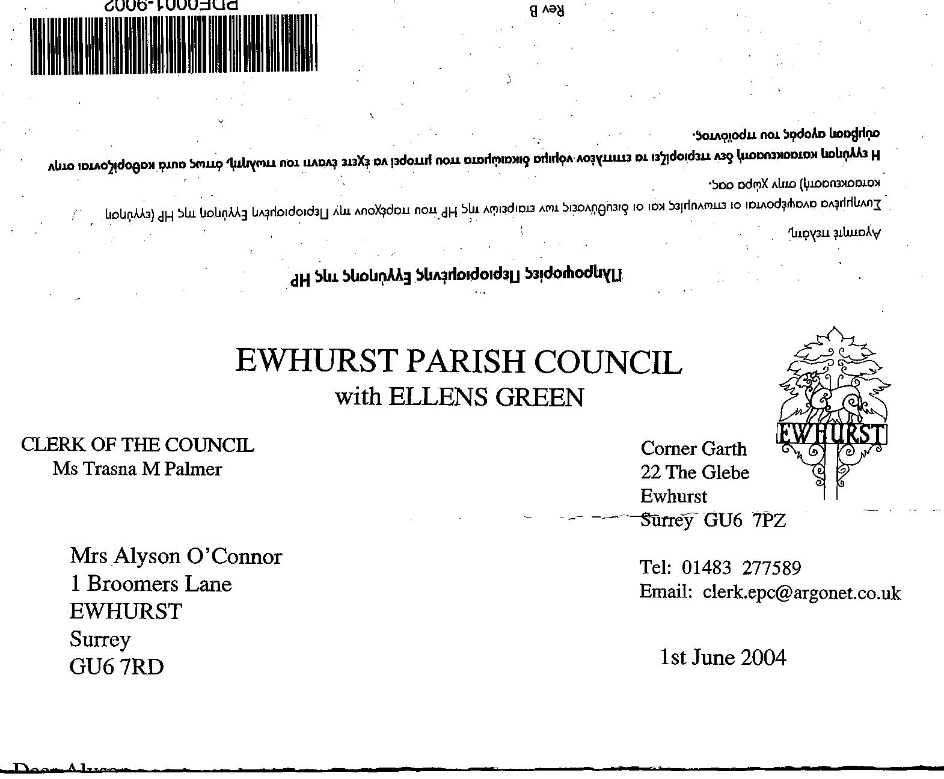
EWHURST PARISH COUNCIL
WITH ELLENS GREEN

Clerk to the Council: Joanna Cadman Tel: 01483 268627 email: clerk@ewhurstellensgreen-pc.gov.uk
EWHURST WITH ELLENS GREEN PARISH COUNCIL MEETING.
Minutes of the Meeting of the Parish Council held at
8.00 pm on Monday 17th March 2025 at the EYSC

Present: Cllr N Clowes (in the chair), Cllrs J Bloomfield, T Bloomfield, V Henry, M Higgins,
J Lilley, L Tingley, M White
2 members of the public
In attendance: The Clerk, Mrs J Cadman
The Assistant Clerk, Mrs J Luker-Brown

PUBLIC SESSION:
- Yellow marking on pavement opposite hall: the Council was thanked for arranging for this to be renewed.

- Lights on gateposts opposite hall: these are not currently being switched on.

- Build out on Green: Dealt with under agenda item 038 (2025)

- Footpath 362: dealt with under agenda item 041 (2025)

030 (2025) | APOLOGIES FOR ABSENCE. were received from Cllr Mitchell
031 (2025) | DECLARATIONS OF INTEREST: none were made.
032 (2025) | MINUTES OF PARISH COUNCIL MEETING HELD 17th FEBRUARY 2025: were agreed as a correct record of the meeting and signed by the Chairman.
033 (2025) | ACTION LIST: to receive reports from Members and the Clerk
  Date of meeting | Minute no | Action | responsibility
  Mar 24 | 033 | Glebe Lease | JM/MH/Clerk  Ongoing
  May 24 | 077d | Invasive pond weed | Clerk  Deferred to April, as treatment should be carried out at the beginning of the season
  May 24 | 077f | Tennis courts | TB  2 quotes received
  Oct 24 |  | Glebe heating | - Cllr White to investigate alternative heating  - Cllr Mitchell to review E.ON bills
  Nov 24 | PS | Footpath at junction of Mapledrakes and Williams Close | Clerk  LEAP will lay the scalpings in April
  Jan 25 | Public 3 | Yellow spot on pavement | Clerk  Has been renewed
  Jan 25 | 014iii | House on the Green | Clerk  The Clerk has raised the issues with the Countryside Ranger
  Feb 25 | 025iii | Ewhurst Charities | Clerk  Copy awaited from Charities
  Feb 25 | 027 i | Cemetery | Clerk  The Clerk has a list of graves in the bottom left hand corner of the cemetery and will discuss with the gravedigger
  Feb 25 | 027 iv | Tennis courts | TB  Cllr T Bloomfield will speak to the commercial user
034 (2025) | MATTERS ARISING not covered by the Action List  None.
035 (2025) | THE PLANNING COMMITTEE:  - Minutes of planning meeting held 17th February 2025: were agreed.  - To agree members of the Planning Committee: it was agreed that the Planning Committee should remain with its current membership of all members of the Parish Council, unless they specifically requested to be removed from this committee.
036 (2024) | CIL COMMITTEE  Minutes of meeting held 25th February 2025 were noted.  Kitchen at the EYSC: Members ratified the approval given to the proposal submitted by the CIL committee to award the contract to Wren Kitchens, whose design and price were most favourable. This agreement was made out of meeting due to meeting the deadline for a winter saving.  Affordable Housing: members noted that there is no point in progressing further with affordable housing until there is a site option, but agreed that a Community Land Trust would be the best way to take this forward.
037(2025) | FINANCIAL REPORT:  - Expenditure for February 2025 of £8,809.30 was noted and agreed.  - Cost centre report to end February 2025 was noted and agreed  - Bank reconciliation statement to end February 2025 was agreed against the bank statement and signed by the Chairman.
038 (2025) | BUILD OUT ON THE GREEN  A resident of the Green, living close to the proposed build out, has raised concerns regarding the placing of the build out and the consequent impact on sight lines. He also wanted to know how long the work would take and how disruptive it would be. He agreed with the Clerk that he had also raised these issues with the SCC Highways engineer, who was to meet him shortly as SCC are the owners of the project.  It had been understood that the work would start at the end of the month, but now established that this was advisory, and there was no firm start date at present.
039 (2025) | WELCOME BOOKLET: FSPSP  Members noted the following statement from the Friends of St Peter and St Paul:  The following proposals were agreed with the volunteers who worked on the original booklet, at the FSPSP meeting in February 2025  - The volunteers are very happy to revise and update the current issue to reflect changes in EEG parish and to work with volunteers from EEG PC to do this (Julia Lilley has personally agreed to do this)  - The update will not be published before the new Church Parochial Council of Ewhurst and Ellens Green has been fully agreed and designated by the Church of England  - The volunteers will not continue working on the Information Booklet if advertising is put in the publication  - The volunteers will need funding to print the revised booklet, as they, or FSPSP, cannot provide this. Hopefully EEG PC can provide this  - The volunteers are willing to meet & talk with EEG PC if there are problems with funding  It was agreed that the Chairman and Clerk would meet with them, as suggested. Members were of the view that advertising would, in fact, be a benefit.
040 (2025) | CEMETERY: members considered investigating the possibility of installing a robust permanent access and gate to the cemetery, on the right side, in order to mitigate the damage done to drainage by heavy machinery such as grave diggers equipment and the contractor’s ride on mower. Concern was expressed regarding the amount of earthwork needed, as the ground is so soft, but it was agreed to pass this to the CIL Committee for further investigation.
041(2025) | FOOTPATH 362:  This path runs from the end of Coneyhurst Lane, up Pitch Hill. Cllr J Bloomfield reminded the meeting that this had last been discussed at the January meeting in 2024. This is a footpath on a steep hill, with ditches running parallel which often get blocked. One resident along this footpath claims that she received a verbal agreement from SCC that they would clear her ditch, but SCC are of the view that the clearing of ditches is the responsibility of the landowner adjacent to the right of way.  Mrs Horton had drafted a letter to residents asking if they would contribute to the cost of clearing the ditch. Cllr J Bloomfield suggested that the Parish Council cover any deficit between the cost and the contributions.  Cllr Higgins proposed that the Parish Council agree to cover the cost of clearing the ditches, up to £400 on a one-off basis, and write to residents telling them of this decision, and that the Parish Council may decide to re-claim its costs. Proposed by Cllr T Bloomfield, Seconded by Cllr V Henry, all in favour.  Cllr J Bloomfield will agree the scope of the work with the proposed contractor and ask for a written quotation.
042 (2025) | VE DAY COMMEMORATIONS 2025:  The Clerk reported that the Fabulous Nobodies are booked, the Rev’d Rosemary Mason will take a service at the War Memorial, the History Society will lend us a display, to be used in the EYSC, and food and drink is currently in progress.  VJ day – it was agreed to lay a wreath on 2nd September. Cllr Tingley will report back on any other activities to take place that day.
043 (2025) | PARISH UPDATE FROM CLERK  Thames Water work on Green: The Clerk reported that Thames Water had recently installed pressure regulators on a mains pipe on the Green, accessing it through the footpath, and had not reinstated the footpath, covering it with soil and seeding it instead. This will make the path inaccessible in wet weather. There is no mechanism for raising an issue of this sort on the Thames Water website and she proposed to write to the Chief Executive. Cllr Higgins would also speak to his contact.
044 (2025) | PARISH BUSINESS: other matters to be noted or included on a future agenda  - Sewage Leak on the recreation ground: This has been reported to Thames Water on a number of occasions, but has not been resolved, despite their assurances that it has. Cllr Higgins undertook to raise this with his contact, as well as WBC and the Environment Agency.  - Litter Pick at Ellens Green: to take place on 29th March.
045 (2025) | NEXT FULL MEETING OF THE PARISH COUNCIL: Monday 28th April, 8pm.  ANNUAL PARISH MEETING: Monday 7th April
The meeting closed a 21.40

