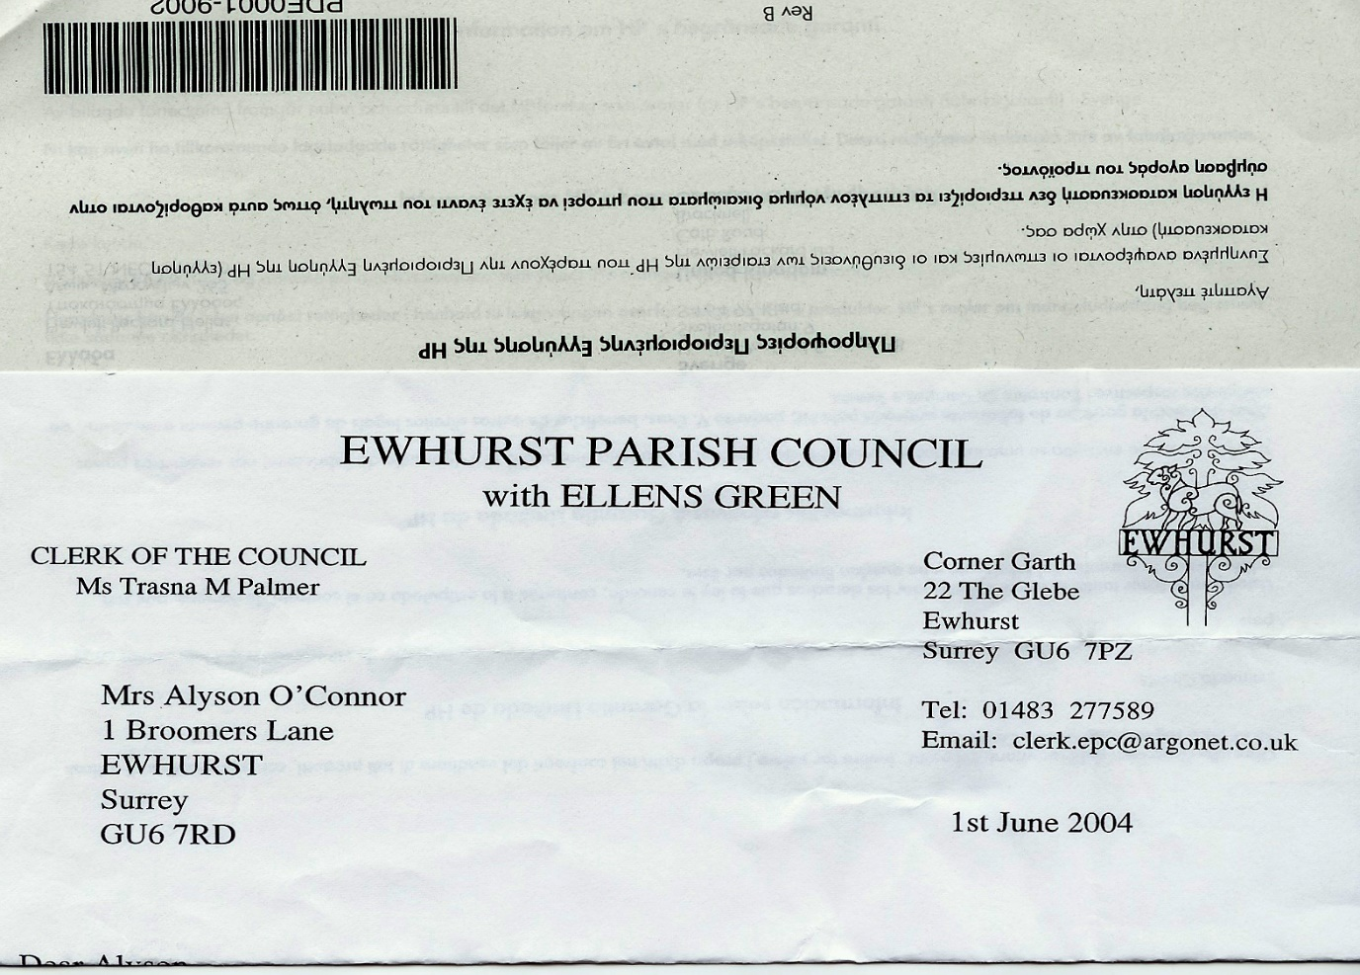**EWHURST PARISH COUNCIL**

**WITH ELLENS GREEN**

**Clerk to the Council: Joanna Cadman Tel: 01483 268627 email:** [**clerk@ewhurstellensgreen-pc.gov.uk**](mailto:clerk@ewhurstellensgreen-pc.gov.uk)

**CIL COMMITTEE MEETING**

**At the EYSC, 4pm**

**Wednesday 26th March 2025**

**Present:** Cllr N Clowes (in the chair),T Bloomfield, M Higgins

The Clerk, Mrs J Cadman

|  |  |
| --- | --- |
| 1 | **Apologies:** all members were present |
| 2. | **Minutes from February meeting:** these were agreed to be a correct record of the meeting. |
| 3. | **Matters arising and outstanding actions:**  The CIL application form is now on the website,, with a more detailed explanation of the application process. |
| 4. | **Rural Housing**   1. *Parish Council working party:* it was agreed that it was too early to formalise a working party, as there would be little need for it until some land was identified, and that it would remain an informal element of the CIL Committee for the time being. 2. *Housing needs survey:* It was agreed to explore the possibilities of undertaking a Housing Needs Survey with Surrey Community Action now, as these have a 5 year shelf life. 3. *Brockham Development:* noted. 4. *Potential land for affordable housing:* a meeting would be arranged with Adrian Selby, SCC Highways, to look at the sightlines from the allotment road. It was also agreed that, when a new development is proposed in the village, this Committee should speak to the developers about releasing some land for affordable housing, using a Community Land Trust. |
| 5. | **EYSC kitchen**: the kitchen will be delivered in early July. In the meantime, the Clerk will work with an electrician and our handyman on the preparatory work, in conjunction with Wren Kitchens. |
| 6. | **Recreation Ground**   1. *Webb Groundworks:* the Clerk had met with the Webb contractor the previous week, who had advised that planning permission was probably necessary for impermeable surfacing. She had checked the WBC website: *if the surface to be covered is more than 5 metres square planning permission will be needed for laying traditional, impermeable driveways that do not provide for the water to run to a permeable area.* The run off from the car park is not obvious. It was agreed to ask Webb and Tidey and Webb to quote for plastic webbing filled with gravel, and also for permeable tarmac. 2. *Jennings:* cannot provide lighting, which could be accessed elsewhere, but have not yet quoted. |
| 7. | **Refurbishment of Tennis Courts**  Quotes have been received from Martin Gurr and Prestige Tennis, although Prestige Tennis had addressed their quote to another Council and did not feel pressurised to change it. Both quotes were for £6,900 + VAT, but Martin Gurr had quoted a further £350 for nets. It was agreed to recommend to Council that the quote from Martin Gurr is accepted, as he is a known and trusted contractor. |
| 8. | **Road Access to Cemetery**  Following a site meeting, members agreed to ask the contractor who wins the contract for the recreation ground car park to quote for an access on the right side of the lych gate, to meet up with the existing path on the cemetery side. |
| 9. | **Any Other Matters:** no more matters were raised. |
| 10. | **Date of next meeting:** Tuesday 29th April, 4pm, EYSC. |