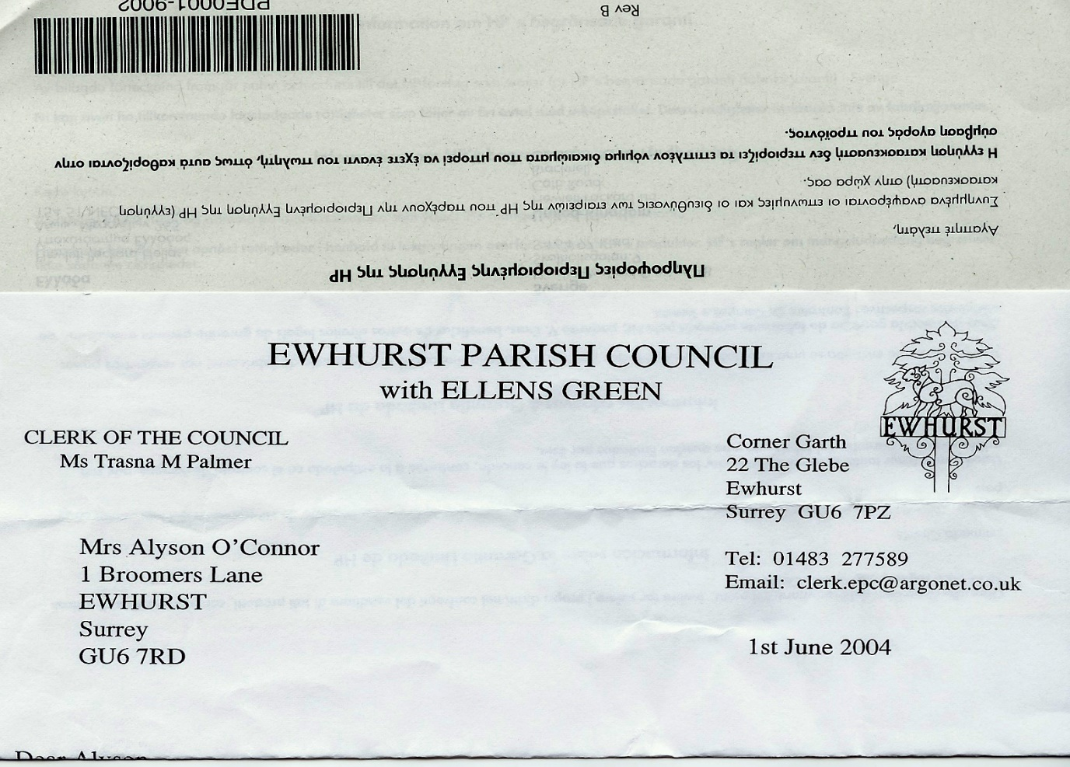 **EWHURST PARISH COUNCIL**

**WITH ELLENS GREEN**

**Clerk to the Council: Joanna Cadman Tel: 01483 268627 email: clerk@ewhurstellensgreen-pc.gov.uk**

**ACTION LIST: April 2025**

|  |  |  |  |  |  |  |  |  |  |  |  |  |  |  |  |  |  |  |  |  |  |  |  |  |  |  |  |  |  |  |  |  |  |  |  |  |  |  |  |  |  |  |  |  |  |  |  |  |  |  |  |  |
| --- | --- | --- | --- | --- | --- | --- | --- | --- | --- | --- | --- | --- | --- | --- | --- | --- | --- | --- | --- | --- | --- | --- | --- | --- | --- | --- | --- | --- | --- | --- | --- | --- | --- | --- | --- | --- | --- | --- | --- | --- | --- | --- | --- | --- | --- | --- | --- | --- | --- | --- | --- | --- |
| |  |  |  |  | | --- | --- | --- | --- | | **Date of meeting** | **Minute no** | **Action** | **responsibility** | | Mar 24 | 033 | Glebe Lease | JM/MH/Clerk  Ongoing | | May 24 | 077d | Invasive pond weed | Clerk  An order has been placed for the treatment | | ~~May 24~~ | ~~077f~~ | ~~Tennis courts~~ | ~~TB~~  ~~Contract awarded for refurbishment of courts and new tennis nets~~ | | ~~Nov 24~~ | ~~PS~~ | ~~Footpath at junction of Mapledrakes and Williams Close~~ | ~~Clerk~~  ~~LEAP have laid the scalpings~~ | | ~~Jan 25~~ | ~~Public 3~~ | ~~Yellow spot on pavement~~ | ~~Clerk~~  ~~Has been renewed~~ | | Jan 25 | 014iii | House on the Green | Clerk  The Clerk has raised the issues with the Countryside Ranger | | Feb 25 | 025iii | Ewhurst Charities | Clerk  Copy awaited from Charities | | Feb 25 | 027 i | Cemetery | Clerk  The Clerk has a list of graves in the bottom left hand corner of the cemetery and will discuss with the gravedigger | | Feb 25 | 027 iv | Tennis courts | Clerk  Ongoing investigation into commercial use | | Mar 25 | Ps | Lights opposite hall | Clerk  A letter has been written to the new owners | | Mar 25 | 043 | Thames Water work on the Green | Agenda item | | Mar 25 | 044 | Sewage Leak on recreation ground | Agenda item | |