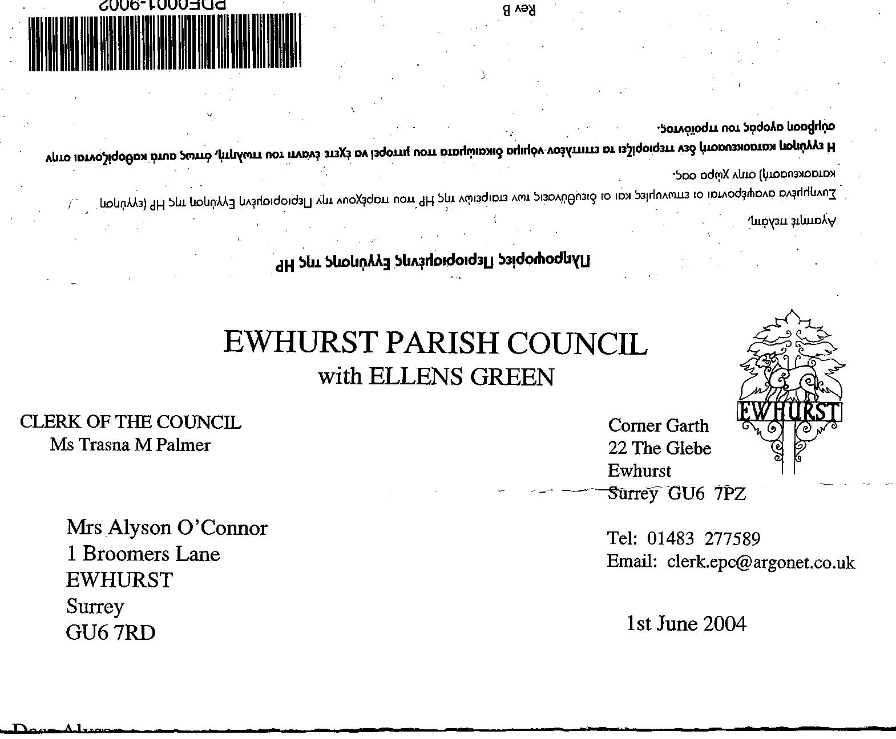
EWHURST PARISH COUNCIL
WITH ELLENS GREEN

Clerk to the Council: Joanna Cadman Tel: 01483 268627 email: clerk@ewhurstellensgreen-pc.gov.uk
EWHURST WITH ELLENS GREEN PARISH COUNCIL MEETING.
Minutes of the Meeting of the Parish Council held at
8.00 pm on Monday 17th February 2025 at the EYSC

Present: Cllr N Clowes (in the chair), Cllrs J Bloomfield, T Bloomfield, V Henry, J Lilley, J Mitchell, L Tingley
1 member of the public
In attendance: The Clerk, Mrs J Cadman

PUBLIC SESSION: an opportunity for members of the public who live or work in the parish to ask questions relevant to the work of the Council. The Council meeting will start immediately following the Public Session or at 8.15, whichever is the earlier: No matters were raised.

017 (2025) | APOLOGIES FOR ABSENCE: were received from Cllrs M Higgins and M White
018 (2025) | DECLARATIONS OF INTEREST: none were made
019 (2025) | MINUTES OF PARISH COUNCIL MEETING HELD 20th JANUARY 2025: were agreed as a correct record of the meeting and signed by the Chairman.
020 (2025) | ACTION LIST:
  Date of meeting | Minute no | Action | responsibility
  Mar 24 | 033 | Glebe Lease | JM/MH  Ongoing
  May 24 | 077d | Invasive pond weed | Clerk  Deferred to next April, as treatment should be carried out at the beginning of the season
  May 24 | 077f | Tennis courts | TB  Met with contractor, now waiting for quotes
  June 24 | Public | Lights in village hall car park | completed
  Sept 24 | 122 | VE day commemorations | Agenda item
  Oct 24 | 143a | Foul water on recreation ground | Reported to Thames Water and EA  completed
  Oct 24 |  | Glebe heating | - Cllr White to investigate alternative heating: future agenda item. Removed from Action list.  - Cllr Mitchell to review E.ON bills – agreed to take any further action off the action list and to report back when possible
  Nov 24 | PS | Footpath at junction of Mapledrakes and Williams Close | The Clerk met with Mrs Palmer: 1 tonne of scalpings should be sufficient, but access from a place to drop the scalpings is not good. LEAP have very kindly agreed to undertake the barrowing and laying of the scalpings. To be arranged shortly.
  Nov 24 | 157 | Pavement opposite village hall | Clrl J Bloomfield reported the pavement is not wide enough for a new barrier even if the hedge is trimmed back  Cllr J Bloomfield has raised this issue with our County Cllr and will bring this back to the meeting when appropriate.
  Jan 25 | 014iii | House on the Green | The Clerk has raised the issues with the Countryside Ranger
021 (2025) | MATTERS ARISING not covered by the Action List  Wildwoods Footpath: Cllr J Bloomfield advised that he had met with the resident whose complaints about the footpath had been reported at the last meeting.  Footpath 75: Stile and two sleeper bridges: Cllr J Bloomfield was advised by the Ramblers Association that these had been reported, that the landowner is co-operating with SCC and they will be repaired in March.  Footpath 71: the resident had said this was impossible to walk, but LEAP had done some work on it in December 2024 and it was now accessible.  Footpath 75: the ground conditions on the part leading from Boat 541 were very bad. Cllr J Bloomfield will report this to SCC.
022(2025) | THE PLANNING COMMITTEE:  Minutes of planning meeting held 20th January 2025: were noted and agreed
023 (2024) | CIL COMMITTEE minutes of meeting held 27th January 2025: noted and agreed
024 (2025) | FINANCIAL REPORT:  - Expenditure for January 2025: expenditure of £11,340.62 was noted and agreed.  - Cost centre report to end January 2025: noted and agreed  - Bank reconciliation statement to end January 2025, for current and deposit accounts. Noted and agreed and figures verified and signed by Cllr N Clowes.
025 (2025) | COMMUNICATIONS:  - EEG News: Members agreed to increase the grant for the printing of this newsletter from £300 pa to £400 pa, at £100 an edition. Proposed by Cllr Clowes, Seconded by Cllr Henry, all in favour.  - Future of EEG News: a new editor will be needed after the next edition, when Mrs Handley will step down after many years as editor. It was noted that News and Views would no longer be published, as the church could not find a new editor.  - Ewhurst Charities: Cllr Clowes had been advised at recent meetings that they were struggling to find grant recipients and believed that people were not sufficiently aware of their existence. He proposed that the Parish Council produce a 4 page leaflet, one page for each charity, with ‘Can We Help’ on the front, to be delivered with the Newsletter. On the last page will be the Parish Council’s contact details, advising people to contact the Clerk if they are unsure which charity to apply to. The Clerk will contact the Charities and ask them for copy. Agreement to the costs for this exercise were proposed by Cllr Henry, Seconded by Cllr Tingley, all in favour.
026 (2025) | VE DAY COMMEMORATIONS 2025: The Clerk advised that preparations were going well, but there were still loose ends to be tied up.  The Ewhurst Players are putting on a production of ‘Goodnight Mr Tom’ at the end of May, and would like to link this to the commemorations. They asked for some financial support and it was agreed to waive charges for the performances. Proposed by Cllr Tingley, Seconded by Cllr J Bloomfield, all in favour.
027 (2025) | PARISH UPDATE FROM CLERK  - Cemetery: The Clerk advised that flooding at the lower right end of the cemetery had meant that a Ewhurst resident could not be buried with her husband in January. The Clerk had given the family a new grave and the family proposed to exhume the husband’s body and reinter it with his wife. This would require a faculty, which was currently being applied for. The Clerk had not charged the family for the new grave, under the circumstances and this was approved. She would shut down the lower right of the cemetery to new burials and would investigate the situation with the current graves.  - Cemetery: the village handyman is currently clearing the bottom right of the cemetery, where it has become very overgrown, to the extent that it was not possible to identify some graves.  - Annual Parish Meeting: Cllr Townsend has agreed to talk on the NPPF and SCC Rights of Way Officer will talk about rights of way and who is responsible for what element of their upkeep.  - Tennis Courts: it has been brought to the Clerk’s attention that the Courts appear to be used for commercial tennis lessons. She will identify the person involved and discuss this further with Cllr T Bloomfield.
028 (2025) | PARISH BUSINESS: other matters to be noted or included on a future agenda  - Ewhurst Green Pond: The SCC Countryside Ranger had led a work party on the 25th January, with a good turnout of 8 people. A lot of clearance was effected around the edge, opening the pond up, and Cllr J Bloomfield was thanked for instigating this.  - Surrey Hills : Cllr J Bloomfield was contacted by a volunteer at the Surrey Hills Society, wishing to organise a visit to Ewhurst later in the year, in collaboration with the History Society. Cllr J Bloomfield will liaise with the Society and the History Society.  - Ellens Green picnic: to take place this year on the 2st June, in National Picnic Week. Cllr Lilley will draw up a flyer to be distributed around Ellens Green, the Clerk will print it. The hall will not charge this year.
029 (2025) | NEXT FULL MEETING OF THE PARISH COUNCIL: Monday 17th March 2025 at the EYSC  The meeting closed at 20.48.

