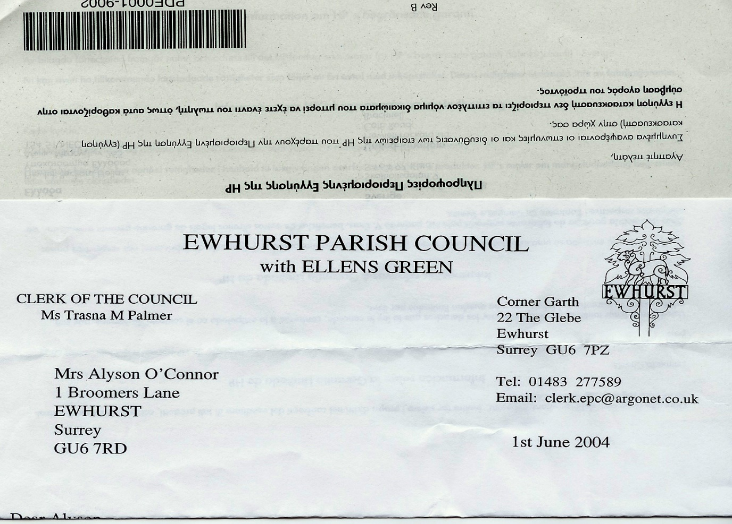**EWHURST PARISH COUNCIL**

**WITH ELLENS GREEN**

**Clerk to the Council: Joanna Cadman Tel: 01483 268627 email:** [**clerk@ewhurstellensgreen-pc.gov.uk**](mailto:clerk@ewhurstellensgreen-pc.gov.uk)

**CIL COMMITTEE MEETING**

**At the EYSC, 4pm**

**Tuesday 25th February 2025**

**Present:** Cllr T Bloomfield, M Higgins

David Cowan, Surrey Community Action

The Clerk, Mrs J Cadman

|  |  |
| --- | --- |
| 1 | **Apologies:** were received from Cllr N Clowes |
| 2. | **Discussion with David Cowan,** Rural Housing Enabler, Surrey Community Action  Following an in-depth discussion, the following actions were agreed:   1. As rural housing would be built on rural exception sites, a site or sites need to be identified and the landowners approached. There is no point in progressing further unless there is a site option. **Action: Parish Council working party (not yet formed)** 2. Purchase the land (either PC or handed to a rural housing association) 3. Obtain planning permission (probably outline) for this site(s) 4. Consider the options to lead this project: 5. Community Land Trust (CLT): A Land Trust would be Parish Council led, rather than handed to a third party, who would be recommended by SCA. 6. Rural Housing Association 7. Rural Housing Association(RHA) to purchase land and transfer to Community Land Trust. Who lease back to the RHA. 8. Rural Housing Association build houses and sell to CLT/PC. 9. Housing Need Survey: to be undertaken once a site or sites is identified. Run by SCA, but the survey wording agreed by PC and results owned by PC for action. Demonstrates local need.   Would include local businesses, to bring in those who travel to this Parish for work   1. Housing Associations introduced by SCA. 2. Grant funding for land purchase/house building available from Homes England. Up to 30% of total costs. (David will confirm costs) 3. Ellens Green is not ruled out by not having a settlement area. 4. Call for sites: this could be done via the Housing needs survey. David will ask WBC for sites rejected at the last call for sites in this parish, to see what might fit a rural exception project. **Action: DC** 5. David will send the Clerk a Housing Needs Survey template, for information. **Action: DC** 6. Brockham development (community led development at Poland Meadow and is under the Poland Trust): David to send details to the Clerk. **Action: DC** |
| 3. | **Minutes from last meeting:** these were agreed to be a correct record of the meeting. |
| 4. | **Matters arising and outstanding actions:**  *04/25: Ellens Green Memorial Hall:* the Clerk had offered the Trustees a grant of 50% of their project, at £7,200, subject to evidence that the remainder had been raised elsewhere. They had responded with thanks and will come back when funds have been raised |
| 5 | **EYSC kitchen**  Members examined the quotations from Magnet and Howdens, and agreed that they were probably of too high a standard for a community room, but thanked the Clerk for the site visits and visits to the showrooms that she had made to obtain these.  It was agreed to pursue the more straightforward quote with Wren and the Clerk would bring this to the next meeting, after seeing a design and adding a dishwasher. They would also be asked to quote for the village hall kitchen. **Action: Clerk** |
| 6. | **Recreation ground**  Quote from Tidey and Webb has been received and will be used as specification to approach two other companies. **Action:** TB to advise Clerk of another company to approach. She will approach the company who dealt with the Bowls Club car park.  The Clerk will ask the footballers when the best time to do this work would be. **Action:** The Clerk. |
| 7. | **Refurbishment of Tennis Courts**  A quote has been received as will be used as a specification to approach two other companies. The quotes to include two new heavy duty nets with centre straps. **Action: Clerk** |
| 8. | **VAS**  Members agreed not the accept the responses from SCC with respect to the provision of VAS and the solar powered option. Cllr Bloomfield tabled a letter to our MPs. Once this has been circulated and agreed, it will be sent by the Clerk. **Action: Clerk** |
| 10. | **Any other matters**  Cllr Higgins tabled an update to the website with reference to CIL applications. This will be circulated to the committee and, once agreed, actioned. **Action: Clerk** |
| 11. | **Date of next meeting:** 26th March, 4pm, EYSC. |