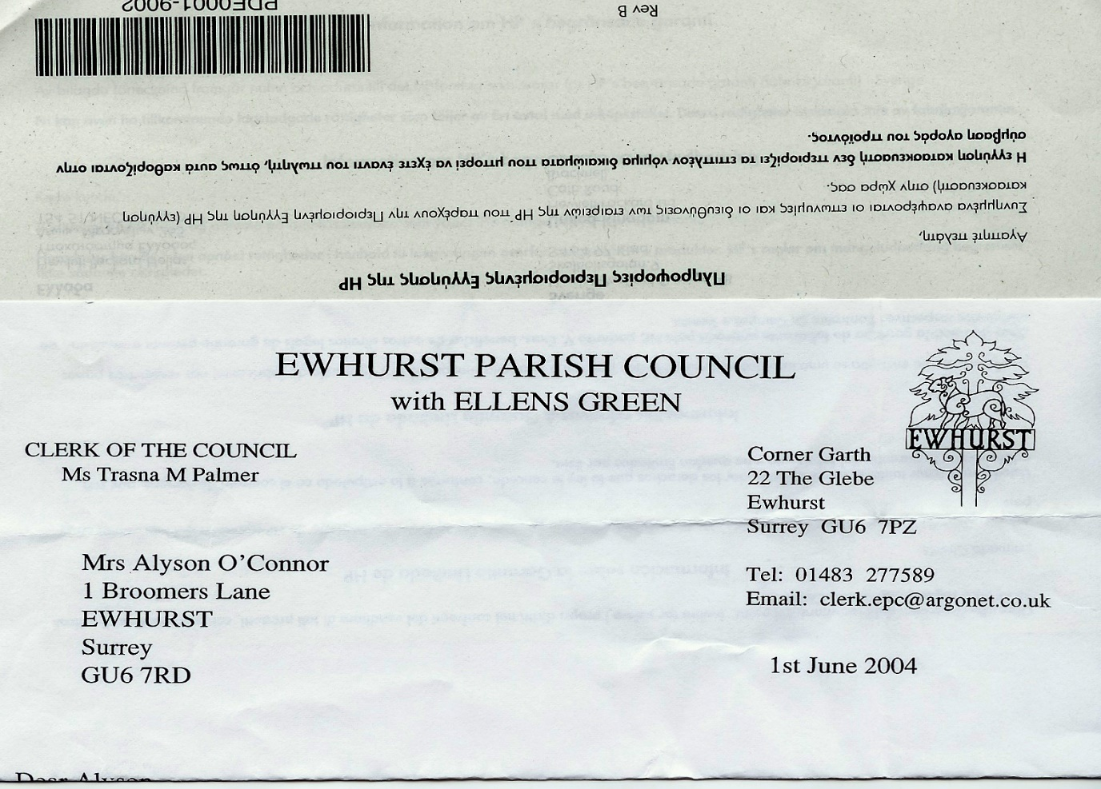 **EWHURST PARISH COUNCIL**

**WITH ELLENS GREEN**

**Clerk to the Council: Joanna Cadman Tel: 01483 268627 email: clerk@ewhurstellensgreen-pc.gov.uk**

**ACTION LIST: March 2025**

|  |  |  |  |  |  |  |  |  |  |  |  |  |  |  |  |  |  |  |  |  |  |  |  |  |  |  |  |  |  |  |  |  |  |  |  |  |  |  |  |  |  |  |  |  |
| --- | --- | --- | --- | --- | --- | --- | --- | --- | --- | --- | --- | --- | --- | --- | --- | --- | --- | --- | --- | --- | --- | --- | --- | --- | --- | --- | --- | --- | --- | --- | --- | --- | --- | --- | --- | --- | --- | --- | --- | --- | --- | --- | --- | --- |
| |  |  |  |  | | --- | --- | --- | --- | | **Date of meeting** | **Minute no** | **Action** | **responsibility** | | Mar 24 | 033 | Glebe Lease | JM/MH/Clerk  Ongoing | | May 24 | 077d | Invasive pond weed | Clerk  Deferred to next April, as treatment should be carried out at the beginning of the season | | May 24 | 077f | Tennis courts | TB  Quote from 1 contractor, 2 more awaited | | ~~Oct 24~~ |  | ~~Glebe heating~~ | 1. ~~Cllr White to investigate alternative heating~~ 2. ~~Cllr Mitchell to review E.ON bills~~ | | Nov 24 | PS | Footpath at junction of Mapledrakes and Williams Close | Clerk  LEAP will lay the scalpings in April | | Jan 25 | Public 3 | Yellow spot on pavement | Clerk  Will be renewed until the weather improves | | Jan 25 | 014iii | House on the Green | Clerk  The Clerk has raised the issues with the Countryside Ranger | | Feb 25 | 025iii | Ewhurst Charities | Clerk  Copy awaited from Charities | | Feb 25 | 027 i | Cemetery | Clerk  The Clerk has a list of graves in the bottom left hand corner of the cemetery and will discuss with the gravedigger | | Feb 25 | 027 iv | Tennis courts | Clerk  Ongoing investigation into commercial use | |