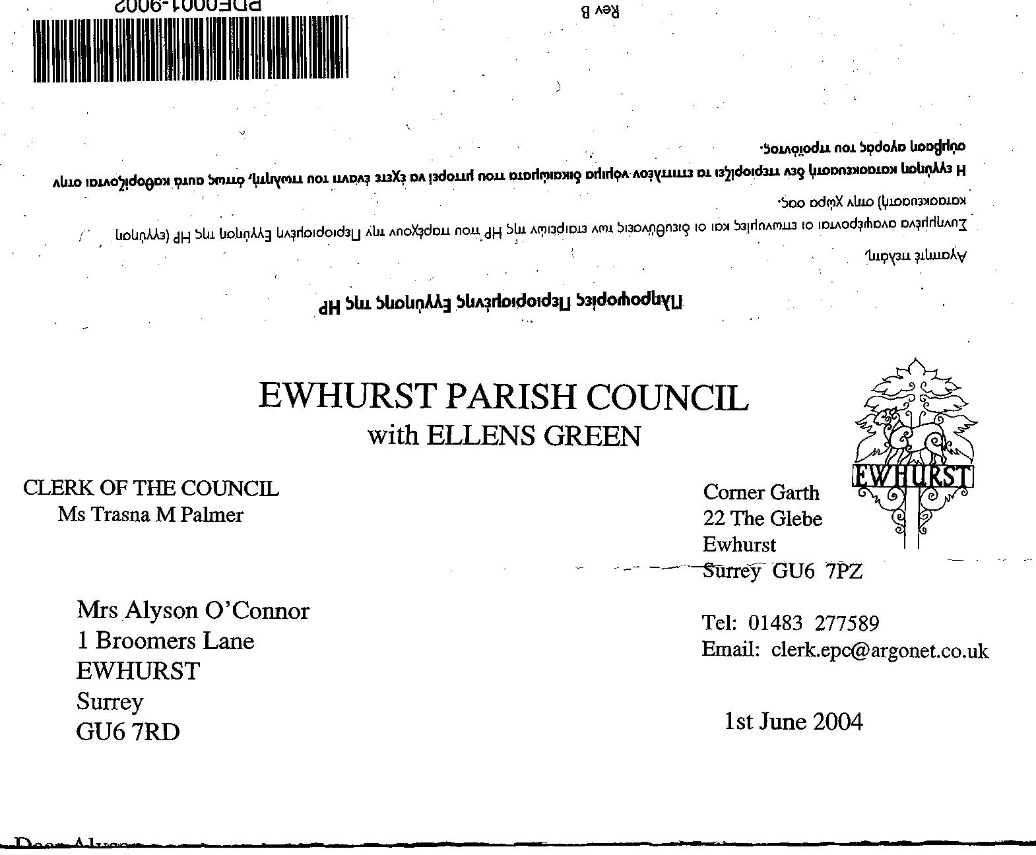
EWHURST PARISH COUNCIL
WITH ELLENS GREEN

Clerk to the Council: Joanna Cadman Tel: 01483 268627 email: clerk@ewhurstellensgreen-pc.gov.uk
EWHURST PARISH COUNCIL WITH ELLENS GREEN PARISH COUNCIL MEETING.
Minutes of the Meeting of the Parish Council held at
8.00 pm on Monday 20th January 2025 at the EYSC

Present: Cllr V Henry (in the chair), Cllrs J Bloomfield, T Bloomfield, M Higgins, J Lilley, L Tingley,
M White
6 Members of the public
In attendance: The Clerk, Mrs J Cadman
The Assistant Clerk, Mrs J

Public Session:

- Communications: Tony Gauvain, Church Warden, presented the following:

‘I am speaking as a Church Warden of Ewhurst Church in the context of the demise of the News & Views magazine last December, the expected change of editorship of the Ewhurst & Ellens Green (EEF) News from March, and the change of parochial boundary expected from September.
‘Broad consultation agrees that one publication is needed which covers both secular and parochial news. The retired editor of N&V has handed over all data to me, and in the absence of any application to take over, I have decided it is unrealistic and even undesirable to attempt to continue it.
‘The editor of EEG News plans to publish her last edition at the end of February and to invite applicants to take over. She has agreed that parochial news can be presented on the fourth page, and that it should continue to be published four times a year.
‘Therefore, we have a satisfactory solution going forward and I would ask the Parish Council to agree to continue funding at £300 per edition.’

Mr Gauvain was advised that, currently, the Parish Council make a grant of £300 per annum towards the Newsletter. He was thanked for taking on the task of communications and it was agreed to discuss this in more depth.

- CIL Application: the Chairman of the Ellens Green Memorial hall Trust asked for an update on their application for funding for playground equipment. He was advised that this would be discussed at the next meeting of the CIL Committee the following week, but it would be helpful if the Trust would consider how to provide some matched funding.

- Yellow spot on pavement opposite village hall: this is badly worn, but cannot be renewed until the weather improves.

- Fabulously Festive event at the Polo Club: the owners of Brew House represented residents around the Green, Plough Lane and Lower Breache Road, who had been very disturbed by the level of noise from the music at this event, and the very bright lights. It appears that the Polo Club’s licence, granted in 2012, allows these events throughout the year, with an additional 10 evens of up to 5,000 people. It was agreed that the Parish Council would write to WBC with the residents concerns and ask that this licence be reviewed, in view of the fact that the Polo Club is in a rural area.

- Widewoods Footpath: concern had been raised about the inaccessibility of a footpath on this Estate, and this would be investigated.

- Piping in of a ditch on the Green: The Clerk had advised the couple in question that they should apply for permission from the Countryside Ranger, WBC.

- Cutting back of ditches and verges on the Green: The Council was thanked for this work.

001 (2025) | APOLOGIES FOR ABSENCE: were received from Cllrs N Clowes and J Mitchell.
002 (2025) | DECLARATIONS OF INTEREST: none were made.
003 (2025) | INTRODUCTION TO ASSISTANT CLERK:  Jane Luker-Brown, a local resident, was introduced to the Council. She had started work as the Assistant Clerk on the 6th January, and would initially work 6 hours a week. Her hours would increase as she took on responsibilities. Jane was welcomed by all present.
004 (2025) | MINUTES OF PARISH COUNCIL MEETING HELD 18TH NOVEMBER 2024 were agreed as a correct record of the meeting and signed by the Chairman, after the following amendment:  County Cllr: c) Solar Powered VAS signs: Ellens Green cannot have VAS as the speed limit is 40mph, whereas the upper limit for VAS is 30mph.
005 (2025) | Appendix 2: ACTION LIST: to receive reports from Members and the Clerk
  Date of meeting | Minute no | Action | responsibility
  Mar 24 | 033 | Glebe Lease | JM/MH  Ongoing
  May 24 | 077d | Invasive pond weed | Clerk  Deferred to next April, as treatment should be carried out at the beginning of the season
  May 24 | 077f | Tennis courts | TB  Is meeting with a contractor shortly, and will seek a firm quote for refurbishment, and also replacement of the nets.  To investigate potential of CIL for this purpose
  June 24 | Public | Lights in village hall car park | The electrician has visited and is waiting for parts
  Sept 24 | 122 | VE day commemorations | Agenda item
  Oct 24 | 143a | Foul water on recreation ground | Reported to Thames Water and EA
  Oct 24 |  | Glebe heating | - Cllr White has a quote of £7695 for gas central heating  - Cllr Mitchell to review E.ON bills
  Nov 24 | PS | Footpath at junction of Mapledrakes and Williams Close | The Clerk to meet with Mrs Palmer and then action scalpings
  Nov 24 | 157 | Pavement opposite village hall | The hedge cannot be cut back enough to provide a wide enough pavement for SCC’s requirements.  It was agreed to investigate taking out the hedge for sufficient run that the railing can be moved back
006 (2025) | MATTERS ARISING not covered by the Action List  152 (2024) Cricket club: the expected quotation was received and approved, and the work has been carried out on the cricket club pavilion and paid for. This agreement had been sought via email in order that the work could be carried out before the winter, and was now ratified. Proposed by Cllr T Bloomfield, Seconded by Cllr White, all in favour.  155 (2024) Christmas Festival: the Clerk had received more complaints about the noise levels, which she passed to the organisers. As discussed in the public session, the Parish Council will discuss the Polo Clubs Licence with WBC.
007 (2025) | THE PLANNING COMMITTEE:  Minutes of planning meeting held 18th November 2024: were noted and agreed.
008 (2024) | Appendix 4: CIL COMMITTEE  - Members approved the constitution of a CIL Committee to replace the CIL working group, in accordance with the proposal tabled before the meeting. Proposed by Cllr White, Seconded by Cllr Tingley, all in favour.  - Members agreed a working budget of £2,000 for the committee, to enable the committee to authorise specialist advice when required. This budget to be taken from the contingency in the Parish Council budget for 2025/26. Proposed by Cllr J Bloomfield, Seconded by Cllr White, all in favour.
009 (2025) | FINANCIAL REPORT:  - Expenditure for November and December 2024 of £35,771.67 and £23,594.16 respectively, was noted and agreed.  - Cost centre report to end December 2024 was noted and agreed.  - Bank reconciliation statement to end December 2024 was checked against the bank statement and signed by the Chairman.  - Budget and precept request for financial year 1/4/25 to 31/3/26. Members approved the budget and precept request submitted to all members in December 2024, following approval by the Finance Committee. The precept request is for £124,100, an increase of 5% after two years of no increase, giving a Council tax impact on a Band D property of £92.37.
009 (2025) | COMMUNICATIONS:  Future of News and Views: discussed in the Public Session.
010 (2025) | CIL WORKING GROUP  Minutes of the meeting held 27th November: were noted and agreed.  Broxap Cycle Racks: members agreed to purchase Broxap cycle stands at £99 each, with possible extra coating, to be decided. 4 to be placed in the village hall car park, 4 on the recreation ground and 2 outside the shop, if a suitable space can be found. Agreement was also given to the cost of installing the cycle stands. Proposed by Cllr Henry, Seconded by Cllr Tingley, all in favour.
011 (2025) | VE DAY COMMEMORATIONS 2025:  - The Clerk reported that The Fabulous Nobodies have been engaged to do two sets on the recreation ground, on Saturday 10th May, starting at 7pm, at a cost of £1400.  - The village club will be asked to run a bar, the pizza van, or equivalent, will be asked to provide food.  - Rev’d Rosemary Mason will conduct a service at the Recreation Ground War Memorial, details to be agreed.  - It is hoped to provide other focus points during that weekend.
012 (2025) | ANNUAL PARISH MEETING:  - 7th April, 7pm, village hall.  - Content:  - Report from Parish Council  - Newsletter  - NPPF – to ask Cllr Townsend
013 (2025) | PARISH UPDATE FROM CLERK: The Clerk had no further matters to report
014 (2025) | PARISH BUSINESS: other matters to be noted or included on a future agenda  - VJ Day: Cllr Tingley reported that the fete would be held on the 6th September, and would observe VJ day. The church would look to getting other societies involved.  - Festive notices: are still around the village. The organisers will be asked to remove them.  - House on the Green, Ellens Green: the issues are not resolved. The Clerk will speak to the Countryside Ranger.  - Unitary Councils: the proposals from Government will mean that Borough Councils will be scrapped, but Parish and Town Councils will remain.
015 (2025) | NEXT FULL MEETING OF THE PARISH COUNCIL: Monday 17th February 2025 at the EYSC
016 (2025) | EXCLUSION OF MEMBERS OF THE PUBLIC AND PRESS  The Motion: in accordance with the provisions of section 1(2) of the Pubic Bodies (admission to Meetings) Act 1960 the press and pubic be excluded from the meeting by reason of the confidential nature of the business to be transacted: staffing matters.

The meeting closed at 9.30pm

