EWHURST PARISH COUNCIL
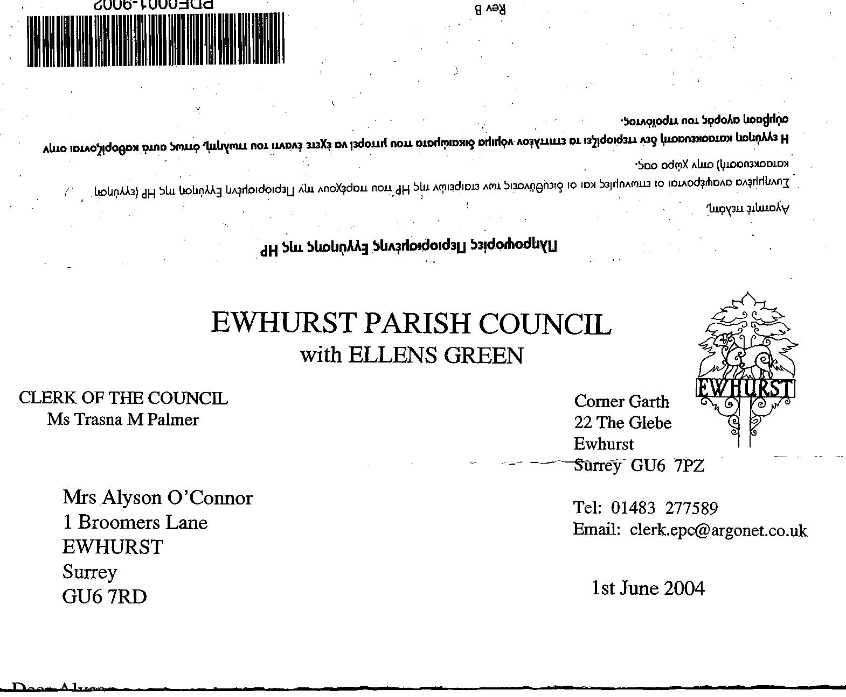
with ELLEN’S GREEN

Parish Council CIL Funding Application
Form

25% of money received through the Community Infrastructure Levy, collected by Waverley Borough Council (WBC) from development in Ewhurst, is paid to Ewhurst Parish Council.. The funds are available to spend on local projects in Ewhurst. As set out in the CIL Regulations, this local proportion of CIL should be used for:

- The provision, improvement, replacement, operation or maintenance of infrastructure; or
- Anything else that is concerned with addressing the demands that development places on an area
The definition of infrastructure is broad and includes amongst other items:
- Roads and other transport infrastructure
- Schools and other educational facilities
- Medical facilities
- Open spaces
- Sporting and recreational facilities
- Flood defences

Please read the Ewhurst Parish Council CIL funding application form guidance notes before completing this form. To discuss a potential project, or for further guidance, please contact the Parish Clerk at clerk@ewhurstellensgreen-pc.gov.uk or on 07711 566458.
Please note that if an external organisation has been granted CIL funds for a project it may not apply for further CIL funding, regardless of the project, until twelve months have elapsed since the previous award was granted.

CIL applications will be considered at full meetings of Ewhurst Parish Council – there are 10 meetings per year and dates of meetings are available on the Ewhurst Parish Council website – wwww.ewhurstellensgreen-pc.gov.uk or on the noticeboards.

Please return the completed application forms and supporting information to: clerk@ewhurstellensgreen-pc.gov.uk at least 2 weeks prior to a meeting of the full Ewhurst Parish Council

Ewhurst Parish Council CIL Funding Application Form

1. Applicant organisation
2. Name and position of main contact

3. Applicant contact details (phone no, email and address)
4. Type of organisation

If a charity, please provide registration number
5. Is the organisation able to reclaim VAT?
6. Location of project

7. Summary of the project proposal
8. Estimated project cost
9. Please show in the table the amount of CIL funding being sought and any other contributions that may have been allocated for this scheme
 | Amount | Detail
CIL funding sought
Any other Local authority contribution eg WBC and/or SCC
Third party contribution
Total cost

10. Detail of additional sources of funding available
11. Why is CIL funding being sought? Please provide details of sources of funding already considered or applications made for funding
12. Please indicate whether the organisation has previously received CIL or other funding sources from either Ewhurst Parish Council and/or Waverley Borough Council. If yes, provide amounts and timings

13. How does the project help address the demands of development in the area. What evidence is there to support this?
14. What evidence is there of support from the community
15. How does this project help mitigate climate change?

16. Proposed timescales for the project
17. Is there a related revenue spend (i.e. day-to- day running costs) associated with the project? How will this be addressed?
18. If the organisation is not in the public sector please provide details of
the organisation’s finances
Please include a copy of the most recently audited accounts, including details of unrestricted reserves
19. Do you need planning permission to carry out the works?
20. If planning permission is required is it in place to carry out the works?
If so, please provide the application number

Section E: Declaration

When you have completed the application, please sign this declaration and submit the application form as directed.

To the best of my knowledge the information I have provided on this application form is correct.

If Ewhurst Parish Council agrees to release funds for the specified project, these funds will be used exclusively for the purposes described. In such an event, I agree to inform Ewhurst Parish Council via the Parish Clerk of any material changes to the proposals set out above. When requested, I agree to provide Ewhurst Parish Council with all necessary information required for the purposes of reporting on the progress or otherwise of the identified project. I recognise the Parish Council’s statutory rights as the designated provider of these CIL funds, which includes provisions to reclaim unspent or misappropriated funds.

Privacy Notice: By signing this form, the applicant agrees to Ewhurst Parish Council checking all supplied information for the purposes of informing decision making. The information on this form will be stored in the Parish Council’s filing system and summarised in the Council’s accounting system for the sole purpose of fund processing, analysis and accounting. Information about the project may be publicised on Ewhurst Parish Council’s website and in public material for publicity purposes. Personal data will not be disclosed without any prior agreement of those concerned, unless required by law. For further information on the Council’s privacy policy, please see:
www.ewhurstellensgreen-pc.gov.uk .

Signed:

Organisation:
Date:

All organisations involved with the application will need to sign and date the form. Signed:
Organisation:

Date:

Adopted March 2024

