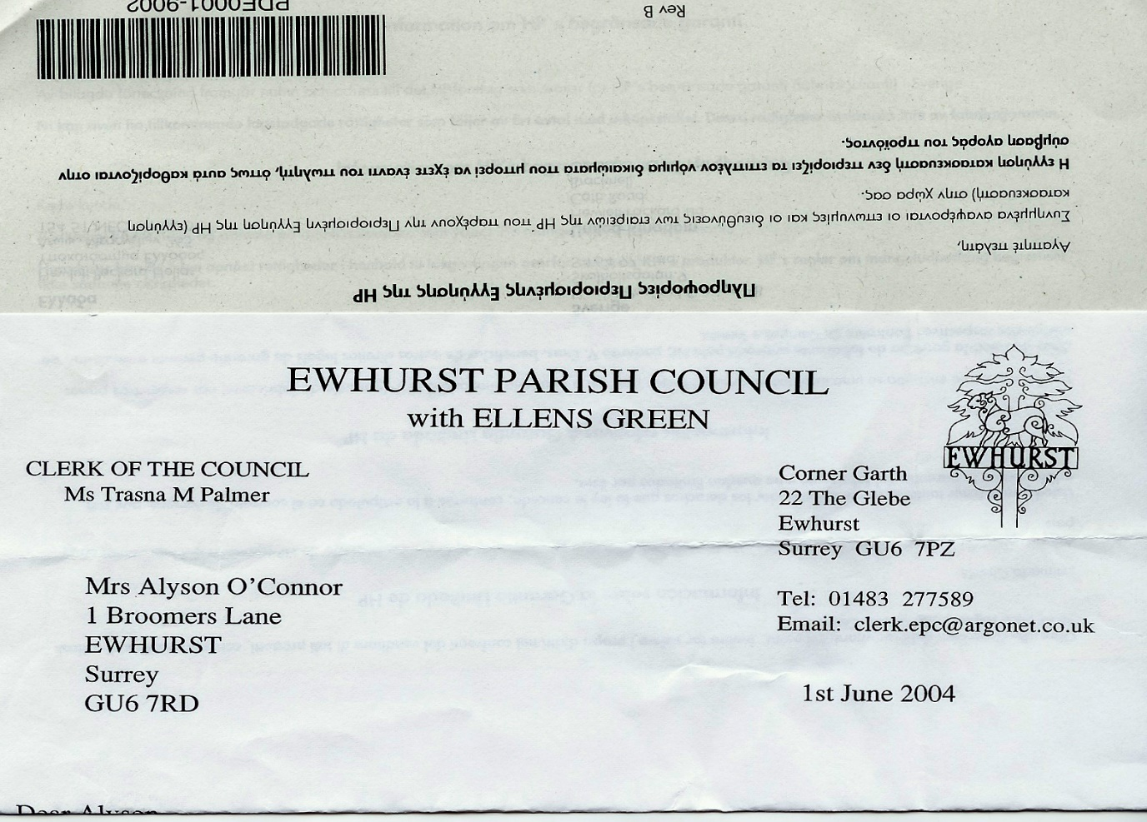**EWHURST PARISH COUNCIL**

**WITH ELLENS GREEN**

**Clerk to the Council: Joanna Cadman Tel: 01483 268627 email:** [**clerk@ewhurstellensgreen-pc.gov.uk**](mailto:clerk@ewhurstellensgreen-pc.gov.uk)

**CIL COMMITTEE MEETING**

**At the EYSC, 4pm**

**Monday 27th January 2025**

**Present:** Cllr N Clowes (in the chair), Cllrs T Bloomfield, M Higgins

In attendance: The Clerk, Mrs J Cadman

|  |  |
| --- | --- |
| 01/25 | **Apologies:** all members were present |
| 02/25 | **Notes from last meeting:** were agreed as a correct record of the meeting of the working group. |
| 03/25 | **Matters arising and outstanding actions**  *34/24: Recreation Ground:* Cllr T Bloomfield and the Clerk had met with Tidey and Webb at the recreation ground, who will produce a revised quotation to include lighting bollards at agreed intervals.  The Clerk will then seek 2 other quotations.  34/24 *Speed Cameras:* The Clerk will follow up the results of the experimental solar VAS scheme elsewhere in the county and will also ask SCC if the experiment could be repeated here, using our own funding.  34/24 *new village hall:* the Clerk will follow up the request to SCC to assess the access, using the school car park as part of the access road.  34/24 *Cricket pavilion:* the work has been completed and is much appreciated. Cllr Higgins advised that the cricket club are now pursuing other funding for refurbishments inside the Club.  *34/24: affordable housing seminar:* the Clerk is seeking new dates. |
| 04/25 | **Ellens Green Memorial Hall application**  The total cost of the project is £14,400 including VAT. The Trustees are seeking funding of £13,200 with a 3rd party contribution of £1,200.  Ellens Green is not affected by the demands put on Ewhurst by new developments and it is therefore harder to justify support using CIL funds. However, it was noted that the hall is heavily used by parish residents for parties and meetings and it is reasonable to expect that this use has increased as a result of a larger population.  It was agreed to offer a 50% grant to this project, at £7,200, subject to evidence that the remainder had been raised elsewhere. |
| 05/25 | **VAS: next steps**  Dealt with under 03/25 above. |
| 6 | **EYSC kitchen**  The Clerk had met with Wren Kitchens and had obtained a design and quote from them. The following actions were agreed:   1. The Clerk will seek detail on what is included in the broad brush quote 2. Two further kitchen companies will be asked to quote, once this detail is received. 3. All companies will also be asked to quote for the village hall kitchen. 4. to establish whether the figures quoted include or are net of VAT. |
| 7 | **Any other matters**   1. *Tennis Courts:* Cllr T Bloomfield is to meet with the preferred contractor shortly and will obtain a quote for refurbishment of the courts and new nets. The Clerk will then seek 2 further quotes. |
| 8 | **Date of next meeting:** 25th February, 4pm, EYSC. |