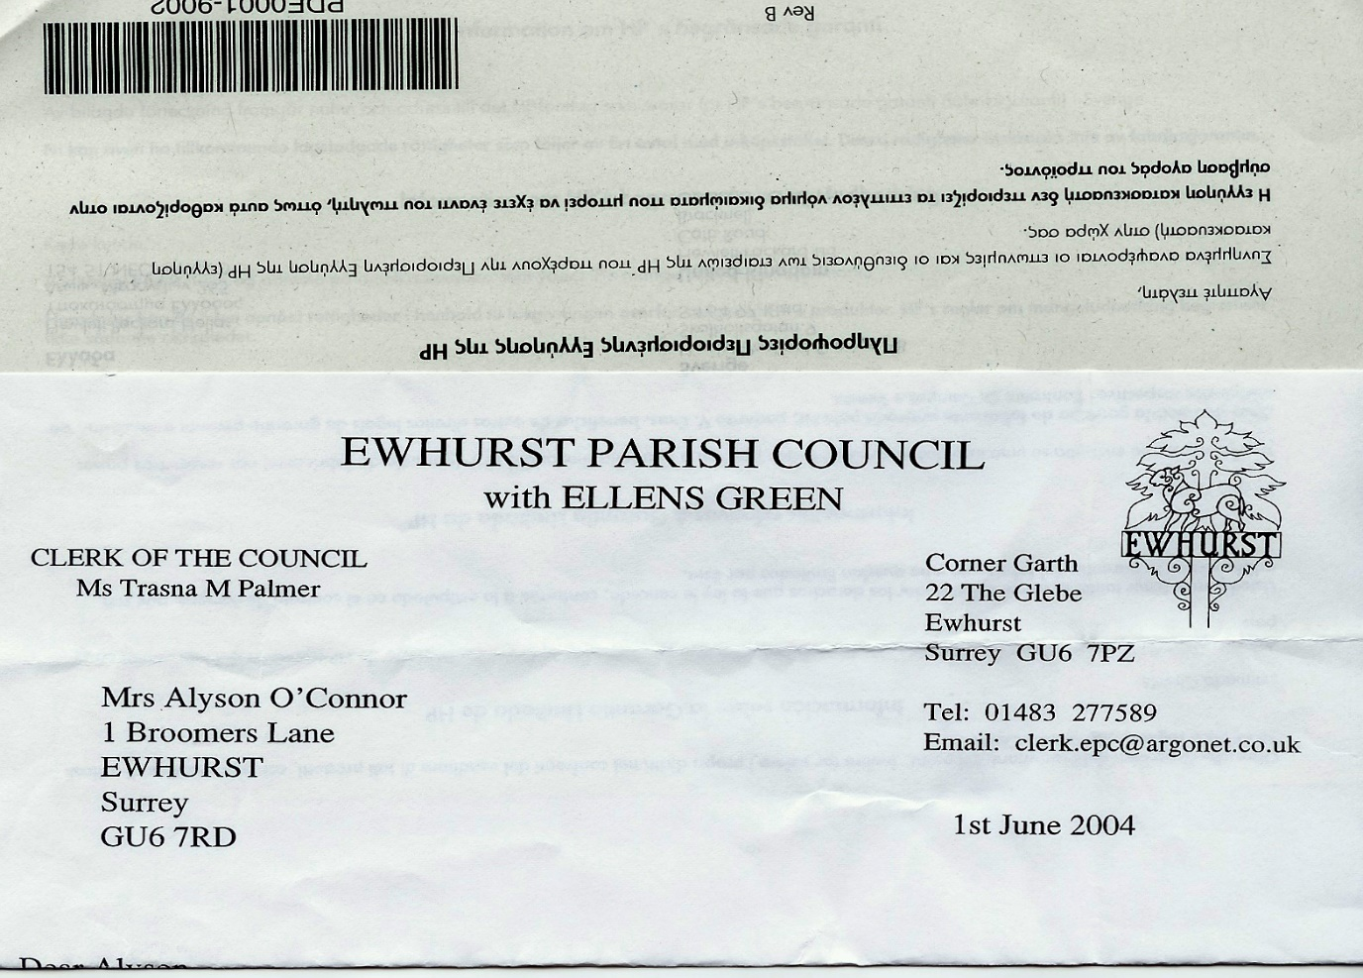 **EWHURST PARISH COUNCIL**

**WITH ELLENS GREEN**

**Clerk to the Council: Joanna Cadman Tel: 01483 268627 email: clerk@ewhurstellensgreen-pc.gov.uk**

**ACTION LIST: February 2025**

|  |  |  |  |  |  |  |  |  |  |  |  |  |  |  |  |  |  |  |  |  |  |  |  |  |  |  |  |  |  |  |  |  |  |  |  |  |  |  |  |  |  |  |  |  |
| --- | --- | --- | --- | --- | --- | --- | --- | --- | --- | --- | --- | --- | --- | --- | --- | --- | --- | --- | --- | --- | --- | --- | --- | --- | --- | --- | --- | --- | --- | --- | --- | --- | --- | --- | --- | --- | --- | --- | --- | --- | --- | --- | --- | --- |
| |  |  |  |  | | --- | --- | --- | --- | | **Date of meeting** | **Minute no** | **Action** | **responsibility** | | Mar 24 | 033 | Glebe Lease | JM/MH  Ongoing | | May 24 | 077d | Invasive pond weed | Clerk  Deferred to next April, as treatment should be carried out at the beginning of the season | | May 24 | 077f | Tennis courts | TB  To advise on options for refurbishment  Waiting for contractor | | ~~June 24~~ | ~~Public~~ | ~~Lights in village hall car park~~ | ~~completed~~ | | ~~Sept 24~~ | ~~122~~ | ~~VE day commemorations~~ | ~~Agenda item~~ | | ~~Oct 24~~ | ~~143a~~ | ~~Foul water on recreation ground~~ | ~~Reported to Thames Water and EA~~  ~~completed~~ | | Oct 24 |  | Glebe heating | 1. Cllr White to investigate alternative heating 2. Cllr Mitchell to review E.ON bills | | Nov 24 | PS | Footpath at junction of Mapledrakes and Williams Close | The Clerk to meet with Mrs Palmer and then action scalpings | | ~~Nov 24~~ | ~~157~~ | ~~Pavement opposite village hall~~ | ~~Clrl J Bloomfield reported the pavement is not wide enough for a new barrier even if the hedge is trimmed back~~ | | Jan 25 | 014iii | House on the Green | The Clerk has raised the issues with the Countryside Ranger | |