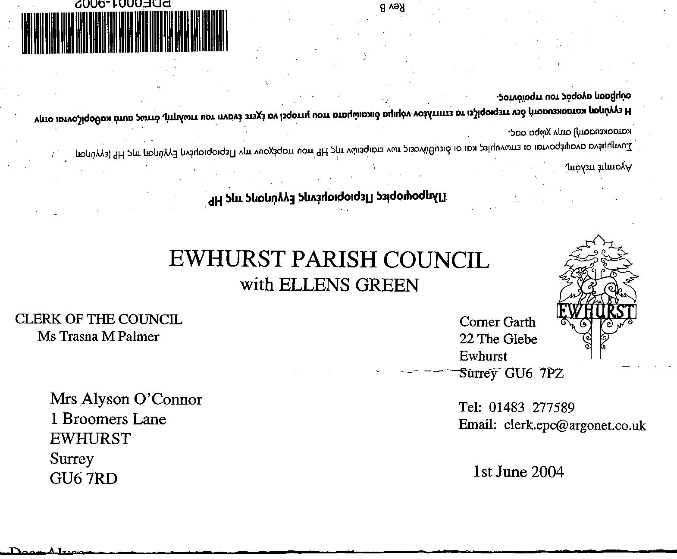
EWHURST PARISH COUNCIL
WITH ELLENS GREEN

Clerk to the Council: Joanna Cadman Tel: 01483 268627 email: clerk@ewhurstellensgreen-pc.gov.uk
EWHURST PARISH COUNCIL WITH ELLENS GREEN PARISH COUNCIL MEETING.
Minutes of the Meeting of the Parish Council held at
8.00 pm on Monday 18th November 2024 at the EYSC

Present: Cllr N Clowes (in the chair), Cllrs J Bloomfield, T Bloomfield, V Henry, J Mitchell,
L Tingley, M White
County Cllr L Townsend
4 members of the public
In attendance: The Clerk, Mrs J Cadman

PUBLIC SESSION:
- Christmas event at the Polo Ground: A resident of Ewhurst Green complained about the noise. It was also commented that there were no marshalls or lighting at the entrance. The Clerk, who had met with the organisers, would raise this with them.
- Cranleigh Leisure centre re-build: In response to concern about the lack of parking whilst the centre was being re-build, Cllr Townsend advised that, except for market day, the car park was only 40% to 50% used. The Parish Council would allow the tennis courts to be used for parking, the market will be moved to Stocklund Square and discussions were under way with Hoppa to expand their role. The new centre should be completed in 2027, with a start date in the autumn of 2025.
- Ewhurst Church: Tony Gauvain, church warden, advised the Council that Ewhurst Church is separating from Okewood and Forest Green, subject to a vote by the PCC on the 27th November. The Parish will officially come under Cranleigh and Roy Woodhams will be the priest in charge. He hoped that Ellens Green will be officially recognised as part of Ewhurst Church and that they could find an Ellens Green representative to sit on the PCC.
- Footpath at junction of Mapledrakes Road and Williams Close: a resident asked if scalpings could be laid here, as the constant puddle is very large. This was agreed and the Clerk will action.

County Councillor
- National Landscape Boundary changes: Cllr J Bloomfield and the Clerk will look at this consultation.
- Build out on the Green: this will hopefully happen in early spring.
- Solar Powered VAS signs: Mr Selby SCC, is looking at a new scheme in the west of the county, to establish whether they are practical, and will report back. Ellens Green cannot have VAS as the speed limit is 40mph, the upper limit for VAS. Cllr T Bloomfield advised that they would discuss this again at the forthcoming CIL meeting, where he will recommend that a letter is written to our MP.
- 30mph roundels on Cranleigh Road: Cllr Townsend will raise this with SCC.
- NPPF: will be published before Christmas. Cllr Townsend confirmed that WBC will take into account new housing from the base date.

145 (2024) | APOLOGIES FOR ABSENCE: were received from Cllr Higgins and Cllr Lilley.
146 (2024) | DECLARATIONS OF INTEREST: none were made.
147 (2024) | MINUTES OF PARISH COUNCIL MEETING HELD 21st OCTOBER 2024: were agreed as a correct record and signed by the Chairman.
148 (2024) | ACTION LIST:
  Date of meeting | Minute no | Action | responsibility
  Mar 24 | 033 | Glebe Lease | JM/MH  Ongoing
  April 24 | 049 | Cemetery – advice on planting | Clerk  Pending a site visit
  May 24 | 077d | Invasive pond weed | Clerk  Deferred to next April, as treatment should be carried out at the beginning of the season
  May 24 | 077f | Tennis courts | Moved to the CIL Committee to look at criteria.
  May 24 | 077g | Phone box | Clerk  Reported BT to Ofcom
  June 24 | Public | Lights in village hall car park | Two have been repaired, one in the hedge is still not working
  June 24 | 091a | Asbestos pipes | The Clerk will write to Thames Water and the EA and seek their views
  Sept 24 | 122 | VE day commemorations | Agenda item
  Sept 24 | 126b | Rubbish in burial ground | Bins locked and notice in v hall kitchen.
  Oct 24 | 143a | Foul water on recreation ground | Reported to Thames Water and EA
  Oct 24 |  | Glebe heating | - Cllr White to investigate alternative heating  - Cllr Mitchell is reviewing E.ON bills and noted that the Council is paying the same rate for day and night
149 (2024) | MATTERS ARISING not covered by the Action List.  All matters are covered by the Action list and the agenda
150 (2024) | THE PLANNING COMMITTEE:  - Minutes of planning meeting held 21st October: were noted and agreed.
151 (2024) | FINANCIAL REPORT:  - Expenditure for October 2024 of £7,261.86 was noted and agreed.  - Cost centre report to end October: noted. Cllr Clowes pointed out areas where the budget is over or under-spent.  - Bank reconciliation statement to end October 24: tverified by the Chairman  - Interim Internal Audit report, circulated prior to the meeting. Members noted that there were no outstanding actions and congratulated the Clerk on a clear audit.  - Budget planning: The Finance committee will meet shortly to draw up a proposed budget for 2025/26 which will then be circulated to members for their comments, and ratified at the January full Council meeting.  - S106 money: the S106 funding for the Bowls Club and Recreation Ground car park in the sum of £26,991.75 has been received.
152 (2024) | CIL:  - Cycle rack detail and costings: this item will be taken forward by the CIL working group.  - Cricket Club: The Club are waiting for one further quote, as there were doubts regarding the quality of the work of the company that had been chosen. Once this had been received and approved by the CIL working group, the work will go ahead.
153 (2024) | SPEEDER BOT: some trouble was being experienced in exporting data into another data set. The concept is good, and will work, but it is technically difficult and will take some time.
154 (2024) | VE DAY COMMEMORATIONS 2025: the Clerk reported that she had asked all the village societies, and had very little response and certainly no enthusiasm. It was agreed to proceed with a concert, barbecue and bar, on the 10th May, funded by the Parish Council, and to ask the Church for a service of dedication at the recreation ground memorial.
155 (2024) | CHRISTMAS FESTIVAL: The Clerk had met with the organisers and discussed the Parish Council concerns. She reported the following:  - There is plenty of off road parking on a firm base, so there will be no issues with cars on the roads.  - The entry will be manned to ensure smooth access and ingress.  - It is intended to be a family affair, so a number of events will be covered within the ticket price.  - The noise levels will be managed  - Local residents (The Green, Plough Lane, Lower Breache and Upper Breache) will receive free tickets, to compensate for any noise or upset.  The Clerk will speak to the organisers again , given the complaint at the beginning of the meeting, as she had also noted the high noise levels at the weekend.
156 (2024) | PARISH UPDATE FROM CLERK:  The Clerk confirmed that the Christmas tree will go up on the hall porch roof on the first weekend of December..
157 (2024) | PARISH BUSINESS: other matters to be noted or included on a future agenda  - Yellow spot on pavement opposite the village hall: this needs to be re-painted.  - Pavement opposite village hall: discussion took place on the width of the hedge. Cllr J Bloomfield will investigate.
158 (2024) | NEXT FULL MEETING OF THE PARISH COUNCIL: Monday 20th January 2025 at the EYSC
The meeting closed at 21.30.

