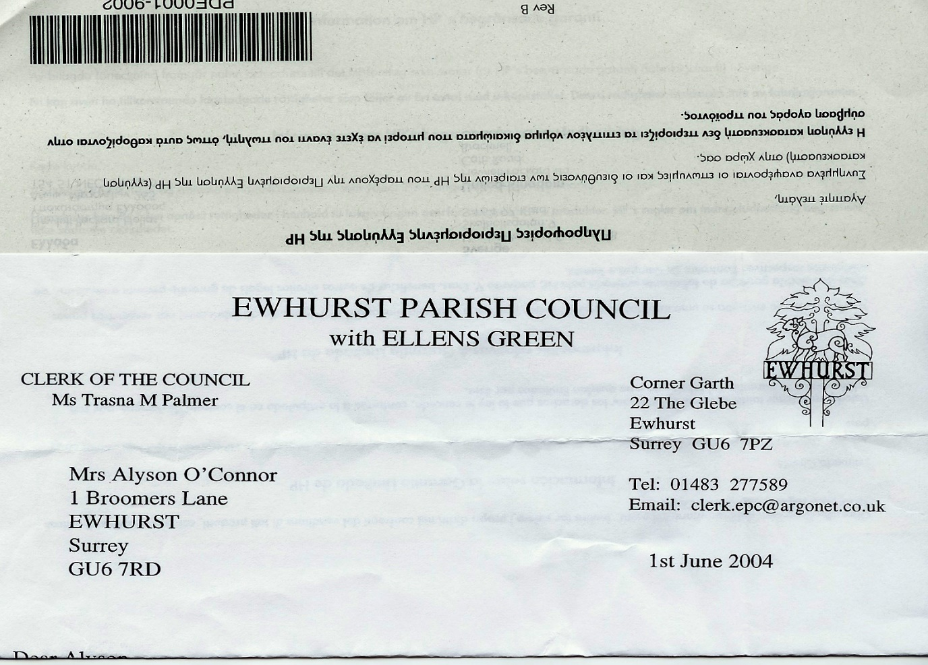 **EWHURST PARISH COUNCIL**

**Community Infrastructure Committee**

Section 102 of the Local Government Act 1972 empowers Parish Councils to establish Committees to facilitate their functions and responsibilities.

The Community Infrastructure Working Group wishes to re—establish itself as a Committee, in order to be able to move projects forward without returning to the Parish Council each time a decision needs to be made. The Parish Council will continue to receive full reports at each meeting.

*Terms of Reference*

* Purpose: to identify projects that qualify for CIL funding
* Objective: to bring those projects to fruition
* Responsibility: to ensure that all projects identified for CIL funding serve the interests of as many residents as possible, are fundable and sustainable, and balance all the needs of the community.

*Role and authority*

* The committee will act as a committee of the Parish Council and will report back to the Council on a regular basis.
* The Committee will identify CIL projects, liaise with the applicants, seek quotes, seek extra funding where applicable.
* The Committee will agree which CIL projects to fund.
* The Committee will receive an initial budget of £2,000 from parish council funds, to be spent as necessary in the pursuit of expert advice and opinions. The Committee will regularly report its spending to the Parish Council.

*Membership*

Cllrs T Bloomfield, N Clowes, M Higgins, the Clerk

Chairman: Cllr N Clowes

*Meetings and work*

The committee will meet at least bi-monthly to discuss progress, make decisions and take action. Members will collaborate on tasks, share information and expertise and work towards achieving the goals in the terms of reference.

*Reporting and accountability*

The Committee regularly reports to the Parish Council, providing updates on its activities, progress towards objectives and any recommendations or decisions. This ensures transparency and accountability in governance.