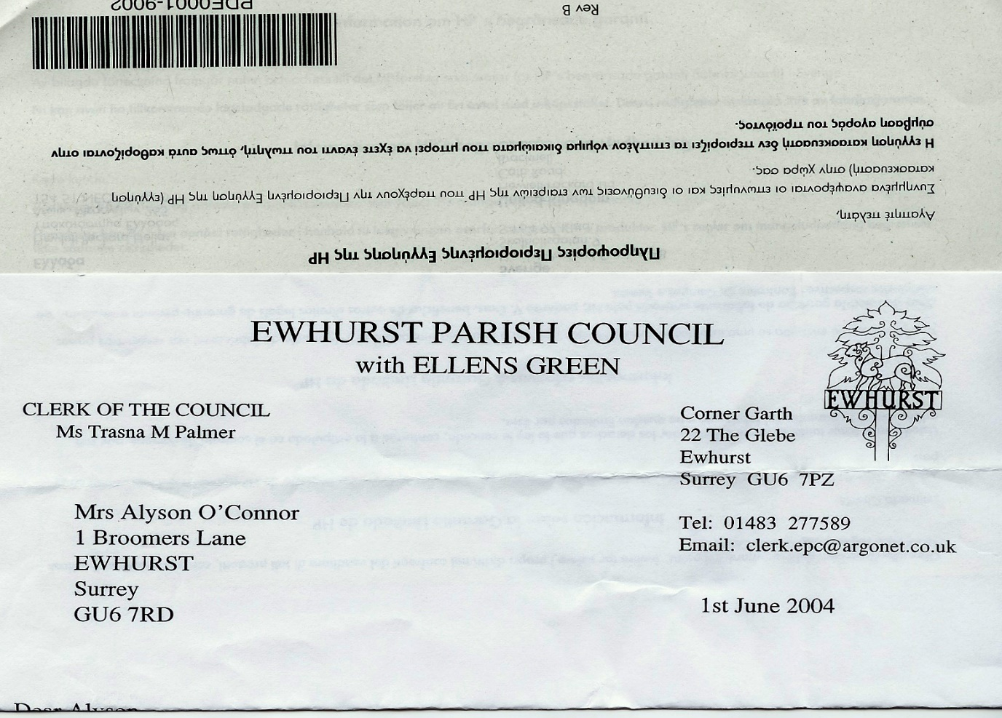**EWHURST PARISH COUNCIL**

**WITH ELLENS GREEN**

**Clerk to the Council: Joanna Cadman Tel: 01483 268627 email:** [**clerk@ewhurstellensgreen-pc.gov.uk**](mailto:clerk@ewhurstellensgreen-pc.gov.uk)

**NOTES FROM A MEETING OF THE CIL WORKING GROUP**

**Wednesday 27th November 2024**

**Present:** Cllr N Clowes (in the chair), T Bloomfield, M Higgins.

The Clerk Mrs J Cadman

|  |  |
| --- | --- |
| 32/24 | **Apologies:** all members were present |
| 33/24 | **Notes from meeting held 2nd October:** these were agreed as a correct record of the meeting. |
| 34/24 | **Matters arising and outstanding actions**  *Ellens Green Memorial Hall playground equipment:* An application had been received. The playground is an asset to the hall and is useful for parties, but Ewhurst is the main area for development and has infrastructure. It was agreed to put this proposal to the Parish Council to clarify the following:   1. What do members think in principle. 2. How much should we grant, as a proportion of what they are requesting and, as a result, how much fund raising will they do themselves. TB will explore their contribution. **Action TB** 3. Consider matched funding.   *Recreation ground car park:* the company approached had asked how many solar bollards were needed. It was agreed to ask them for their recommendation.  *Speed Cameras:* TB pointed out that Sussex CC do not have any concerns with solar cameras, which challenged Surrey CC’s conception that these did not work. Ewhurst PC are prepared to fund a camera and to bear the cost if it fails, it is hard to see why Surrey CC should continue to refuse. TB will draft a letter to our MPs to ask for their support. **Action TB.**  *New Village Hall:* before progressing with a feasibility study on a site on the allotment ground it was agreed to ask SCC Highways for an opinion regarding the access. **Action Clerk.**  *Cricket Pavilion:* agreement had been given to a new quotation and work was now proceeding.  *Affordable Housing seminar:* the Clerk would follow up the offer of a separate meeting with The Rural Housing Trust. |
| 35/24 | **Cycle Racks**  Members agreed to take a recommendation to the January Parish Council meeting to purchase Broxap cycle stands at £99 each, with possible extra coating, to be decided. 4 to be placed in the village hall car park, 4 on the recreation ground and 2 outside the shop, if a suitable space can be found. **January full council meeting.** |
| 36/24 | **VAS – next steps**  Discussed under Matters arising |
| 37/24 | **EYSC kitchen**  The Clerk had discussed possible improvements with the village handyman, but it was agreed that something more innovative was needed and she will explore kitchen designers for ideas. **Action Clerk.** |
| 38/24 | **Any other matters**   1. *Tennis Courts:* it was agreed to progress with a refurbishment of the tennis court surfaces, to extend the life of the courts by another 4 to 5 years. TB will obtain a specification and formal quotation. **Action TB** |
| 39/24 | **Date of next meeting**  27th January 2025. 4pm. TB’s house. |