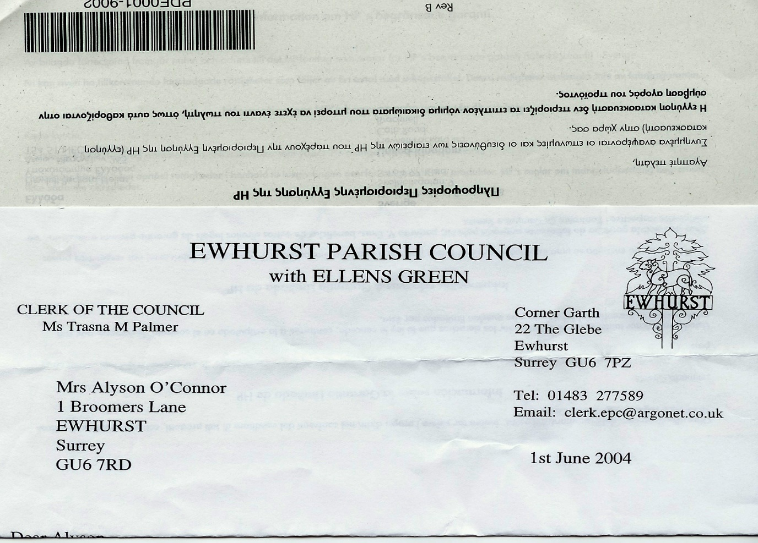 **EWHURST PARISH COUNCIL**

**WITH ELLENS GREEN**

**Clerk to the Council: Joanna Cadman Tel: 01483 268627 email: clerk@ewhurstellensgreen-pc.gov.uk**

**ACTION LIST: January 2025**

|  |  |  |  |  |  |  |  |  |  |  |  |  |  |  |  |  |  |  |  |  |  |  |  |  |  |  |  |  |  |  |  |  |  |  |  |  |  |  |  |  |
| --- | --- | --- | --- | --- | --- | --- | --- | --- | --- | --- | --- | --- | --- | --- | --- | --- | --- | --- | --- | --- | --- | --- | --- | --- | --- | --- | --- | --- | --- | --- | --- | --- | --- | --- | --- | --- | --- | --- | --- | --- |
| |  |  |  |  | | --- | --- | --- | --- | | **Date of meeting** | **Minute no** | **Action** | **responsibility** | | Mar 24 | 033 | Glebe Lease | JM/MH  Ongoing | | May 24 | 077d | Invasive pond weed | Clerk  Deferred to next April, as treatment should be carried out at the beginning of the season | | May 24 | 077f | Tennis courts | TB  To advise on options for refurbishment  Waiting for contractor | | June 24 | Public | Lights in village hall car park | The electrician has been asked to investigate | | Sept 24 | 122 | VE day commemorations | Agenda item | | Oct 24 | 143a | Foul water on recreation ground | Reported to Thames Water and EA | | Oct 24 |  | Glebe heating | 1. Cllr White to investigate alternative heating 2. Cllr Mitchell to review E.ON bills | | Nov 24 | PS | Footpath at junction of Mapledrakes and Williams Close | The Clerk to meet with Mrs Palmer and then action scalpings | | Nov 24 | 157 | Pavement opposite village hall | Clrl J Bloomfield to report on width of hedge | |