**Cycle Racks**

The proposal is to install 3 sets of cycle racks in the village, at the village hall car park, the recreation ground and the village shop.

Having researched the options, I recommend the products of the Bike Storage Company. <https://thebikestoragecompany.co.uk/products/bike-stands/>

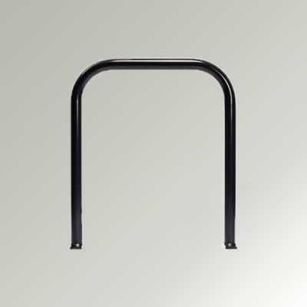

***£52.00 (ex VAT)***

***£62.40 (inc VAT)***

*A stylish upgrade of the traditional version, the Galvanised Black Sheffield Cycle Stand is hot dipped galvanised and polyester powder coated in jet black. It’s a contemporary and minimalist design, which will complement all environments, including:*

* *Residential developments*
* *Town and city centres*
* *Office buildings*

*These stands will also help contribute towards gaining two cycle storage credits the Code for Sustainable Homes, a scheme which encourages improvement in sustainable home building. For commercial developments, it’ll help with your competitive advantage. Our Sheffield Cycle Stand is made from mild steel, and hot-dipped galvanised to BS EN ISO 1461:2022. We only work with a handful of experienced suppliers to ensure all our products are of the highest standards and will stand the test of time.*

The stands are sold individually and I recommend 4 at the hall car park, 4 at the recreation ground and 2 at the village shop. Hazelbank stores have approved the proposal in principle.

The stands would be installed by our village caretaker, using the company’s specification sheet, and would be fixed into concrete using secure bolts. These are an additional £30 per stand.

The total cost for this project is as follows:

10 x cycle stands at £52 £520

10 x fixing packs at £30 £300

Concrete and installation £300

**Total £1120**