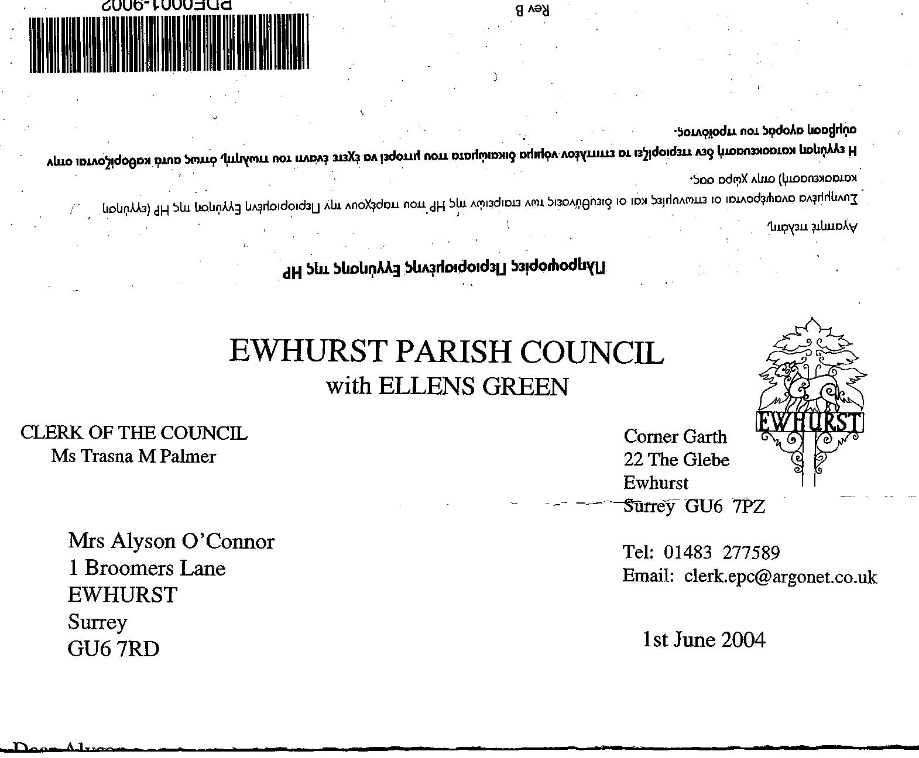
EWHURST PARISH COUNCIL
WITH ELLENS GREEN

Clerk to the Council: Joanna Cadman Tel: 01483 268627 email: clerk@ewhurstellensgreen-pc.gov.uk
EWHURST PARISH COUNCIL WITH ELLENS GREEN PARISH COUNCIL MEETING.
Minutes of the Meeting of the Parish Council held at
8.00 pm on Monday 16th September 2024 at the EYSC

Present: Cllr N Clowes (in the chair), Cllrs J Bloomfield, V Henry, J Lilley, J Mitchell
4 members of the public
In attendance: The Clerk, Mrs J Cadman

PUBLIC SESSION:
- Mrs Palmer asked if the Council would agree to her contacting the electrician about the car park lights. This was agreed.

112 (2024) | APOLOGIES FOR ABSENCE had been received from Cllrs T Bloomfield, M Higgins and L Tingley.
113 (2024) | DECLARATIONS OF INTEREST: none were made.
114 (2024) | MINUTES OF PARISH COUNCIL MEETING HELD 15th July 2024: were agreed as a correct record of the meeting and signed by the Chairman.
115 (2024) | ACTION LIST
  Date of meeting | Minute no | Action | responsibility
  Feb 24 | 027g | Damaged memorial bench - investigate repairs | JB/Clerk  Cllr J Bloomfield has repaired the bench
  Mar 24 | 033 | Glebe Lease | JM/MH  Ongoing – WBC Legal department have not responded
  April 24 | 049 | Cemetery – advice on planting | Clerk  Pending a site visit
  May 24 | 077a | Footpath from Bostocks | Clerk  WBC have written to the developer but do not expect a response  Cllr J Bloomfield requested that the Parish Council consider taking on the restoration of the footpath. This was agreed, the Clerk will seek quotes.
  May 24 | 077d | Invasive pond weed | Clerk  Deferred to next April, as treatment should be carried out at the beginning of the season
  May 24 | 077f | Tennis courts | TB  To advise on options for refurbishment  Waiting for contractor
  May 24 | 077g | Phone box | Clerk  Reported BT to Ofcom
  June 24 | Public | Lights in village hall car park | The electrician has been asked to investigate
  June 24 | Public | Stile on footpath 434 | The stile has been replaced
  June 24 | Public | Community speed watch | the co-ordinator has advised that they currently get out once a month and that there are still a lot of speeders in the village. More volunteers are needed  The Clerk has offered to put a call for volunteers on the website
  June 24 | 091a | Asbestos pipes | The Clerk to discuss with SCC councillor
  July 24 | 104 | WiFi to the Bowls Club | The Bowls Club can be connected, but will not receive WiFi free of charge, but at the preferential rate negotiated by Cllr Mitchell.
  July 24 | 107 | 1 The Glebe | Agenda item
  July 24 | 105 | Defibrillator box | In place but not yet connected to power, after which the grant will be claimed from the Henry Smith Charity
116 (2024) | MATTERS ARISING not covered by the Action List  100 (2024) Bowls Club potholes: these have been repaired.  104 (2024) Defibrillator wall box for the Glebe: this has been installed  106 (2024) Ditch outside Fairview: the Countryside Ranger has repeated his request that the owners of Fairview write to ask formal permission to fill in the ditch.  107 (2024) 1 The Glebe: Cllr Higgins had sent the following report: he had met with the tenant and raised the issues with WBC officer Sharon Doyle. It is clear that there have been failings from the maintenance contractor; for example, a garden gate was promised by 14th August but this did not happen . The gate has now been installed, as of 13th September. Waverley now appear to be addressing the remaining issues.  - 024) Footpath 365a: Sayers Croft volunteers have completed the work.
117 (2024) | THE PLANNING COMMITTEE : Minutes of planning meetings held 15th July and 19th August: were agreed a correct record of the meeting.
118 (2024) | FINANCIAL REPORT:  - Expenditure for July and August 2024 of £39,706.18 was noted and approved.  - Cost centre report to end August: noted and approved  - Bank reconciliation statement to end August 24: noted and approved.  - Annual Return External Auditors Report and AGAR accountability statements and accounting statements. These have been posted on the website, in accordance with legislation, together with a notice advising public rights of access to the Parish Council’s accounts. The external auditors report had been clear, with no issues to address. The Clerk was congratulated on a good audit.
119 (2024) | CIL  All actions agreed at the July meeting have been progressed. The working group will report further at the October full Council meeting, following a meeting of the working group
120 (2024) | GLEBE: Heads of Terms: a response is awaited from WBC’s legal team
121 (2024) | WIFI Captive Portal deployment: Cllr Mitchell advised that he is currently waiting on Box Broadband to sort out various issues, such as the Mailchimp Account. Users will be asked to opt out of receiving communications, rather than opting in, which is acceptable for a parish council as it is providing a public service. All emails will have an unsubscribe button.
122 (2024) | VE DAY COMMEMORATIONS 2025: The Clerk reminded members of the various celebrations which took place in the Platinum Jubilee year, where all village societies had been involved. She undertook to contact all the societies and establish what they might like to do next year, after which she would put together a proposal. The church would be asked to bless the new memorial plaques on the recreation ground.
123 (2024) | MOTHER AND BABY GROUP IN THE EYSC:  The Clerk advised that she had been approached by a resident with 2 babies who wanted to start a mother and baby group as there was nothing similar in the area and there were a number of new families in the village. She wished to run this 3 mornings a week in the EYSC and would need storage.  Members agreed to support this initiative, having checked our own and the user’s insurance, and undertaken a risk assessment. Cllr Mitchell would draft a letter setting out terms of hire.  The hirer would need extra storage and suggested a storage box on the balcony. Members were concerned about the dangers of young children on the balcony and proposed that a storage box be sited in the room.
124 (2024) | FOOTPATH FROM CHERRY TREE LANE TO RECREATION GROUND  This gets quickly very muddy and unusable in wet weather. Members agree to laying 5tonne of scalpings on the path as it enters the recreation ground, at a cost of around £300. Proposed by Cllr Clowes, Seconded by Cllr J Bloomfield, all in favour.
125 (2024) | PARISH UPDATE FROM CLERK: a hornet’s nest had been discovered in the apex of the EYSC roof, and had been destroyed that afternoon.
126 (2024) | PARISH BUSINESS: other matters to be noted or included on a future agenda)  - Damage to burial ground pond outlet: the contractors heavy vehicles are constantly driven over the outlet, posts marking the outlet having been removed. A meeting will be arranged between Cllr J Bloomfield, the Clerk and the contractor.  - Rubbish and debris on the burial ground: this appears to have been caused by young children taking items from the recycling bin in the car park. It was agreed to lock the bins and put a key in the village hall kitchen.
127 (2024) | NEXT FULL MEETING OF THE PARISH COUNCIL: Monday 21st October at the EYSC  The meeting closed at 20.55.
128 (2024) | EXCLUSION OF MEMBERS OF THE PUBLIC AND PRESS  The Motion ‘ in accordance with the provisions of section 1(2) of the Pubic Bodies (admission to Meetings) Act 1960 the press and pubic be excluded from the meeting by reason of the confidential nature of the business to be transacted: staffing matters

