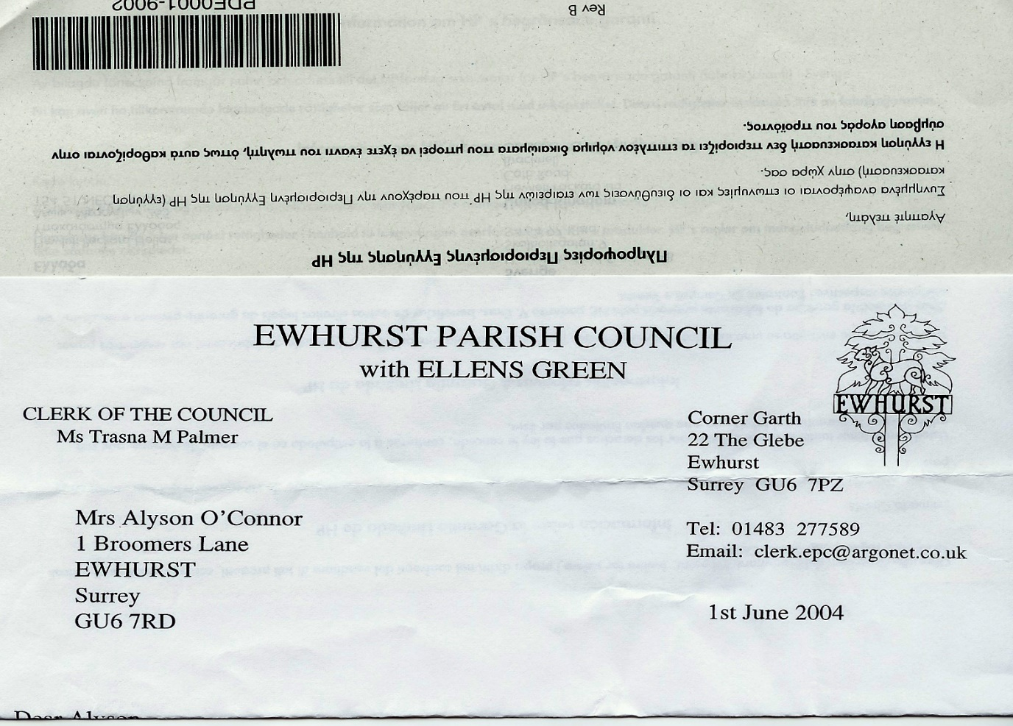**EWHURST PARISH COUNCIL**

**WITH ELLENS GREEN**

**Clerk to the Council: Joanna Cadman Tel: 01483 268627 email:** [**clerk@ewhurstellensgreen-pc.gov.uk**](mailto:clerk@ewhurstellensgreen-pc.gov.uk)

**NOTES FROM A MEETING OF THE CIL WORKING GROUP**

**Wednesday 2nd October 2024**

**Present:** Cllr N Clowes (in the chair), T Bloomfield, M Higgins.

The Clerk Mrs J Cadman

|  |  |
| --- | --- |
| 24/24 | **Apologies:** all members were present |
| 25/24 | **Notes from meeting held 9th July:** these were agreed as a correct record of the meeting. |
| 26/24 | **Matters arising and outstanding actions**  *Ellens Green Memorial Hall playground equipment:* the management team have been sent an application form but have not responded to date.  *Recreation ground car park:* Further quotations needed for resurfacing, to include solar bollards. **Action:** TB  *Speed Cameras:* SCC are very negative about these, despite their obvious efficacy in Rudgwick. A letter to be written to the Leader of SCC, asking for support for this scheme, which would be funded by the Parish Council. **Action:** TB.  *Cycle Racks:*   1. More information needed on how they are installed 2. Hazelbank stores to be approached with regard to installing one outside the shop.   **Action:** Clerk |
| 27/24 | **Reports from visits to Hall to EYSC**  Cllr Clowes reported concerning the initiative to create a better community centrepiece for the parish and the next steps.   1. There was an opportunity for extending the existing Village Hall at the back and using the space far more efficiently all the way back to fence of the house behind. 2. Extending the EYSC to include a Village Hall was rejected primarily due to the lack of suitable access/egress from the Recreation Ground car park and no prospect of widening Broomers Lane. 3. The land behind the allotments was generally well supported as a potential site for a brand new, purpose-built Village Hall, especially if we could widen the road by getting the Infant School to agree to us replacing their side-on parking with parking at the rear.   Members discussed how to progress the third option. It was agreed as follows:   1. To investigate funding for some architects drawings/preliminary sketches and potential funding for an assessment of the scheme and land use generally. 2. If this was undertaken, the working group would have a report to present to other councillors and then to the Parish to ask for their views and hopefully get their support. 3. The Chairman and Clerk to have an informal discussion with the Chair of Governors. 4. The Clerk will approach Surrey Community Action to see how they can help, as they can a dedicated Village Hall team.   Members noted that the advantages were more parking (existing Village Hall car park is acknowledged as too small but not financially viable to extend) and, by starting from scratch, the opportunity to incorporate the needs of all the societies and groups who use the present hall into a far better designed building which utilised space to its maximum benefit. |
| 28/24 | **CIL spending criteria**  The advice from the CIL Support team at WBC, in response to specific questions from the Clerk, is as follows:  Neighbourhood CIL must be spent in accordance with Regulation 59C, which states:  “A local council must use CIL receipts passed to it in accordance with regulation 59A or 59B to support the development of the local council’s area, or any part of that area, by funding—  (a) the provision, improvement, replacement, operation or maintenance of infrastructure; or  (b) anything else that is concerned with addressing the demands that development places on an area.”  Waverley Borough Council do not influence the expenditure of Neighbourhood CIL, and although we are able to provide advice it is ultimately for each Town/Parish Council to ensure their CIL expenditure complies with the Regulations. The Town/Parish Council must be able to justify any expenditure, as if a parish or town council does not spend its Neighbourhood CIL on initiatives that support the development of the area, the Council may require it to repay some or all of those funds.  It should also be noted that CIL is intended to focus on the provision of new infrastructure and should not be used to remedy pre-existing deficiencies in infrastructure provision unless those deficiencies will be made more severe by new development.  Projects  In regard the specific projects you reference, comments below:   * *Recreation ground car park:  We have £8,500 of S106  money to use on renewing this badly worn car park.  The quotation for doing this is £29,000.  Can we use CIL money to make up the difference?*   + - CIL can be used in combination with S106 funds.     - What would be the justification for this project in relation to 59C?     - It appears to be a project that remedies a pre-existing deficiency, could you prove that this deficiency is made more severe by development? E.g. is there quantifiable increases in users for the recreational ground? * *We have had an application for a grant for a new roof for the cricket club, a big community asset.  Can we accept this?*   + - What would be the justification for this project in relation to 59C?     - The need for a new cricket club roof would fall  under general maintenance expected for a building, which is the responsibility of the owners and such need should be considered/budgeted for within the maintenance schedule of a building.     - CIL should not be a funding mechanism which is used to plug existing gaps in funding, unless the expenditure is within the remit of the Regulations.     - We view that it may also be difficult to justify that the need to replace the roof has resulted as a result from development (a key component of Reg 59C).     - Nevertheless it may be possible to justify a roof replacement, however this will be specific on the circumstances behind each building (e.g. if a building was completely out of use, and these works bring it into use? Would the project increase capacity/number of users? Would the project means a different type of user can benefit from the building (e.g. a person with a disability)?). It may also be possible to justify a roof replacement as part of a wider project that addresses the demands that development places on an area (e.g. an extension to increase building capacity, alterations to increase accessibility,  or environmental improvements (e.g. to reduce impact of increased usage). * *The top request was for traffic calming, and we are considering whether we can purchase VAS or similar vehicle activated cameras.  Would this be acceptable?*   + - What would be the justification for this project in relation to 59C?     - In principle, this could be an acceptable expenditure of Neighbourhood CIL – if the requirements of the above definition (i.e. how would such infrastructure support development, or address a demand that development has placed on the Parish, i.e. increased traffics, incidences of speeding etc).     - It will also be necessary for the Parish to obtain any necessary permissions for the installation of such VAS. |
| 29/24 | **Cricket Pavilion Application**  Two actions are required from the cricket club before this can be progressed:   * + - 1. 3 specifications and costed quotes for the work       2. A justification from the cricket club on the additional demand for the club and its facilities due to new housing developments in the village.   **Action:** Clerk  Once these are received and approved by the working group, the proposal to approve this application will be taken to the Parish Council. |
| 30/24 | **Any other matters**   1. *EYSC kitchen:* to progress an upgrade of the kitchen. **Action:** Clerk 2. *Affordable Housing seminar:* this takes place on the evening of the next Parish Council meeting. The Clerk has asked for a separate meeting, which has been agreed. A date to be set. **Action:** Clerk |
| 31/24 | **Date of next meeting**  27th November, 4pm. Rumbeams Cottage. |