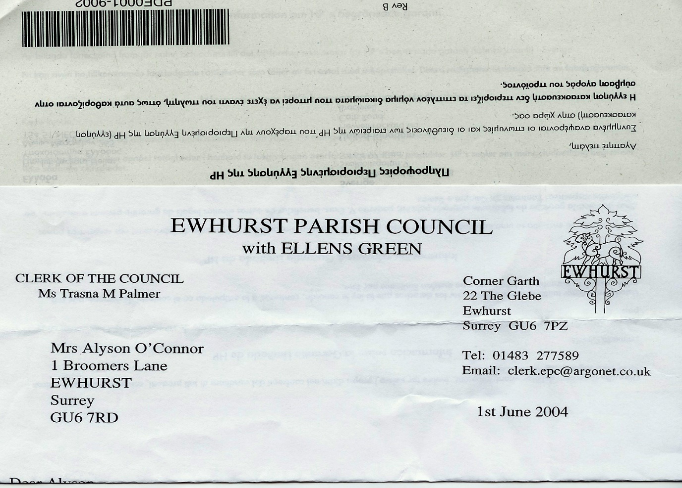 **EWHURST PARISH COUNCIL**

**WITH ELLENS GREEN**

**Clerk to the Council: Joanna Cadman Tel: 01483 268627 email: clerk@ewhurstellensgreen-pc.gov.uk**

**ACTION LIST: October 2024**

|  |  |  |  |  |  |  |  |  |  |  |  |  |  |  |  |  |  |  |  |  |  |  |  |  |  |  |  |  |  |  |  |  |  |  |  |  |  |  |  |  |  |  |  |  |
| --- | --- | --- | --- | --- | --- | --- | --- | --- | --- | --- | --- | --- | --- | --- | --- | --- | --- | --- | --- | --- | --- | --- | --- | --- | --- | --- | --- | --- | --- | --- | --- | --- | --- | --- | --- | --- | --- | --- | --- | --- | --- | --- | --- | --- |
| |  |  |  |  | | --- | --- | --- | --- | | **Date of meeting** | **Minute no** | **Action** | **responsibility** | | Mar 24 | 033 | Glebe Lease | JM/MH  Ongoing – WBC Legal department have not responded | | April 24 | 049 | Cemetery – advice on planting | Clerk  Pending a site visit | | May 24 | 077d | Invasive pond weed | Clerk  Deferred to next April, as treatment should be carried out at the beginning of the season | | May 24 | 077f | Tennis courts | TB  To advise on options for refurbishment  Waiting for contractor | | May 24 | 077g | Phone box | Clerk  Reported BT to Ofcom | | June 24 | Public | Lights in village hall car park | The electrician has been asked to investigate | | June 24 | 091a | Asbestos pipes | The Clerk to discuss with SCC councillor | | ~~July 24~~ | ~~105~~ | ~~Defibrillator box~~ | ~~Now connected~~ | | Sept 24 | 122 | VE day commemorations | Replies being received from village societies. Ongoing | | Sept 24 | 126b | Rubbish in burial ground | Bins locked and notice in v hall kitchen. | |