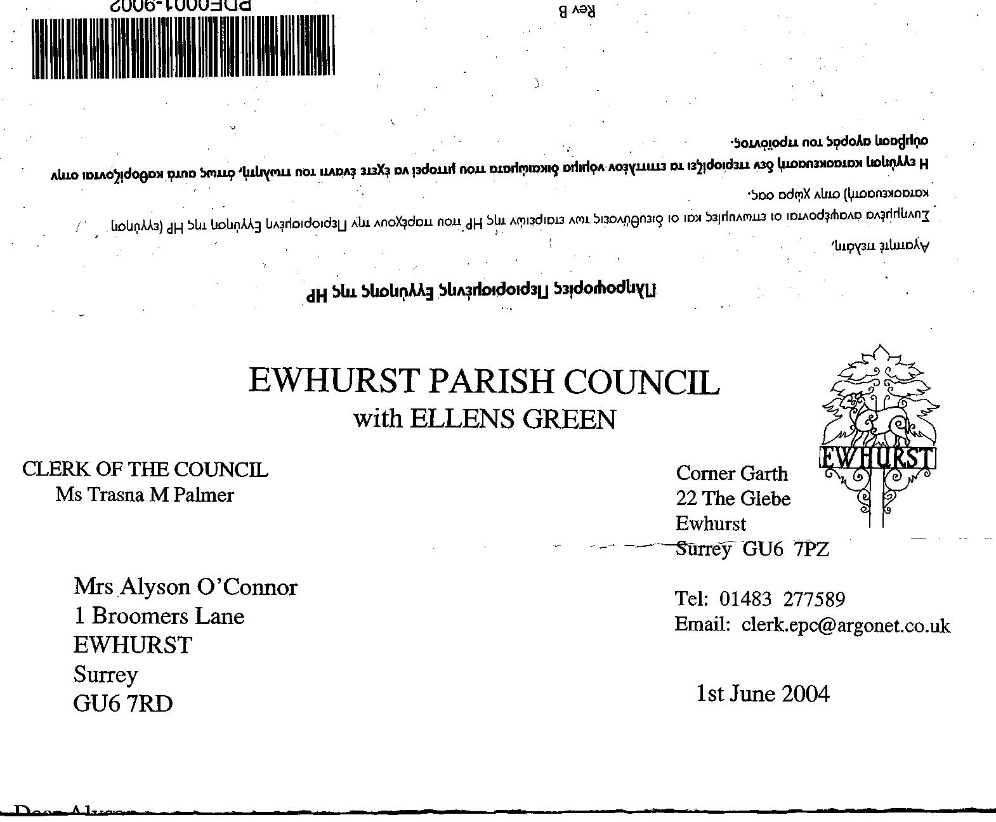
EWHURST PARISH COUNCIL
WITH ELLENS GREEN

Clerk to the Council: Joanna Cadman Tel: 01483 268627 email: clerk@ewhurstellensgreen-pc.gov.uk
EWHURST PARISH COUNCIL WITH ELLENS GREEN PARISH COUNCIL MEETING.
Minutes of the Meeting of the Parish Council held at
8.00 pm on Monday 17th June 2024 At the EYSC

Present: Cllr V Henry (in the chair), Cllrs J Bloomfield, T Bloomfield, J Lilley, L Tingley, M White
County Cllr L Townsend
5 members of the public
In attendance: The Clerk, Mrs J Cadman

PUBLIC SESSION: an opportunity for members of the public who live or work in the parish to ask questions relevant to the work of the Council.

- Lights in village hall car park: 5 lights and one in the hedge, most of which are not working. The Clerk will speak to our electrician.
- Stile on Footpath 434: is dangerous. No-one is living at the property but is understood to live in Cranleigh. The Clerk will ask the help of the Cranleigh Clerk.
- Family Fun Day: the Parish Council were thanked for their support of the upcoming family fun day. Permission had been given for cars to be parked on the perimeter of the recreation ground, but it would be helpful to mark this out so that there were no errors. The Clerk will speak to the footballers and arrange for them to liaise with the Friends of St Peter and St Paul.
- Traffic Calming: in response to a query with regard to progress, Cllr T Bloomfield advised that consideration was being given to using CIL money for VAS cameras. SCC are not in favour of VAS cameras, although West Sussex CC are. This PC would like permission to purchase 2 x VAS cameras, using its own money, to see how effective they are and will take this to the MP if a satisfactory response is not received from SCC. Cllr Townsend confirmed that she had spoken to the cabinet member at SCC and had received the same response.
The resident who raised this matter suggested that 30mph roundels on the roads might also be helpful, and possibly chevrons.
- Community Speed Watch: the co-ordinator had attended the Annual Parish meeting and asked for volunteers. The Clerk will ascertain how they are progressing.

079 (2024) | APOLOGIES FOR ABSENCE: were received from Cllrs N Clowes, M Higgins and J Mitchell.
080 (2024) | DECLARATIONS OF INTEREST: Councillors are reminded of their responsibility to declare any disclosable pecuniary interest which they may have in any item of business on the agenda no later than when that item is reached. Unless dispensation has been granted, you may not participate in any discussion of, or vote on, or discharge any function related to any matter in which you have a pecuniary interest as defined by regulations made by the Secretary of State under the Localism Act 2011. You must withdraw from the room or chamber when the meeting discusses and votes on the matter.  None were made.
081 (2024) | MINUTES OF ANNUAL PARISH COUNCIL MEETING HELD 20th May 2024: these were agreed as a correct record of the meeting and signed by the Chairman
082 (2024) | ACTION LIST: to receive reports from Members and the Clerk
  Date of meeting | Minute no | Action | responsibility
  Feb 24 | 027d | Refurbishments to memorial in rec | Clerk  On agenda
  Feb 24 | 027g | Damaged memorial bench - investigate repairs | JB/Clerk  Cllr Bloomfield had contacted Roser Elms, who had not got back to him. Cllr Bloomfield will repair the bench himself, the bench being relocated to Cllr White’s garden while the work is done.
  Mar 24 | 033 | Glebe Lease | JM/MH  On agenda
  April 24 | 049 | CIL monies – quotes for car parks and potholes | TB  On agenda
  April 24 | 049 | Cemetery – advice on planting | Clerk  On agenda
  April 24 | 050 | NP – meeting with WBC | NC/TB/MH/Clerk  Deferred to July meeting
  May 24 | 077a | Footpath from Bostocks | Clerk  The Clerk has written to WBC but has not yet had a response
  May 24 | 077bii | Sign at village hall car park | Clerk  A picture of the current sign will be circulated for comments
  May 24 | 077c | Grave base at cemetery | JB  advised the clerk of the name on the grave but believes that it has now been moved.
  May 24 | 077d | Invasive pond weed | Clerk  To ascertain control measure and cost
  May 24 | 077f | Tennis courts | TB  had spoken to the contractor but has agreed to look at options to prolong its life.
  May 24 | 077g | Phone box | Clerk  Reported BT to Ofcom
083 (2024) | MATTERS ARISING not covered by the Action List  - Field next to Pennings: Enforcement have advised that, although the mobile home is bigger than would have been approved, there are pigs in the field which need maintenance and so no further action will be taken  - War memorial on recreation ground: the Memorial has been cleaned in time for the 80th anniversary of D Day.  - War memorial: quote to replace plaques. Members reviewed the quotation from Warminster Engraving and agreed to purchase 2 plaques in brass with white infill. The cost for the left hand plaque will be £87.65 plus £6.75 for 127 characters (first 100 included in cost of plaque) and for the right hand plaque will be £87.65 plus £91.50 for 466 characters (first 100 included in cost of plaque). Proposed by Cllr Henry, Seconded by Cllr White, all in favour.  - CCTV at EYSC: this has now been installed and is fully operational. The Clerk has it installed on her phone, and so can access data at any time. Turners can also access data if required for evidence purposes.
084 (2024) | THE PLANNING COMMITTEE:  - Minutes of planning meeting held 20th May: agreed.
FINANCIAL REPORT:
- Expenditure for May 2024: noted and approved.
- Cost centre report to end May: noted and approved
- Bank reconciliation statement to end May 24 for both accounts: noted and approved

- Internal auditors report: members noted the internal auditors report and congratulated the Clerk on a clear report, with no matters raised for action.
- Annual Governance Statement: members considered and responded to the statements as set out, in conjunction with the Internal Auditors Report.
- Accounting statements 2023/24: approved in conjunction with the Internal auditors report. Proposed by Cllr T Bloomfield, Seconded by Cllr L Tingley, all in favour.

The Clerk advised that the Annual Governance and Accounting Statements will now be sent to the External Auditor and placed on the website. A notice will also be placed on the website advising residents that they have the right to inspect the Council’s accounts.

086 (2024) | CIL MONIES : quotations for car parks and potholes in Bowls Club car park. Cllr T Bloomfield advised that the resurfacing quotations will go to the CIL committee for consideration against other projects, but that the pothole quotation was proposed to be met out of budget. He will seek one further quotation, as the cost is over £1,000.
087 (2024) | Planting proposals for cemetery: The Clerk had consulted with a local horticulturalist and proposed a native hedge along the back of the cemetery. A bundle of 50 native plants, flowering and fruiting, would cost less than £100, and two bundles would be sufficient.  Cllr White would prefer to dig out the back of the cemetery and install a fence, Cllr J Bloomfield suggested some native ornamental trees. This matter to be discussed further.
088 (2024) | NP: meeting with Katharine Dove: Agenda item; July meeting
089 (2024) | GLEBE: Heads of Terms: deferred to July meeting
090 (2024) | PARISH UPDATE FROM CLERK: no further matters to raise.
091 (2024) | PARISH BUSINESS: other matters to be noted or included on a future agenda  - Asbestos Pipes: Cllr J Bloomfield had been asked to raise the concern that a number of pipes in Ewhurst were asbestos. Cllr Townsend advised that Thames Water replaced asbestos with plastic when necessary. Cranleigh Council had contacted the World Health Organisation regarding this concern in their parish some time ago. The WHO had organised a water inspection and had said that there was no proof that the asbestos was damaging to health.  - Picnic at Ellens Green: Cllr Lilley thanked everyone for their support and participation. The raffle had raised £281 for Phyllis Tuckwell hospice and the tombola had raised £74.50 for the Fountain Centre at the Royal Surrey.  - Church defibrillator: At present the Church will use the defibrillator at the Glebe, the Clerk had given her the code for the door, to be displayed in the vestry. The Clerk will obtain a quotation for a wall box for the Glebe, so that the defibrillator is more accessible. It was suggested that she approach the Henry Smith charity for a grant.  - House on Furzen Lane: the Clerk had heard no further from the Countryside Ranger about the hedge and the ditch and will pursue this.
092(2024) | NEXT FULL MEETING OF THE PARISH COUNCIL: Monday 15th July at Ellens Green Memorial Hall
 | The meeting closed at 21.15

