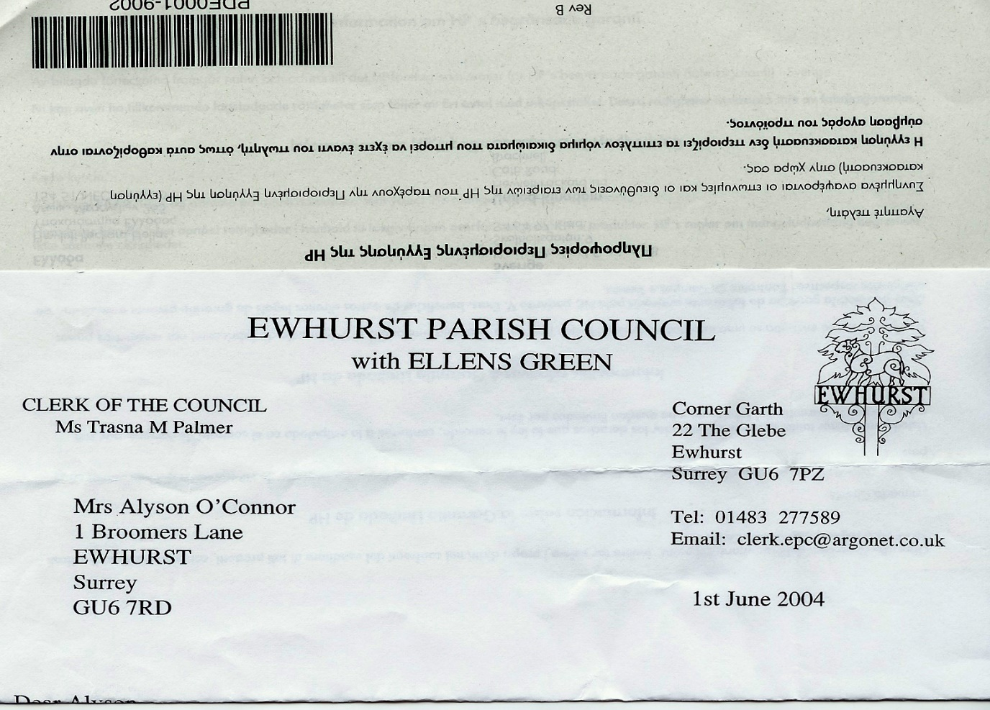**EWHURST PARISH COUNCIL**

**WITH ELLENS GREEN**

**Clerk to the Council: Joanna Cadman Tel: 01483 268627 email:** [**clerk@ewhurstellensgreen-pc.gov.uk**](mailto:clerk@ewhurstellensgreen-pc.gov.uk)

**NOTES FROM A MEETING OF THE CIL WORKING GROUP**

**Tuesday 9th July 2024**

**Present:** Cllr N Clowes (in the chair), T Bloomfield, M Higgins.

The Clerk Mrs J Cadman

|  |  |
| --- | --- |
| 17/24 | **Apologies:** all members were present |
| 18/24 | **Notes from meeting held 16th May:** these were agreed as a correct record of the meeting. |
| 19/24 | **Responses to CIL questionnaire**  *Current Projects score: (1 high, 3 low)*  Bowls Centre car park extension: 1=0. 2=7. 3=28.  Recreation ground car park. 1=17. 2=18. 3=6.  Speed indicator camera. 1=20. 2=9. 3=7  *Additional Projects put forward and working group responses*   |  |  | | --- | --- | | **Name of project** | **Responses** | | Ellens Green memorial hall playground equipment | Will be asked to submit an application | | Solar lit bollards in v hall and EYSC car parks | Already being considered | | Secure bike parking by the cricket pavilion | As part of project to install bike parking through the village | | Increase size and capacity of v hall car park | Not financially viable | | Benches | A budget project | | Circular walks with direction markers | Not a CIL project | | Neighbourhood WiFi | EYSC wifi to recreation ground | | Flashing speed sign in both directions on green | Part of SID project | | Speed indicator signs on all roads | Part of SID project | | Level and lasting road surfaces | SCC highways | | Chicane on Horsham Road | Is planned by SCC highways | | Wifi to the Glebe | Under discussion | | Cricket pavilion refurb | To be addressed | | Clearing roadside ditches, hedgerows, culverts, planting wildflowers | Responsibility of Highways, WBC, PC, local volunteers | | Road surface repair | SCC highways | | EG memorial hall playground | See above | | Restoration of ponds | Not a CIL project | | Local footpath guide | LEAP to be asked if they would pursue this, with some funding. | | EYSC car park and ground surface | Being considered | | Speed cameras, 20mph sign | Being pursued | | Cricket club |  | | Roof and balcony replacement | 45 requests | |
| 20/24 | **Application for Funding**  The Cricket club have submitted an application for 80% funding of £8,500 quotation to replace the balcony of the cricket club and the roof over, due to water ingress to the changing rooms below and safety of the balcony.  Members agreed this to be a worthwhile project, with a well presented application form and community backing. It was agreed to respond to them with outline support for the project, advising them we are considering funding 70% of the project, but seeking the following information:   * Who else they have approached for funding * Who else pays to use the facilities * Two quotations for the work, specifying the work to be carried out, in line with Parish Council financial regulations |
| 21/24 | **Current Projects**  Members reviewed the scoring from the consultation for the current projects and agreed the following:  *Bowls Club:* the Bowls Centre car park extension scores very low and will be very expensive, and so is taken off the list of projects.  *Recreation ground car park:* this project received good support and should be pursued. A quotation received for this work cited £29,000 for this work, which is a large proportion of the CIL money available.  **Action:** TB to asked the contractor for a fuller specification  Additional funding to be sought  *Speed indicator Cameras:* this project received the greatest support, with a great deal of concern being expressed over speeding in the parish.  It was noted that SCC do not support speed indicator cameras, although they receive full support in West Sussex. The Clerk will write to SCC Highways to formally request that the Parish Council is given permission to install 2 poles, one in Ellens Green and one in Ewhurst, and one trial camera, to be moved between them, using Parish Council funding. This letter will be copied to our County Councillor and also Jeremy Hunt, MP for Ellens Green, who is championing speed cameras elsewhere in his constituency. |
| 22/24 | **Ellens Green Memorial Hall**  They are requesting funding for playground refurbishments, specifically replacement of the roundabout, which had to be removed for safety reasons.  The Clerk will send them an application form and ask them to specify other sources of funding in their response. |
| 23/24 | **Other projects to support**   1. *Refurbishment of Village hall:* the group will undertake a site visit of the hall and EYSC in the next week, to take a view on what could potentially be done to improve the facilities . 2. *Cycle racks:* the Clerk will investigate costs, with a view to installing a rack at the shop, the village hall, the recreation ground and the cricket club. |
|  |  |