Comments for ROWIP
Do you have any additional comments to help improve the ROWIP?

Please tell use of any specific ROW issues or improvements in your Parish – provide route number, precise description, and location of route.

Footpath 362 – section north from Rapsley Farm, Ewhurst to junction with Shere Road – local residents concerned with erosion and maintenance of drainage – suggestion has been made for this to be changed to a bridleway to allow horses to avoid using the Shere Road.
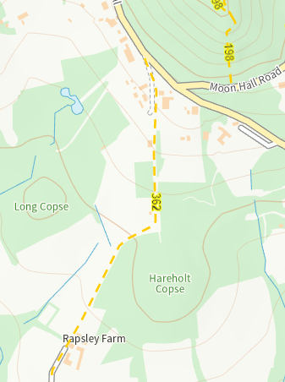

Change FP433 (Farthingham Lane section) to a Bridleway – this has been suggested to provide an alternative route for cyclists and horses to avoid some of the B2127 (Ockley Road) when entering/exiting the centre of Ewhurst village. Note – much of the current surface is deep shingle makes it only suitable for walkers.

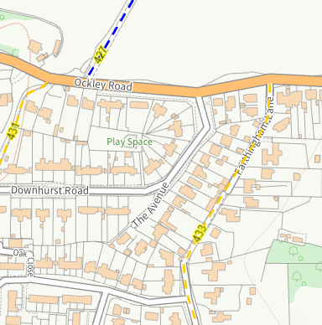

BOAT 541 – although in the neighbouring Parish of Abinger, its proximity to Ewhurst Parish means issues are often brought to our attention. Therefore, may we mention that a section of BOAT 541 (just north of the junction with FP70) was dug up and not properly reinstated.
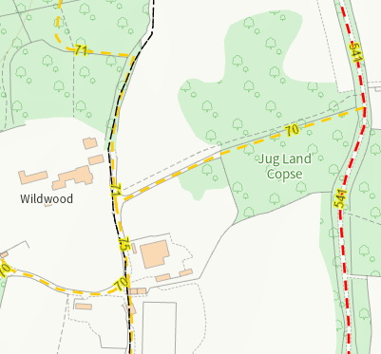

FP512 – section of this path is heavily eroded. The Parish Council has worked with Sayers Croft Field Centre to try and improve surface of this well used path but as it is on a hill erosion continues.

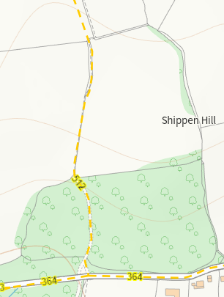
Creation of permissive ROW
To link FP439 (north/south route) to either FP442 or FP444/BW443 (east/west routes)
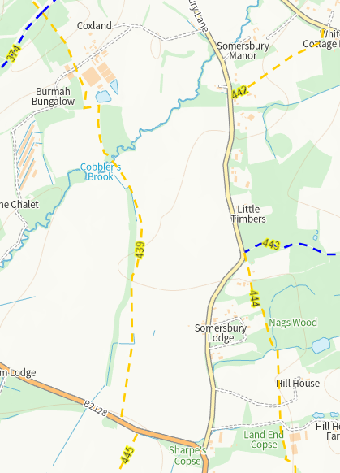

To link FP435 to FP427b.
FP 435 is a north/south route – at its northern extremity it ends where it meets the B2127 (Ockley Road). Walking along the B2127, for example to get to FP428 or the Holmbury Road, is not easy due to traffic and a lack of any verge/refuge for pedestrians. A route continuing north would allow walkers to more easily access ROW that lay to the north.
