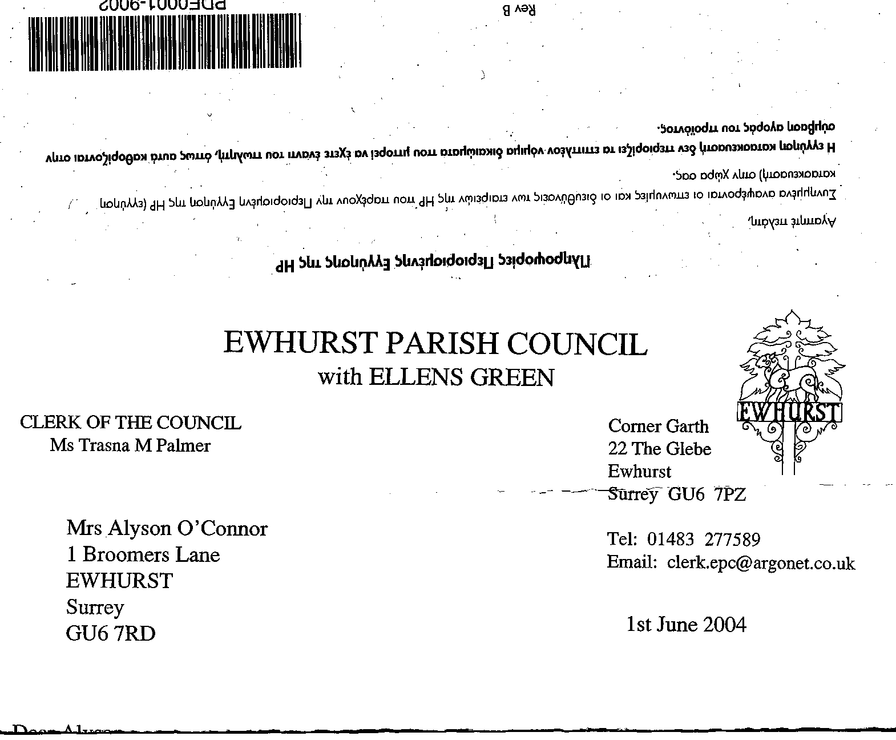
+ EWHURST PARISH COUNCIL
WITH ELLENS GREEN

Clerk to the Council: Joanna Cadman Tel: 01483 268627 email: clerk@ewhurstellensgreen-pc.gov.uk
EWHURST PARISH COUNCIL WITH ELLENS GREEN PARISH COUNCIL MEETING.
Minutes of the Meeting of the Parish Council held at
8.00 pm on Monday 20th November 2023
At the EYSC
Present: Cllr N Clowes (in the chair), Cllrs J Bloomfield, T Bloomfield, V Henry, M Higgins, J Lilley, J Mitchell, L Tingley.
6 members of the public
In attendance: The Clerk, Mrs J Cadman

148(2023) | APOLOGIES FOR ABSENCE: were received from Cllr White
149 (2023) | DECLARATIONS OF INTEREST: none were made.
150 (2023) | MINUTES OF PARISH COUNCIL MEETING HELD 16th October 2023: were agreed as a correct record of the meeting and signed by the Chairman after the following addition:  142(2023) Communications: iv: Box broadband contract: Members gave their permission for the contract to be signed by the Clerk.
151 (2023) | MATTERS ARISING  129(2023) Footpath 512: the work to this footpath was carried out by Sayers Croft volunteers during half term week at the end of October. The Clerk reported that the work had been very successful, with half the length of the path cleared and covered with scalpings. Sayers Croft were happy to provide volunteers for more work in the future and the Clerk would source more scalpings ready for when they were available. She also thanked Cllrs J Bloomfield and M Higgins for working with the volunteers.  138 (2023): Glebe users meeting for further discussion on the acoustics: this is currently being arranged.  138 (2023): Field next to Pennings: Cllr Higgins advised that an officer from WBC was due to visit the site this week.  141 (2023) allotment holders: the final two allotment holders have responded and have undertaken to restore their allotments to full working order before the spring.  146 (2023): 80th anniversary of D Day: the Clerk is seeking quotes to refurbish the war memorial on the recreation ground.  146 (2023)c: Phone box on Ellens Green: members to receive a report on the acquisition of a new K6 phone box from Cllr White. Deferred: to the January meeting.
152 (2023) | ADJOURNMENT: - During the adjournment members of the public may speak on matters of concern  - Village lights: members were advised that the few lights in the village had been placed in 1994, to commemorate the 100th anniversary of the creation of parish councils. One light was placed outside the gate of the house opposite the village hall and was not working any more. The Parish Council was asked to get this reinstated, as it increased safety when crossing the road.  - Speed of cars through the village: this continuous problem was discussed. The resident was advised that the government would not support a 20mph speed limit, but that SCC are reducing the speed limits on a number of surrounding roads. Traffic calming in the village is almost impossible because of the sight lines and lack of lighting. The possibility of average speed cameras was discussed. The Clerk will find out if Community Speed Watch is still in existence in Ewhurst.  - Glebe: the pathway lights have been restored.  - Noticeboard on Ewhurst Green: residents were disappointed that they could no longer put their notices on the new noticeboard, as it is locked. The Clerk advised that she had decided to attach the key to the board by a chain, so that it could be accessed by village societies.  - Road by Cornhill Manor: the road is dangerously full of potholes and generally in a poor state of repair. Cllr T Bloomfield undertook to establish if the road is in SCC’s programme.
153 (2023 | THE PLANNING COMMITTEE :  - Minutes of planning meeting held 16th October: these were agreed as a correct record of the meeting,  - Planning update on meeting held 20th November: Cllr Mitchell requested that this item be removed from the agenda, as those at the planning meeting will be fully aware of the actions of that committee, and they will also be contained in the minutes. Seconded by Cllr T Bloomfield, all in favour.  - Update on recent applications:  - Maybanks: granted  - 31 Downhurst Road: granted  - Bildens Farm: granted  - Site of Lake House: granted  - Furzenhurst: granted
154 (2023) | FINANCIAL REPORT:  : iv: Box broadband contract: Members gave their permission for the contract to be signed by the Clerk.  - Expenditure for Oct 2023: noted and approved  - Cost centre report to end Oct 2023  - Bank reconciliation statement to end Oct 2023  - Interim audit: has been arranged for 28th November  - Budget 2024/25: Members noted the need to meet in December to discuss the budget for 2024/25 and the associated precept request. A date would be agreed.
155 (2023) | COMMUNICATIONS:  - Facebook and Ewhurst community board: It is planned to have a link to the website so that residents can sign up to receive minutes of meetings and other Parish Council information.  - Nextdoor: could be used in the same way.  - Website: The Clerk advised that village societies had been asked to provide a link, or some information, for the website, and a number had done so. She had also offered to publish news of their events in the Parish Council news section.
156 (2023) | CCTV: The Clerk advised that she had met with the current contractors. They would provide a quotation for a more up to date CCTV, with clearer pictures and better accessibility, which would cover the recreation. The quote would include an additional 3 static cameras, to cover dark areas around the building.
157 (2023) | HERITAGE LOTTERY APPLICATION: St Peter and St Paul, South Transept  Members agreed the request from the Friends of St Peter and St Paul and agreed as follows:  That the Parish Council would:  - Emphasise the importance of the church to the Parish Council as a building  - Mention the importance of church and community for the “well being” of the village and its residents  - Encourage support for FSPSP by advertising their events and encouraging participation by the community  - Acknowledge the Parish Council will support the Friends financially when possible by donations to some events and forgoing payment for hire of some Parish equipment/venues. Each request for support to be considered separately by the Council at a full Council meeting.  The Clerk will write to FSPSP to formally agree their request and support their Heritage Lottery application. | Appendix 6: HERITAGE LOTTERY APPLICATION
158 (2023) | FRIENDS OF ST PETER AND ST PAUL  Members agreed the request to allow the FSPST free use of the hall for the February fund raising quiz night and free use of the village hall tables for fund raising events in 2024. Proposed by Cllr Clowes, Seconded by Cllr Mitchell, all in favour.
159 (2023) | ELLENS GREEN PARTY ON THE GREEN 2024  Members to consider the request to pay for the hire of Ellens Green hall for a party on the Green in 2024, probably during National Picnic Week 14th to 23rd June. It was noted that this is the only community event in Ellens Green, and the £50 requested was the comparative sum to that given to the Carnival for its bi-annual event. Proposed by Cllr Mitchell that the sum of £50 for hire of the hall is agreed, seconded by Cllr J Bloomfield, all in agreement. Ellens Green councillors abstained.
160 (2023) | PARISH UPDATE FROM CLERK: the Clerk had nothing further to report.
161 (2023) | PARISH BUSINESS: other matters to be noted or included on a future agenda  - CAB: Cllr Mitchell advised that CAB are running a campaign to alert people to the dangers of scammers and wished to talk to vulnerable people in the village. They had approached representatives of the Glebe coffee morning, who did not think it appropriate. Members agreed that this is a vital service to the village, and that village societies should be asked if they would like a talk, followed by a talk at the Annual Parish Meeting next April.  - Defibrillator at Ellens Green Memorial Hall: its location needs to made clearer.  - Hedges on Cranleigh Road: Cllr J Bloomfield thanked Cllr Higgins for clearing back some of the hedges on the pavement here. .  - Blocked drain on Cranleigh Road: Cllr J Bloomfield has reported this but advised that the system for reporting is poor, as each drain has to be reported separately, which does not make allowance for a connected problem.  - Yellow marker crossing point at hall: this needs repainting.  - Tennis court notices: Cllr T Bloomfield and the Clerk will discuss and arrange notices advising that the courts are for tennis only.  - Notification of road closure on Ockley Road: the diversion does not make sense. Cllr T Bloomfield is meeting with Highways in January and will raise this matter.  - Biffa bin on recreation ground: Cllr J Bloomfield found it full of household items. It was agreed to lock it and give a key to the cleaner, who empties the bins on the recreation ground.  - Defibrillator: the Clerk confirmed that the Bowls Club have a new defibrillator and their old one has gone to the Glebe.  - Box Broadband: Cllr Michell hopes to bring the financial agreement to the January full council meeting.  - EYSC Wifi: a discussion took place on how to protect the Wifi from inappropriate use from people able to access the password. Advice will be sought.
162 (2023 | NEXT FULL MEETING ON THE PARISH COUNCIL: Monday 15th January 2024 at the EYSC  To be preceded by a Planning Meeting at 7.30 pm

